Covid-19 Final

Justin Licea, Jae Hoon Lee, Wesam Farjo, Timothy C Rochester, Riker Santivong

# **Objective**

* Process multiple files while understanding data structure.
* Use HiveQL to clean data.
* Combine multiple cleanse dataset to visualization.
* Use Tableau to make visualization.
* Use Excel to 3D map for covid sentiment analysis.

**PRE-REQUISITES**

1. Excel

2. Tableau

Downloaded and Installed the Tableau with the license key by the instructor or you can visit https://www.tableau.com/academic/students and download the free desktop of tableau.

**OUTLINE**

* **Step 1: Download The Data**
* **Step 2: Upload The Data Files Into HDFS**
* **Step 3: Put Files Into Their Respected Folders And Check Them**
* **Step 4: Create Tables For The Data Using Hive And Hcatalog**
* **Step 5: Download The Files To Your Computer And Use Excel**
* **Step 6: Data Visualization on Excel**
* **Step 7: Data Visualization on Tableau**

**STEP 1: DOWNLOAD THE DATA**

**Open a terminal such as Git Bash. Then, you have to use ssh to Hadoop Cluster at SCU with IP address that is given.**

ssh **jlicea7**@bigdata1.iscu.ac.kr

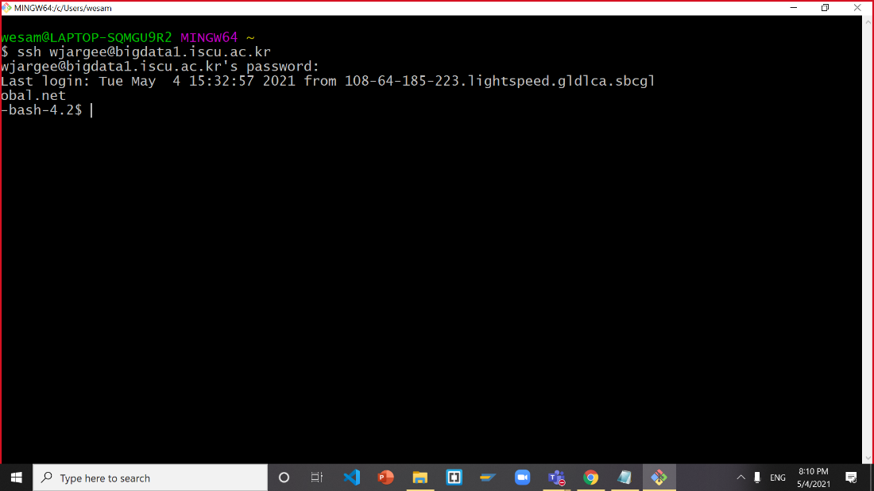

**Download Google Drive file as follows:**

wget --load-cookies /tmp/cookies.txt "https://docs.google.com/uc?export=download&confirm=$(wget --quiet --save-cookies /tmp/cookies.txt --keep-session-cookies --no-check-certificate 'https://docs.google.com/uc?export=download&id=1GDLgobvZK_tVDiZgF3otgzyOtIkvWZAA' -O- | sed -rn 's/.*confirm=([0-9A-Za-z_]+).*/\1\n/p')&id=1GDLgobvZK_tVDiZgF3otgzyOtIkvWZAA" -O group.zip && rm -rf /tmp/cookies.txt

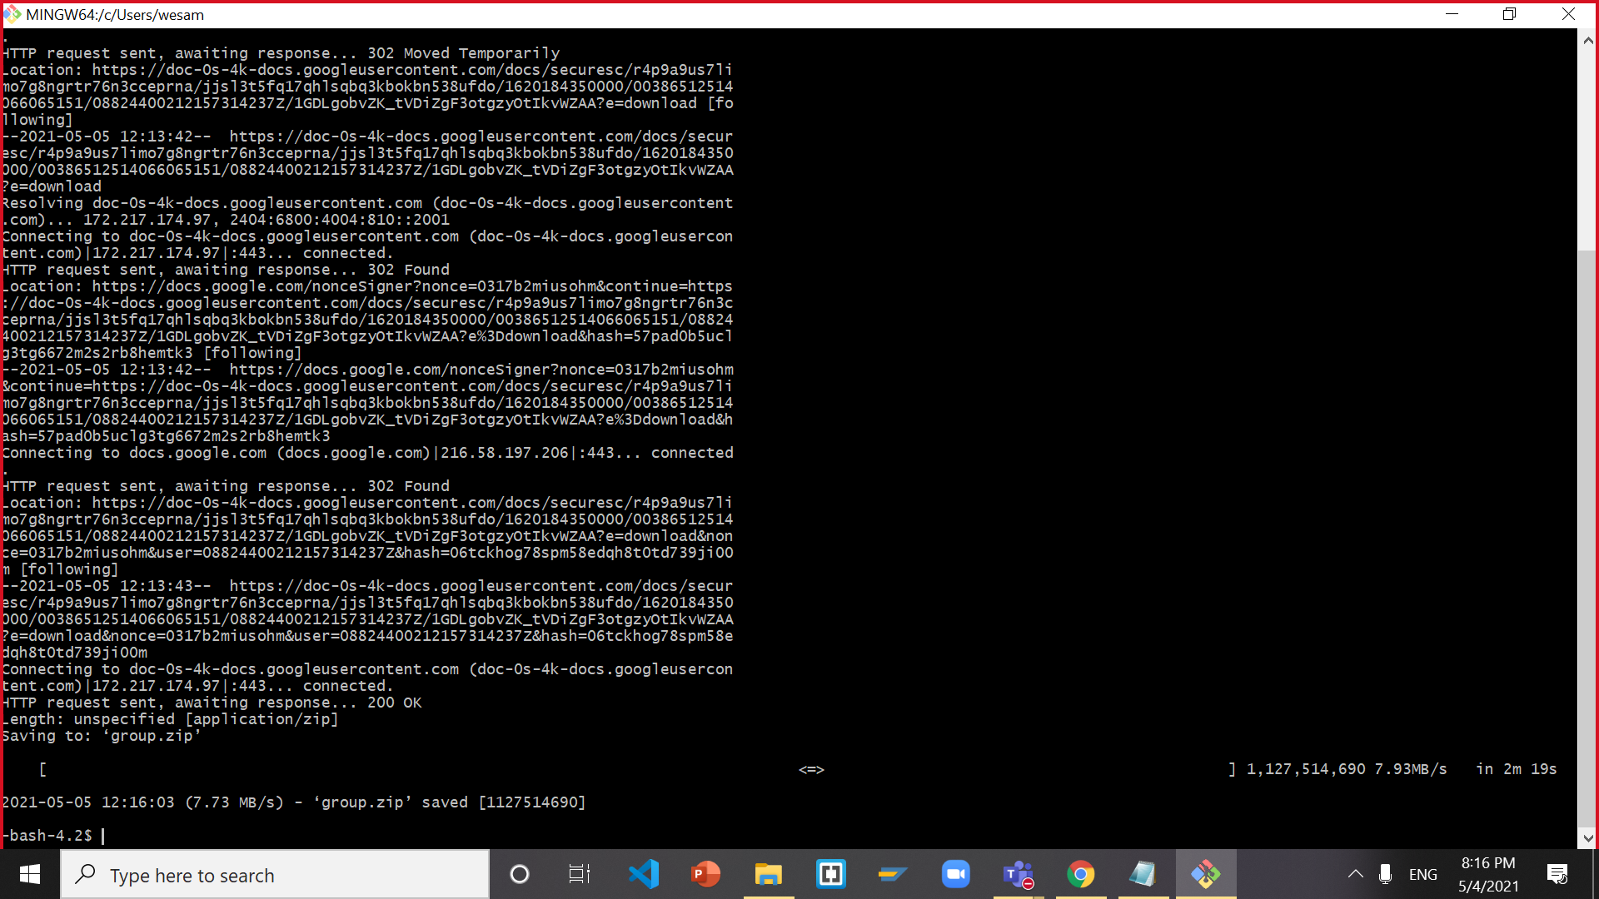

**Once you have the file you will need to unzip (Group.Zip) file into a directory.**

unzip group.zip

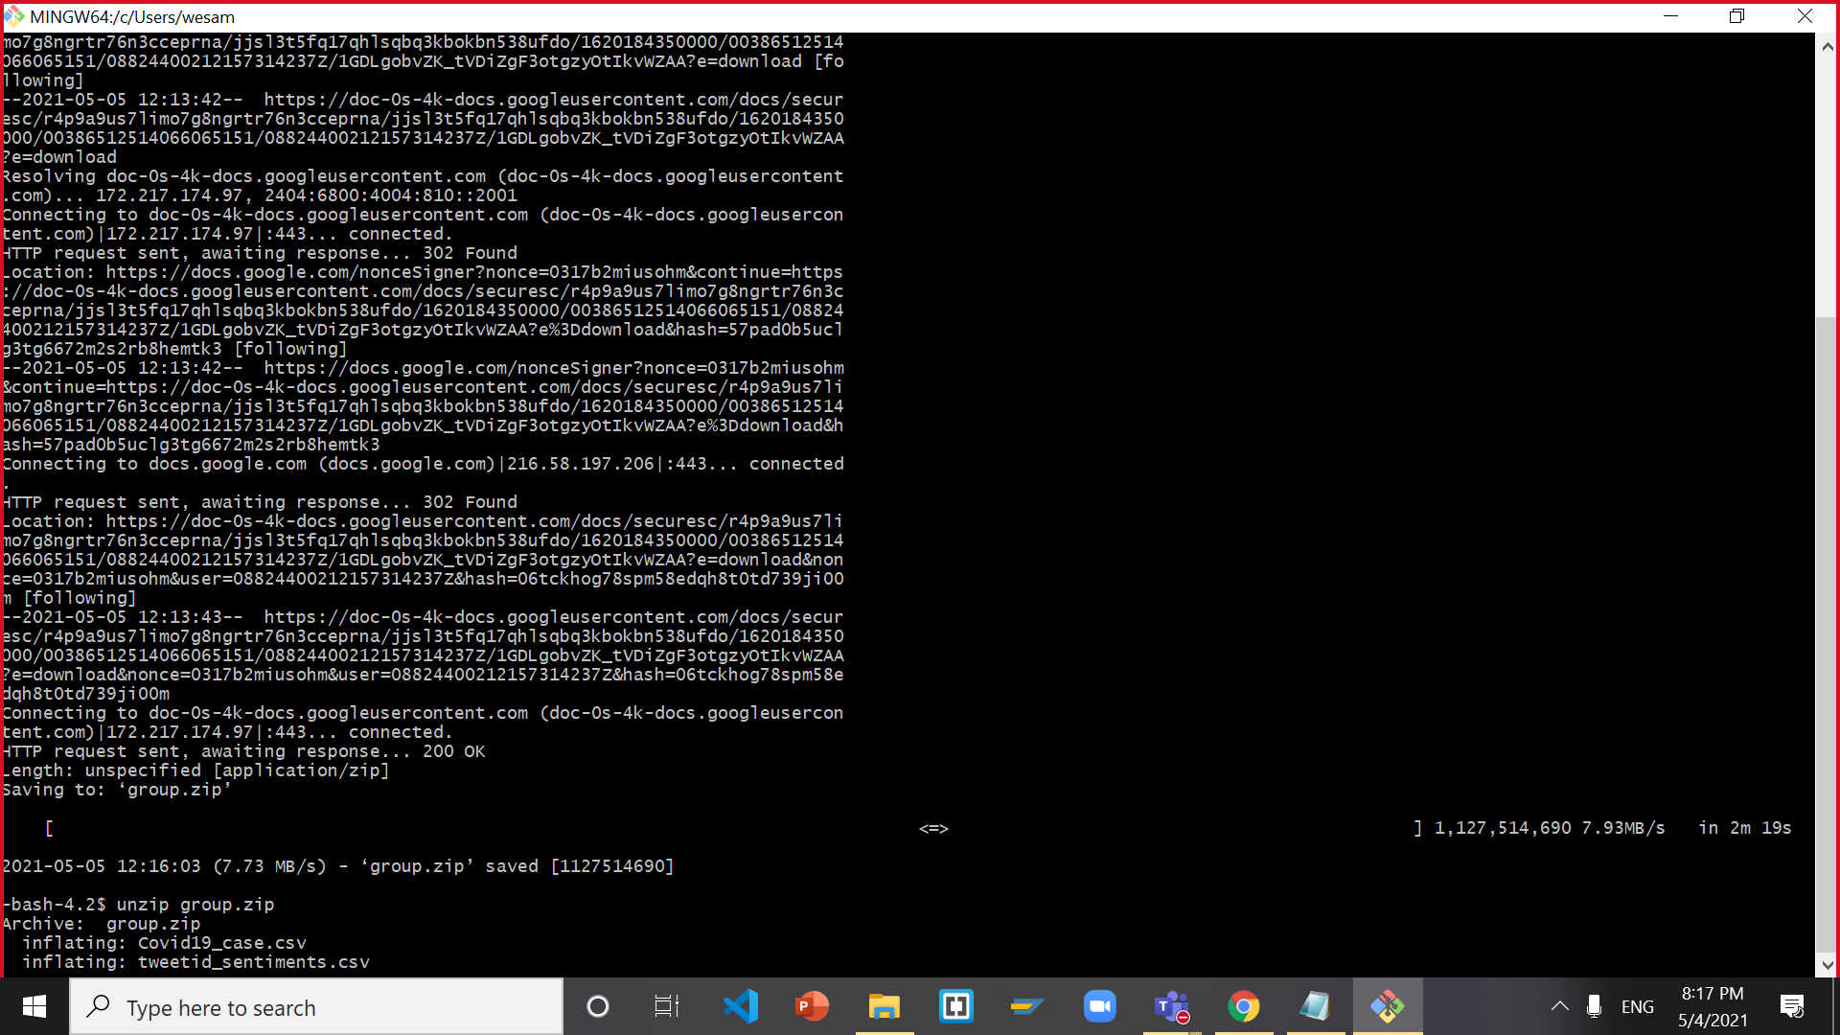

ls

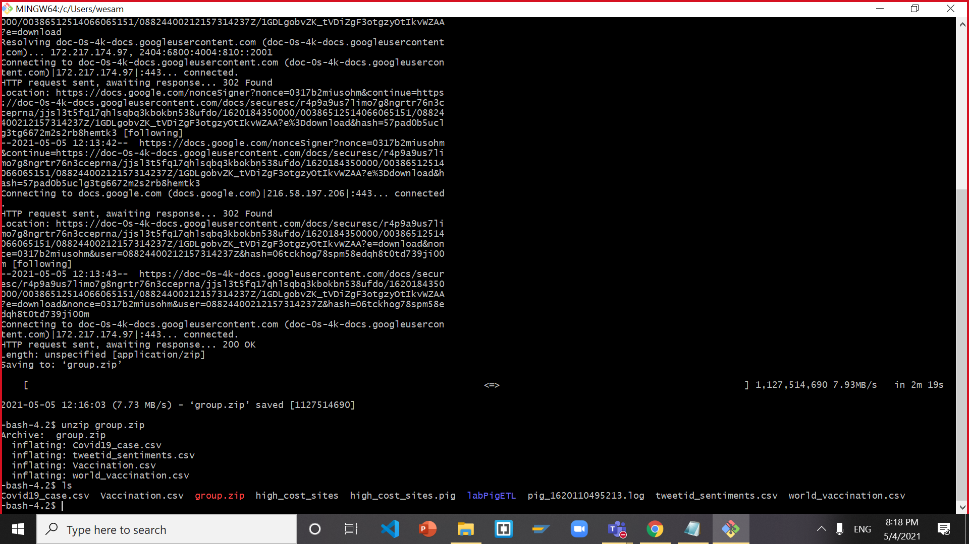

# **STEP 2: UPLOAD THE DATA FILES INTO HDFS**

Run the following HDFS commands to make sure the group work and directories are created:

hdfs dfs -mkdir group_work

hdfs dfs -mkdir group_work/Covid19_case

hdfs dfs -mkdir group_work/tweetid_sentiments

hdfs dfs -mkdir group_work/world_vaccination

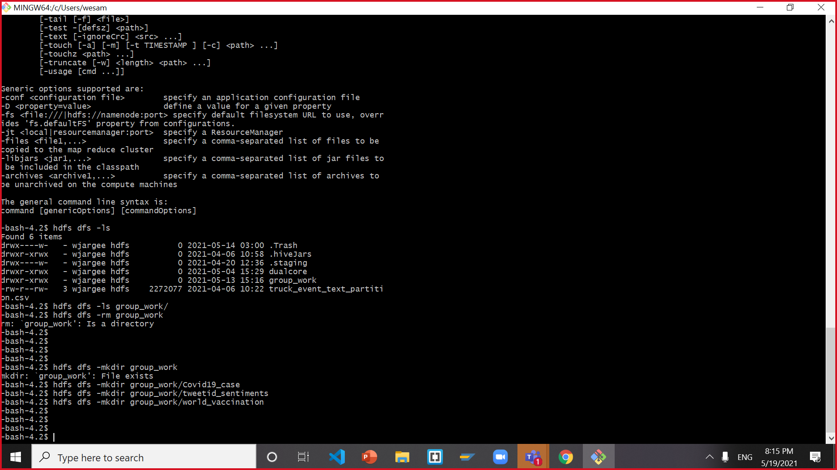

hdfs dfs –ls

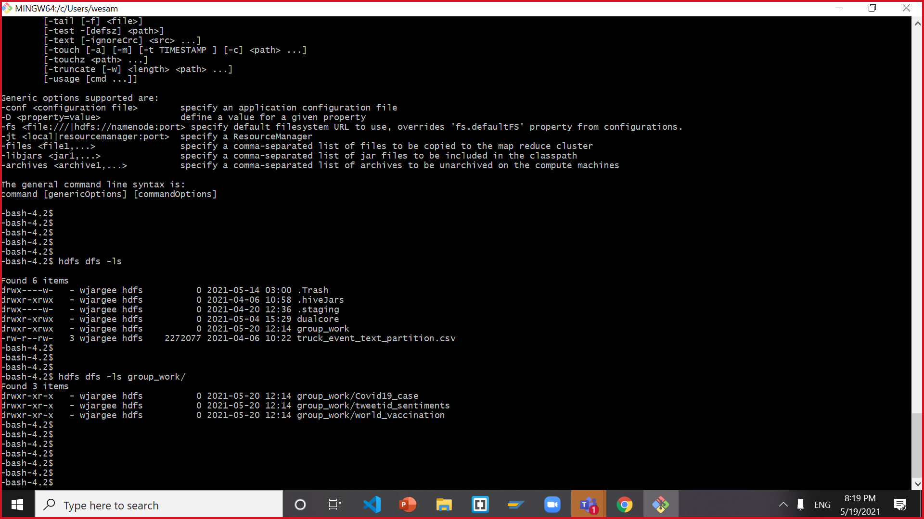

hdfs dfs -ls group_work/



hdfs dfs -ls group_work/Covid19_case

hdfs dfs -ls group_work/tweetid_sentiments

hdfs dfs -ls group_work/world_vaccination

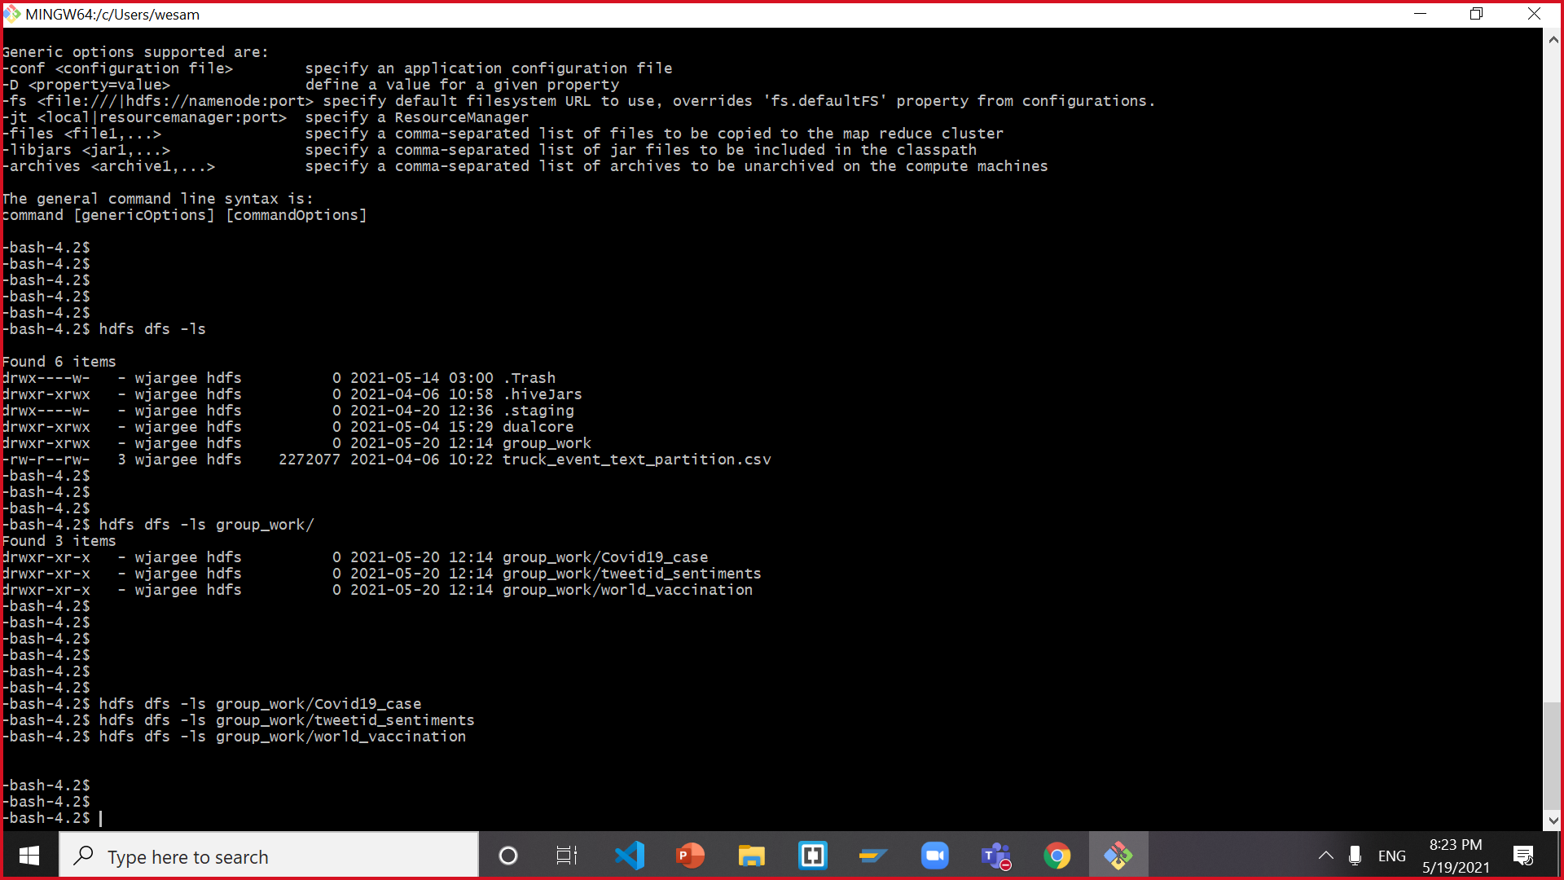

# **STEP 3: Put Files into their respected folders and Check them**

hdfs dfs -put Covid19_case.csv group_work/Covid19_case

hdfs dfs -put tweetid_sentiments.csv group_work/tweetid_sentiments

hdfs dfs -put world_vaccination.csv group_work/world_vaccination

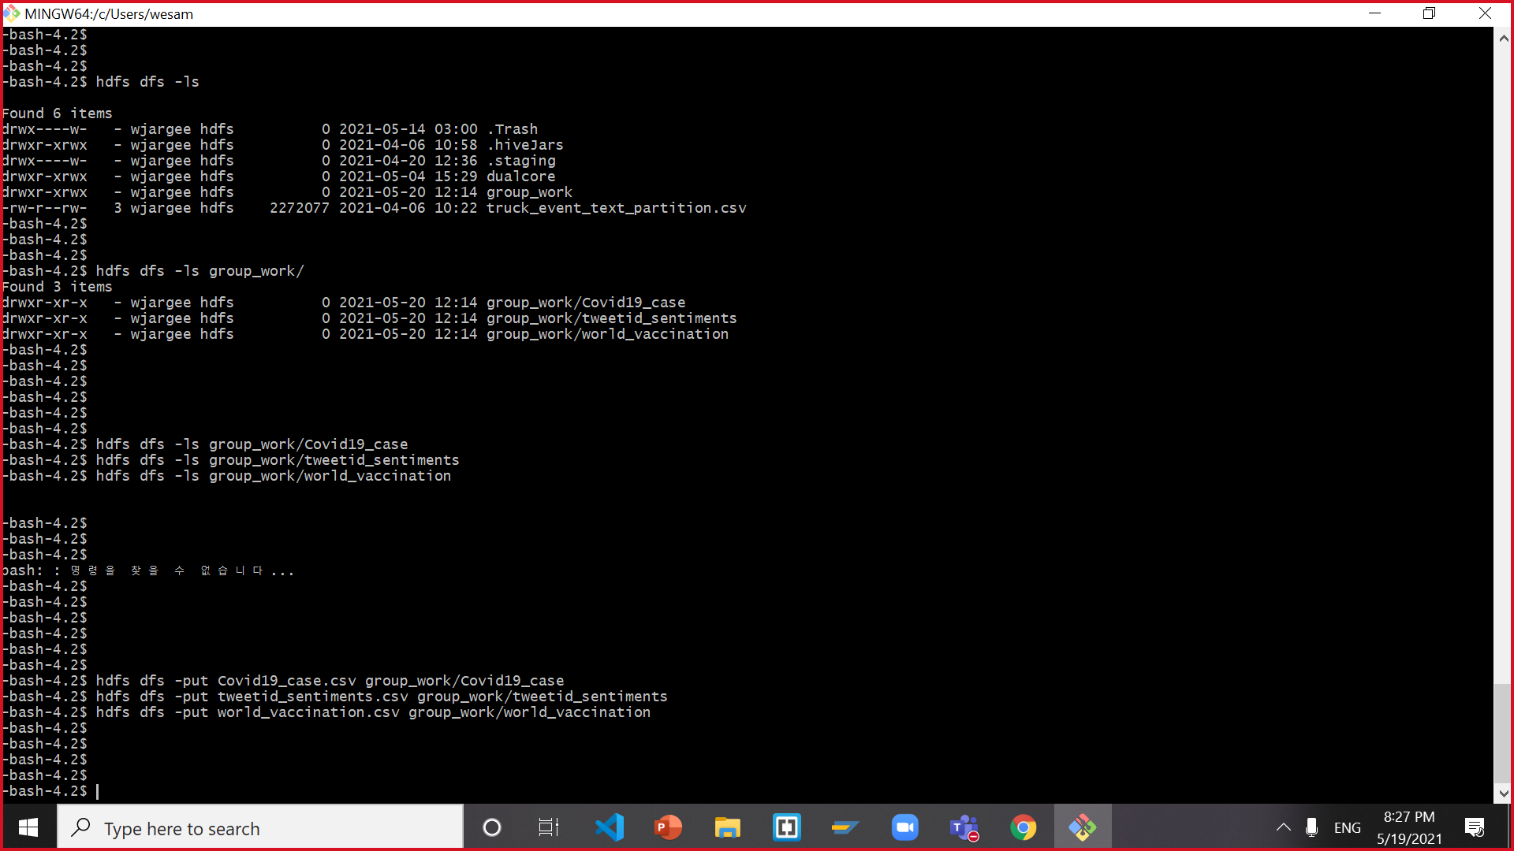

hdfs dfs -ls group_work

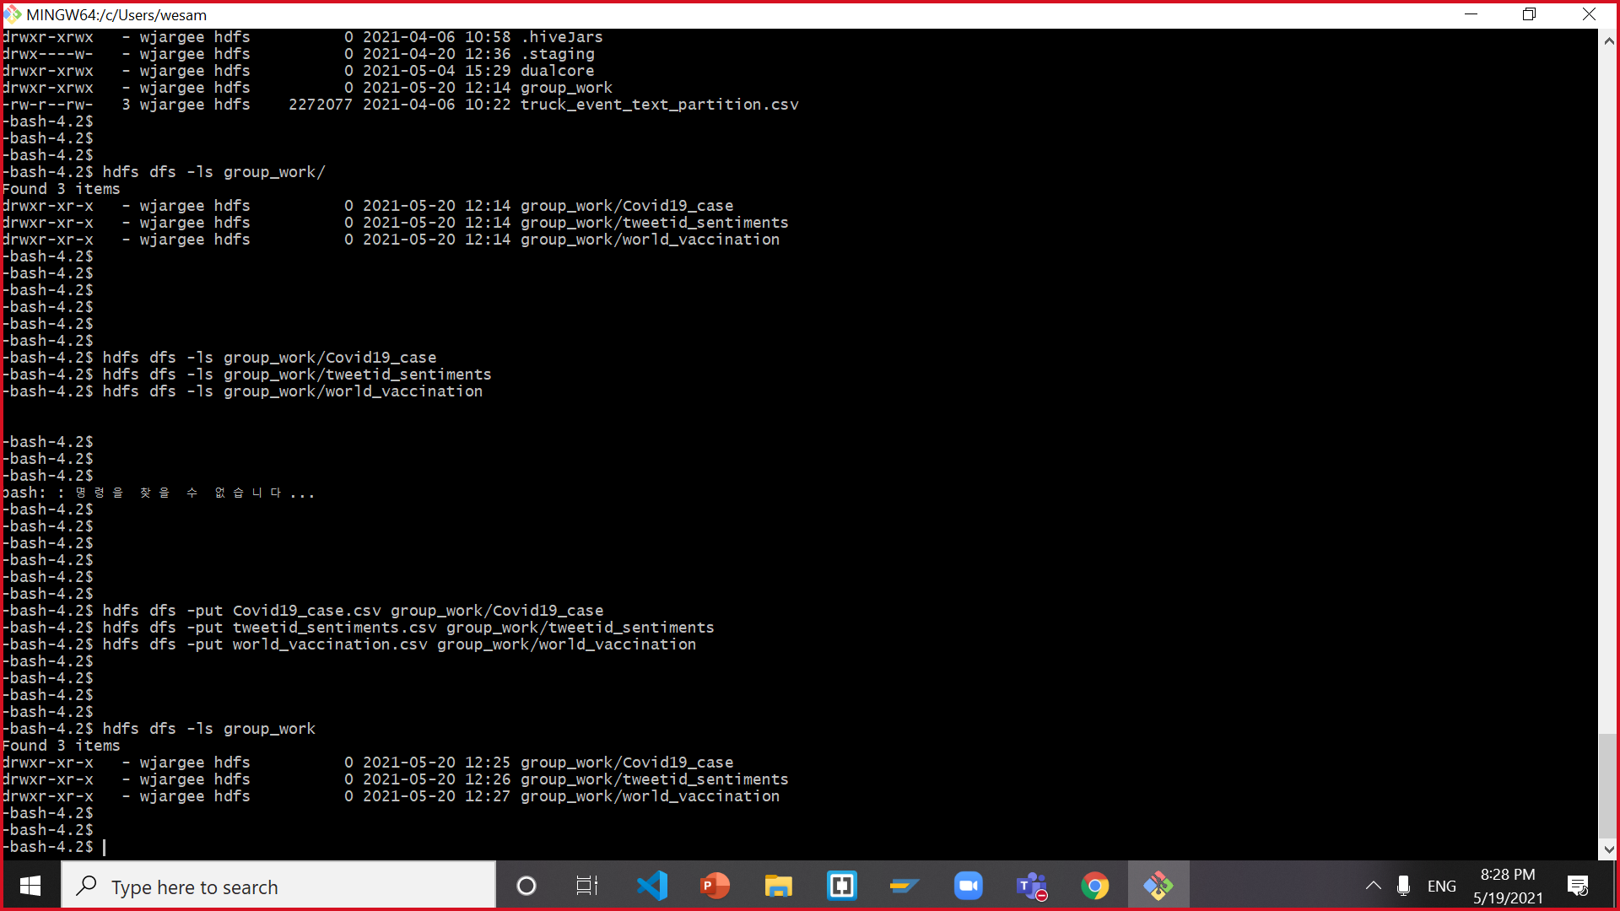

hdfs dfs -ls group_work/Covid19_case

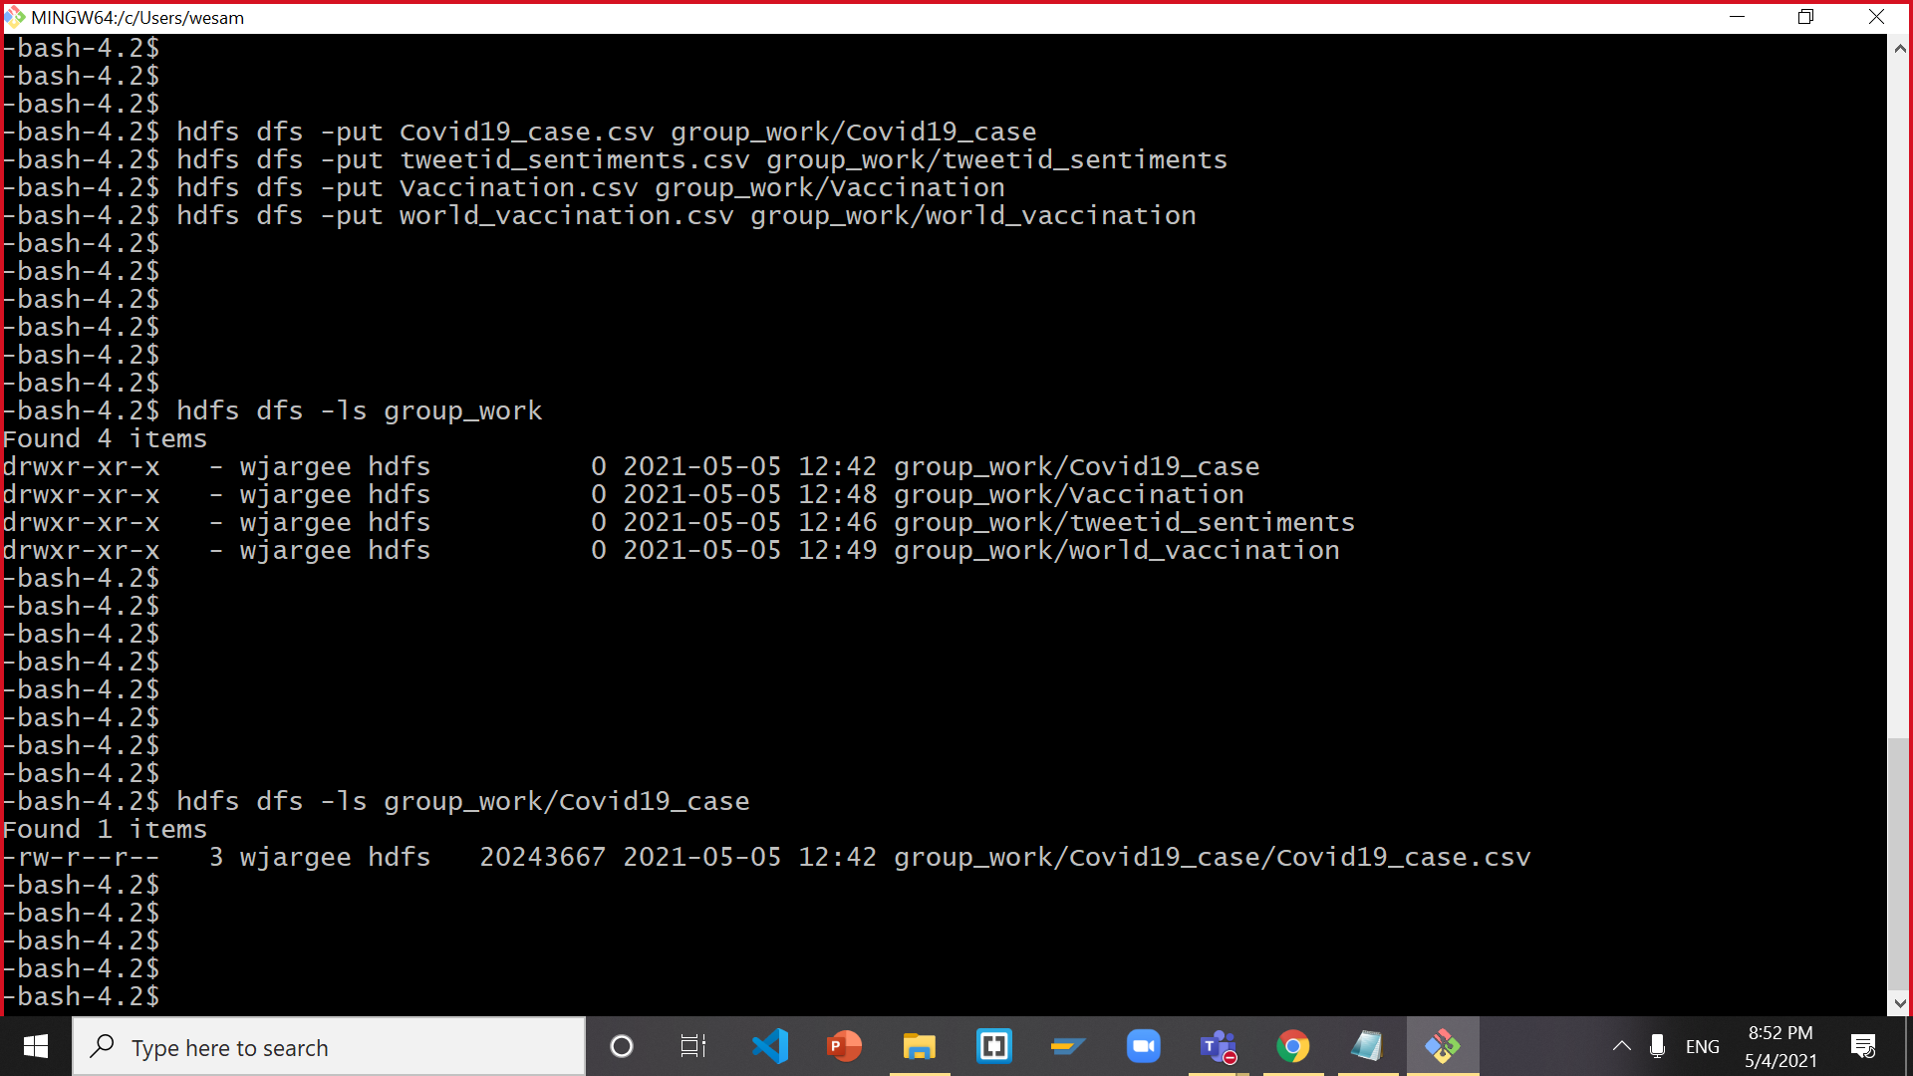

hdfs dfs -ls group_work/tweetid_sentiments

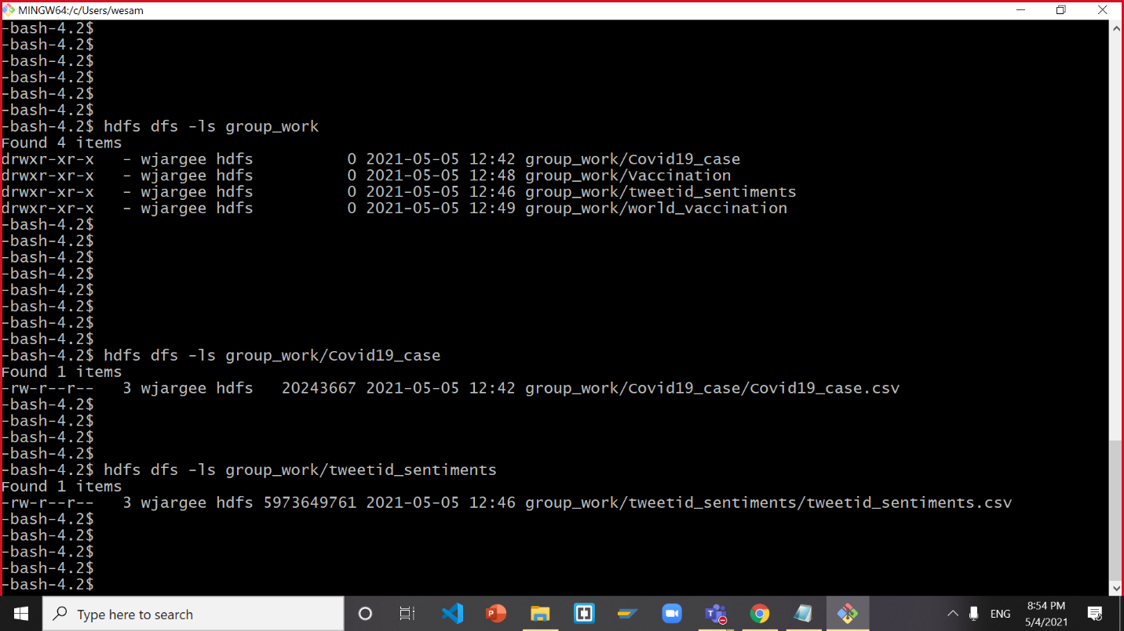

hdfs dfs -ls group_work/world_vaccination

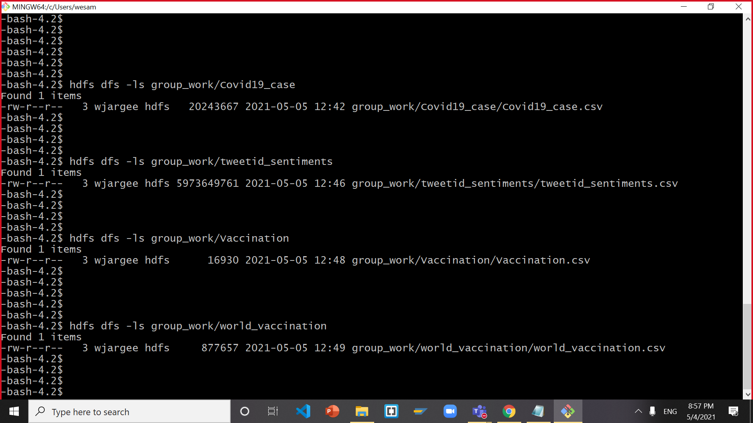

--assign write permit

hdfs dfs -chmod -R o+w .

# **STEP 4: CREATE TABLES FOR THE DATA USING HIVE AND HCATALOG**

**Open the Hive interface on a new terminal by typing in beeline CLI:**

hive

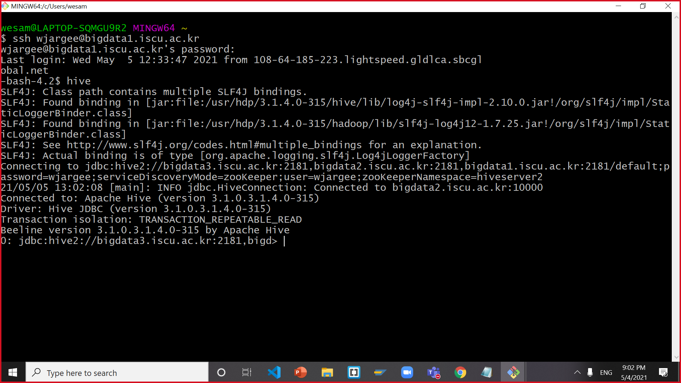

**Don’t forget to use your database:**

use jlicea7;

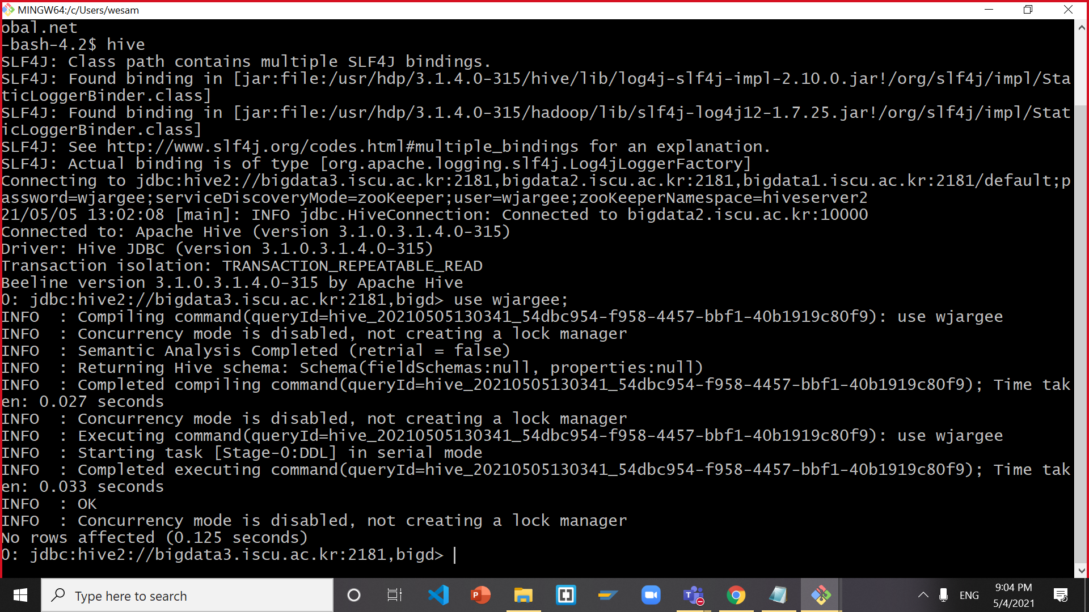

**Now, you need to make table *Covid19_case***

drop table if exists Covid19_case;

CREATE EXTERNAL TABLE IF NOT EXISTS Covid19_case(

iso_code STRING,

continent STRING,

location STRING,

`date` STRING,

total_cases BIGINT,

new_cases BIGINT,

new_cases_smoothed BIGINT,

total_deaths BIGINT,

new_deaths BIGINT,

new_deaths_smoothed FLOAT,

total_cases_per_million FLOAT,

new_cases_per_million FLOAT,

new_cases_smoothed_per_million FLOAT,

total_deaths_per_million FLOAT,

new_deaths_per_million FLOAT,

new_deaths_smoothed_per_million FLOAT,

reproduction_rate FLOAT,

icu_patients BIGINT,

icu_patients_per_million FLOAT,

hosp_patients BIGINT,

hosp_patients_per_million FLOAT,

weekly_icu_admissions FLOAT,

weekly_icu_admissions_per_million FLOAT,

weekly_hosp_admissions FLOAT,

weekly_hosp_admissions_per_million FLOAT,

new_tests BIGINT,

total_tests BIGINT,

total_tests_per_thousand FLOAT,

new_tests_per_thousand FLOAT,

new_tests_smoothed FLOAT,

new_tests_smoothed_per_thousand FLOAT,

positive_rate FLOAT,

tests_per_case FLOAT,

tests_units STRING,

total_vaccinations FLOAT,

people_vaccinated BIGINT,

people_fully_vaccinated BIGINT,

new_vaccinations BIGINT,

new_vaccinations_smoothed FLOAT,

total_vaccinations_per_hundred FLOAT,

people_vaccinated_per_hundred FLOAT,

people_fully_vaccinated_per_hundred FLOAT,

new_vaccinations_smoothed_per_million BIGINT,

stringency_index FLOAT,

population BIGINT,

population_density FLOAT,

median_age FLOAT,

aged_65_older FLOAT,

aged_70_older FLOAT,

gdp_per_capita FLOAT,

extreme_poverty FLOAT,

cardiovasc_death_rate FLOAT,

diabetes_prevalence FLOAT,

female_smokers FLOAT,

male_smokers FLOAT,

handwashing_facilities FLOAT,

hospital_beds_per_thousand FLOAT,

life_expectancy FLOAT,

human_development_index FLOAT)

ROW FORMAT DELIMITED FIELDS TERMINATED BY ','

STORED AS TEXTFILE

LOCATION '/user/jlicea7/group_work/Covid19_case'

TBLPROPERTIES ('skip.header.line.count'='1');

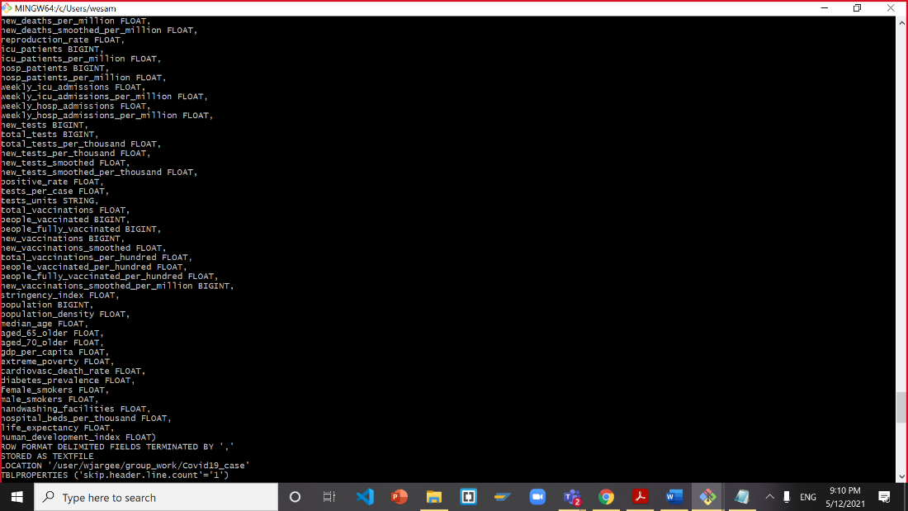

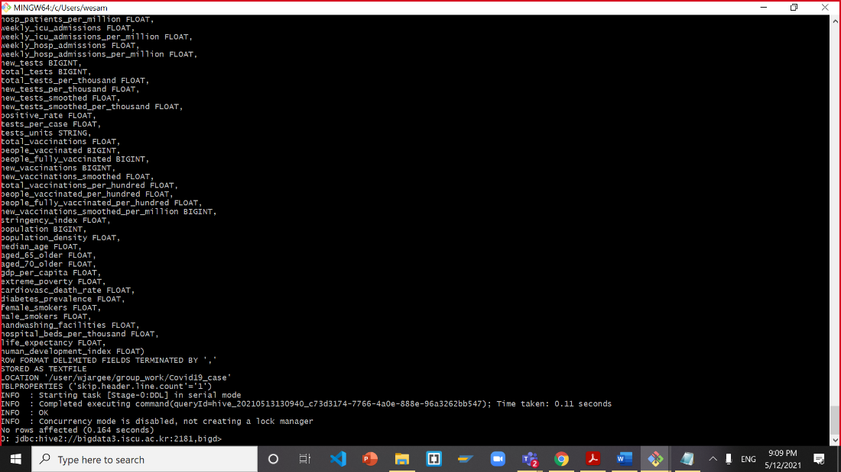

Review the structure and contents of the Covid19_case table to make sure that it’s the same as Hive syntax:

SELECT * from Covid19_case limit 3;

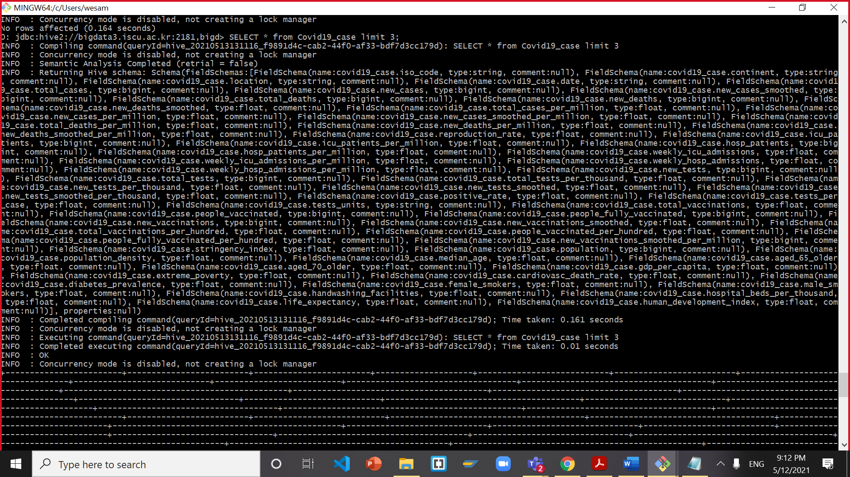

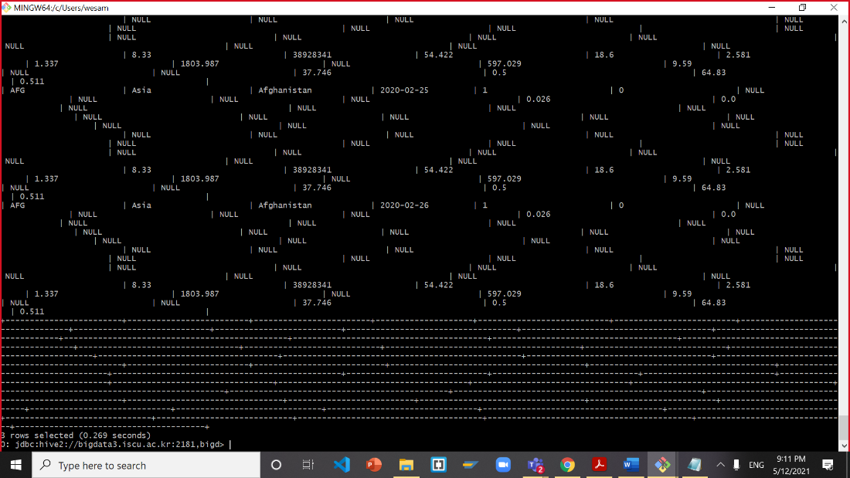

Now you run the following 6 HiveQLs in order to create the tables “Covid19_case, Covid19_case_sample1, world_vaccination, world_vac_sample1, tweet_sample, tweets_cnt”. NOTE: When you create a table with SELECT statement, you cannot create an EXTERNAL TABLE:

drop table if exists Covid19_case_sample1;

CREATE TABLE if not exists covid19_case_sample1

AS SELECT iso_code,

location,

cast(`date` as date) as `date`,

total_cases,

new_cases,

total_deaths,

new_deaths,

total_cases_per_million,

new_cases_per_million,

total_deaths_per_million,

new_deaths_per_million,

population

from Covid19_case

order by location ASC;

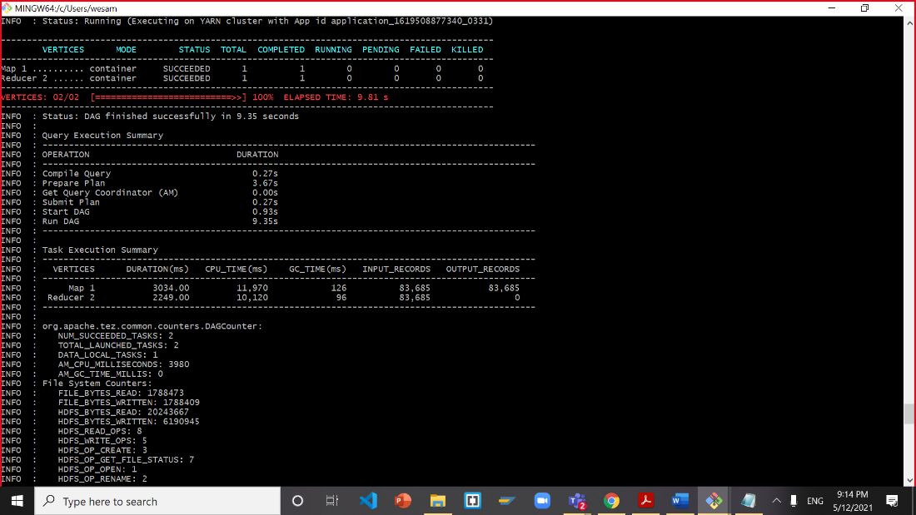

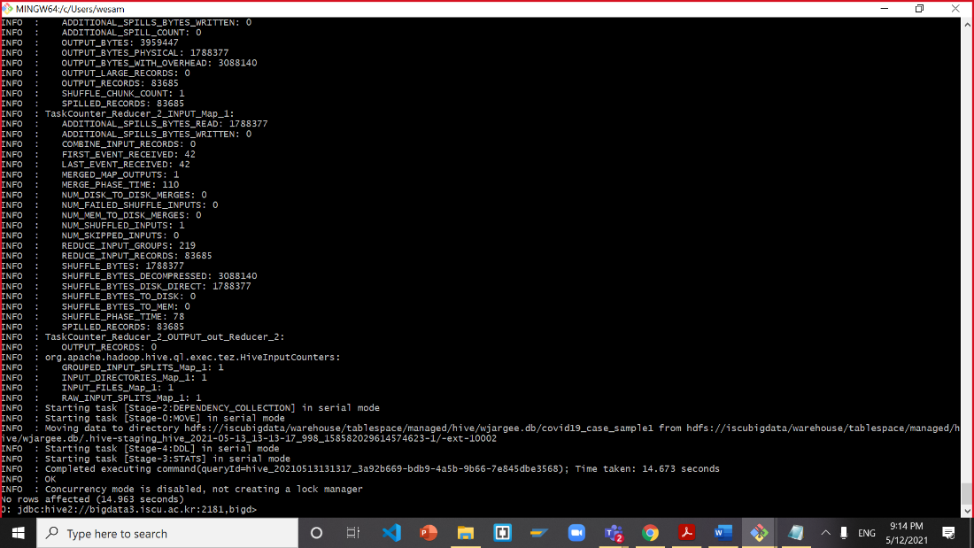

**List the Countries by location, date, total cases per million, and total population**

SELECT DISTINCT * from Covid19_case_sample1 order by location ASC limit 10;

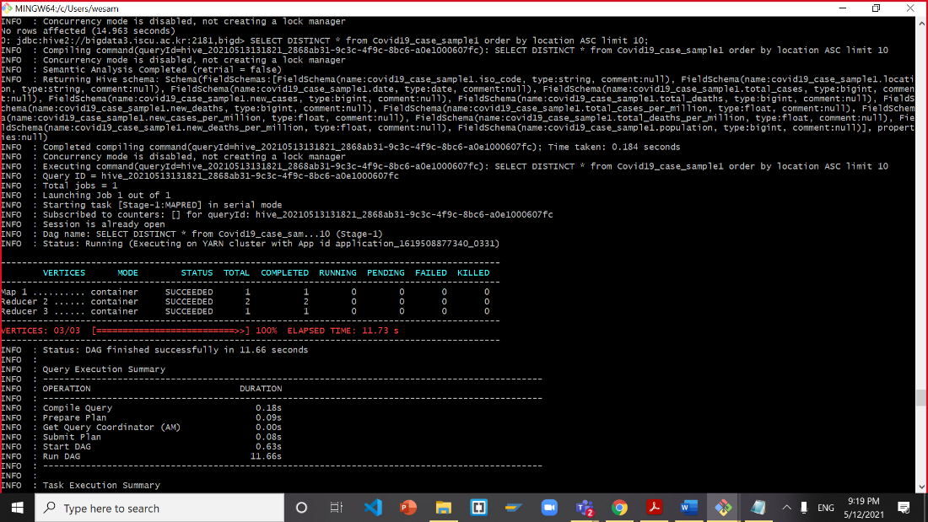

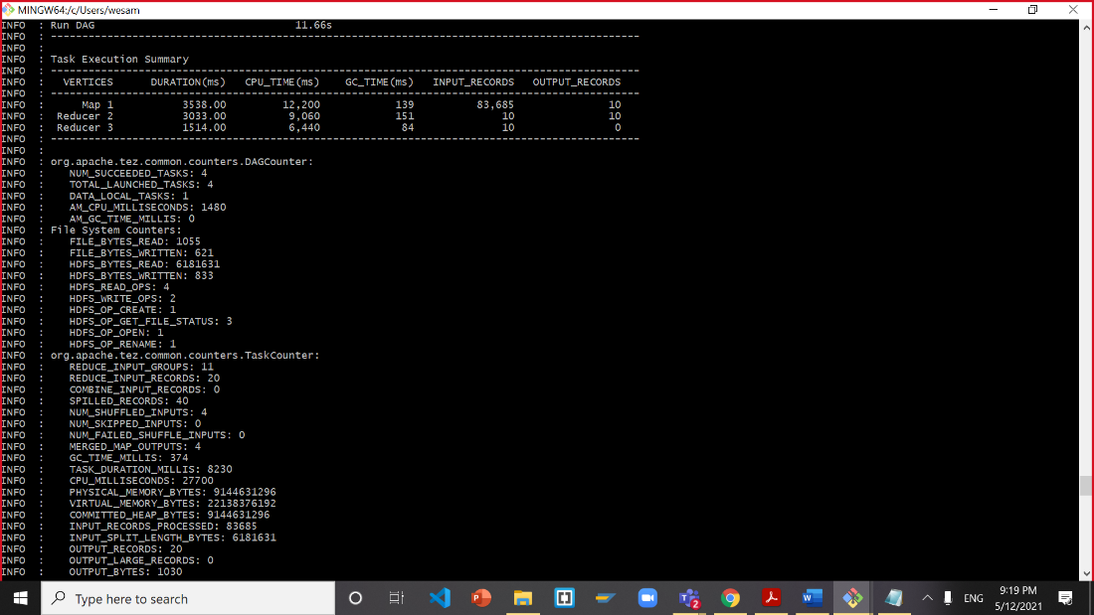

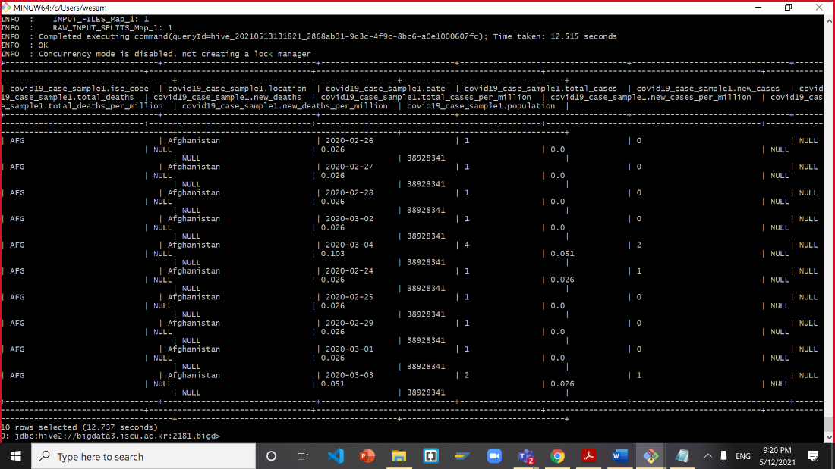

Update your script to filter out all records where the location field contains Afghanistan:

SELECT * from Covid19_case_sample1 where location == "Afghanistan" limit 100;

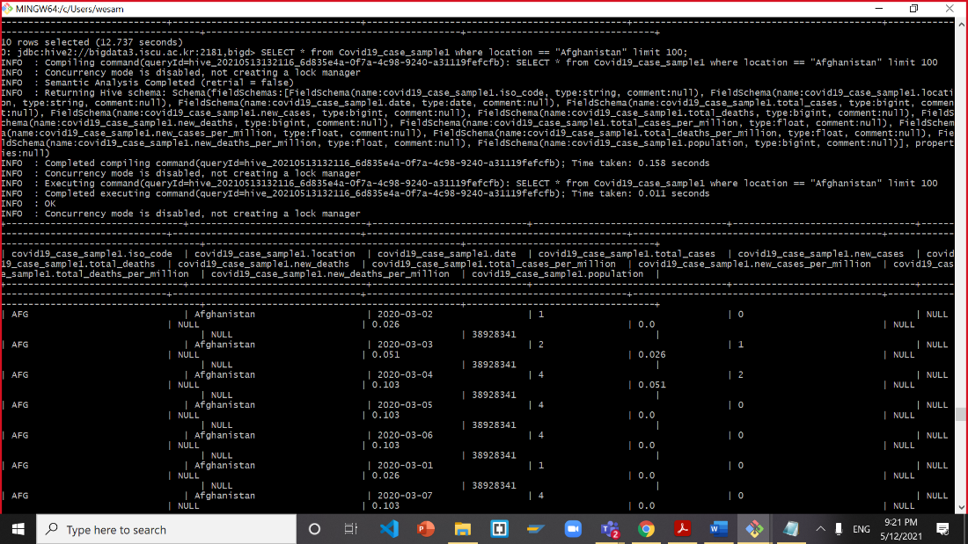

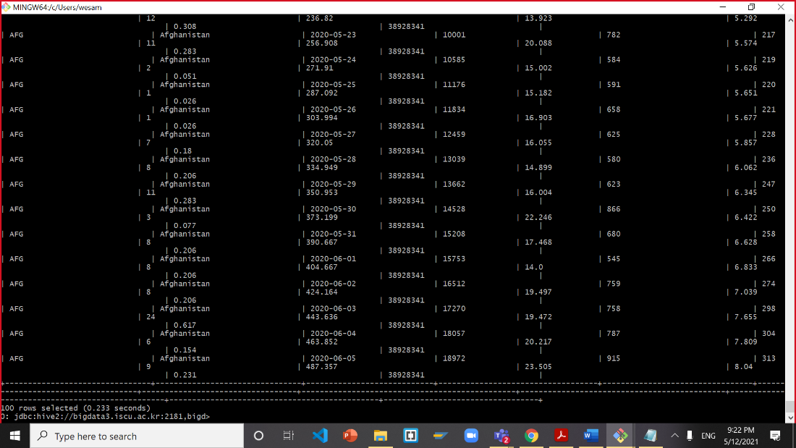

Update your script to filter out all records where the date field contains 2020-02-24:

SELECT * from Covid19_case_sample1 where `date` == "2020-02-24";

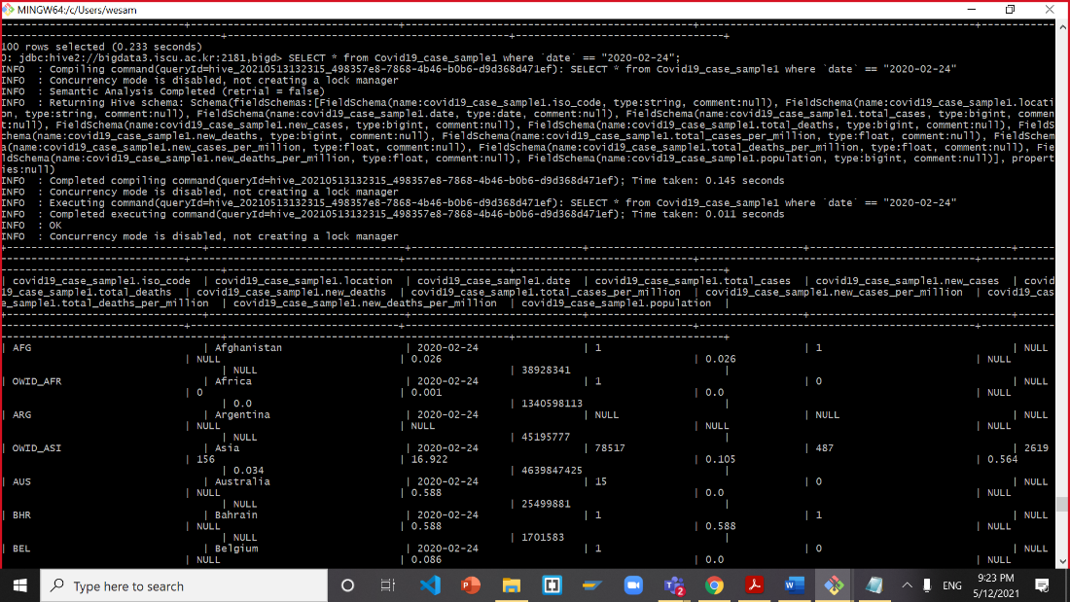

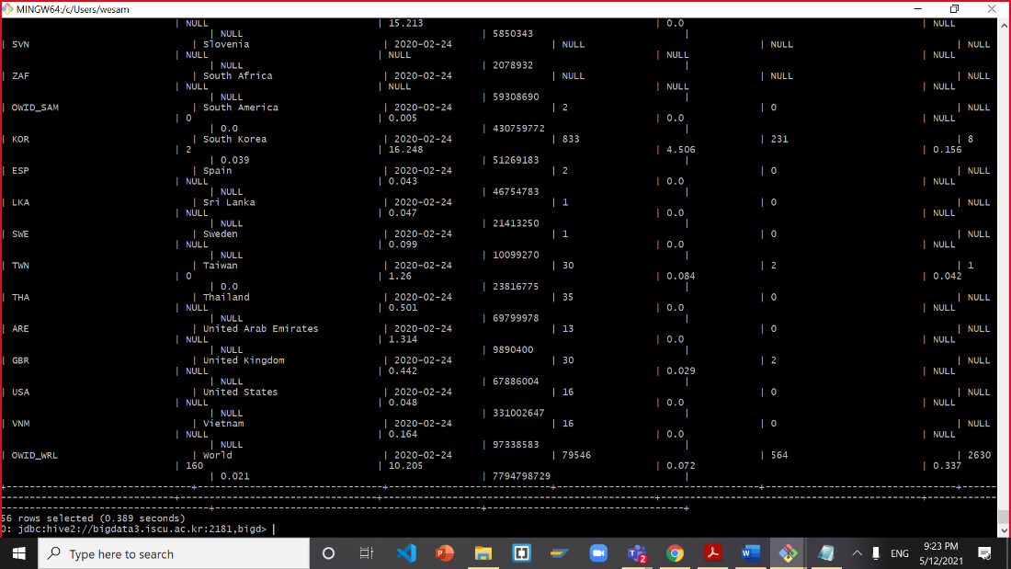

SELECT * from Covid19_case_sample1 order by location, `date` limit 10;

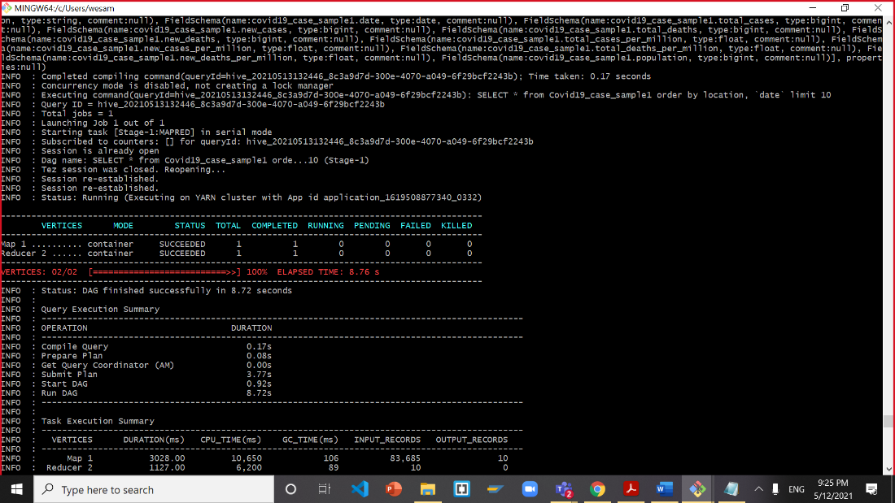

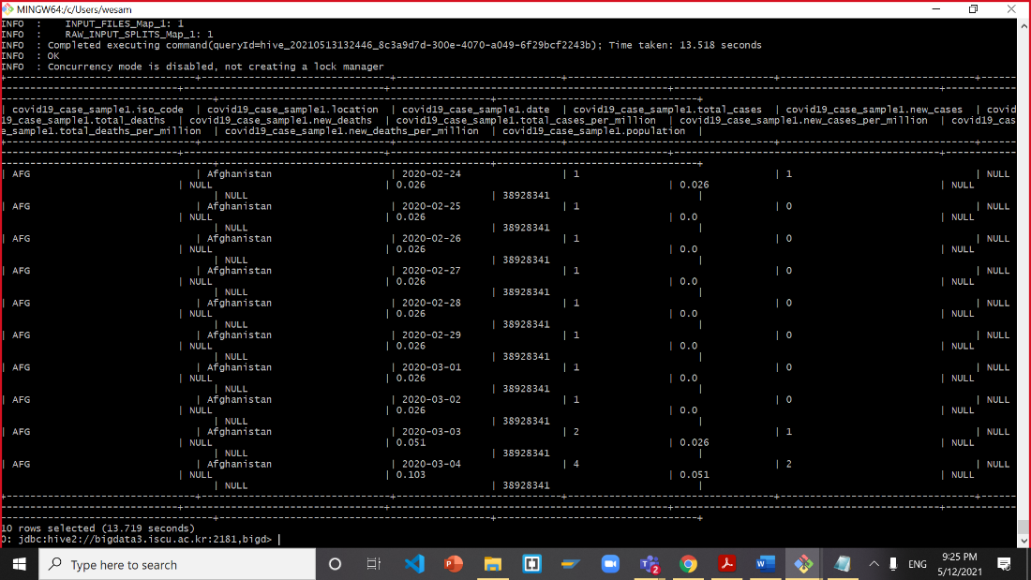

**Now, you need to make the table world_vaccination**

drop table if exists world_vaccination;

CREATE EXTERNAL TABLE IF NOT EXISTS world_vaccination(location STRING,

iso_code STRING,

`date` STRING,

total_vaccinations BIGINT,

people_vaccinated BIGINT,

people_fully_vaccinated BIGINT,

daily_vaccinations_raw BIGINT,

daily_vaccinations BIGINT,

total_vaccinations_per_hundred STRING,

people_vaccinated_per_hundred STRING,

people_fully_vaccinated_per_hundred STRING,

daily_vaccinations_per_million STRING)

ROW FORMAT DELIMITED FIELDS TERMINATED BY ','

STORED AS TEXTFILE

LOCATION '/user/jlicea7/group_work/world_vaccination'

TBLPROPERTIES ('skip.header.line.count'='1');

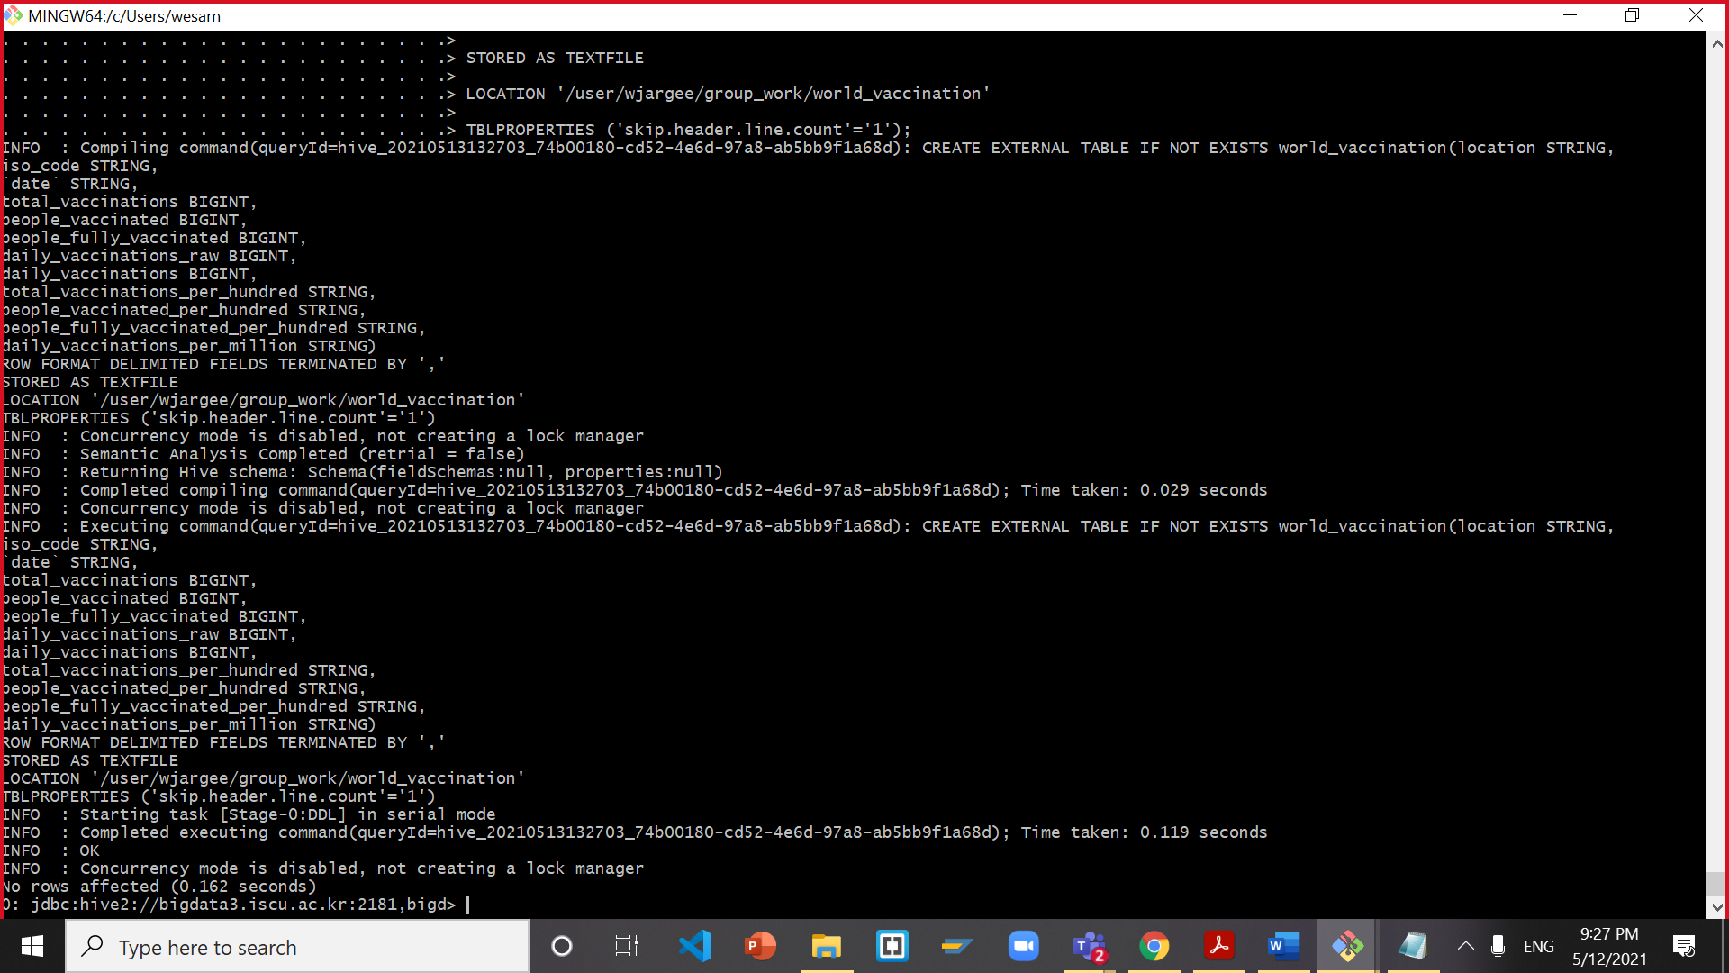

**Test world_vaccination table**

select * from world_vaccination limit 3;

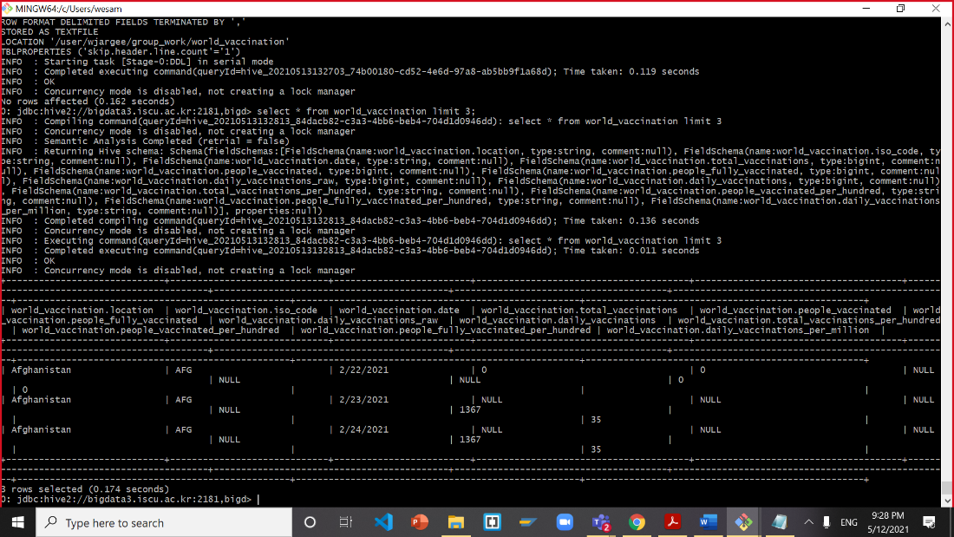

**Now, you need to make the table for world_vac_sample1 to map reduce or filter out data**

drop table if exists world_vac_sample1;

CREATE TABLE if not exists world_vac_sample1

AS SELECT

location,

iso_code,

to_date(from_unixtime(unix_timestamp(`date`,'MM/dd/yyyy'),'yyyy-MM-dd')) as `date`,

total_vaccinations,

people_vaccinated,

people_fully_vaccinated,

total_vaccinations_per_hundred,

people_vaccinated_per_hundred,

people_fully_vaccinated_per_hundred

from world_vaccination

order by location ASC;

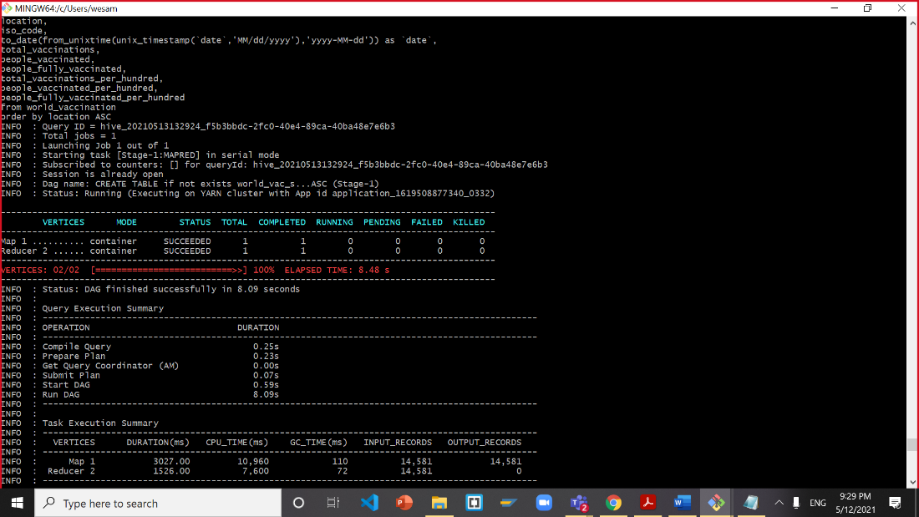

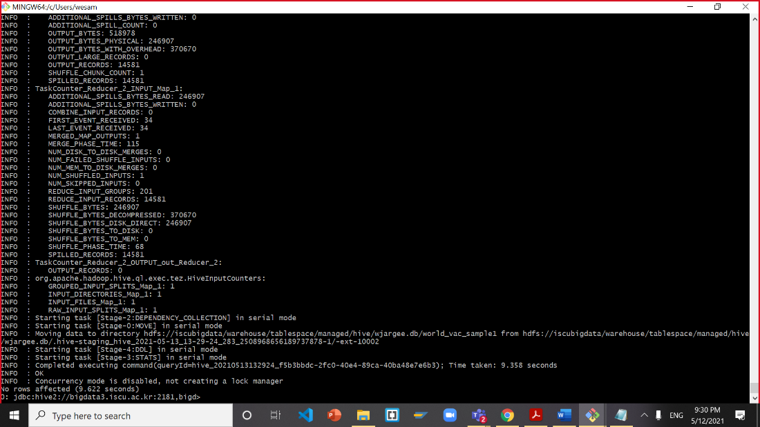

**Test world_vac_sample1 table**

select * from world_vac_sample1 order by location,`date` limit 10;

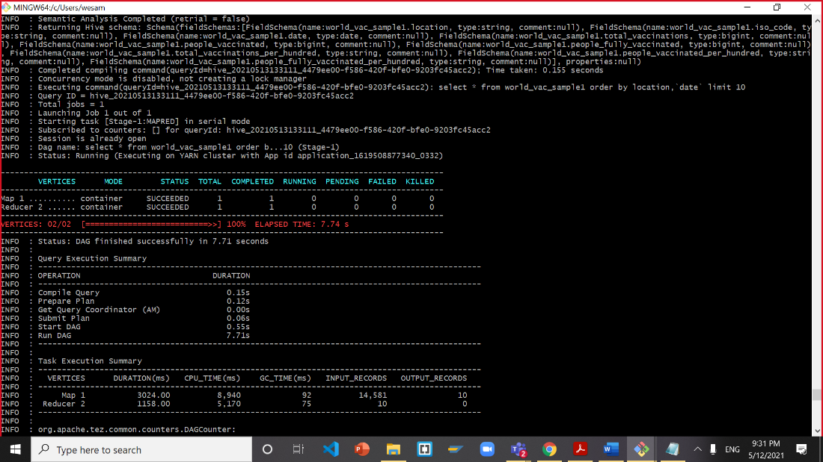

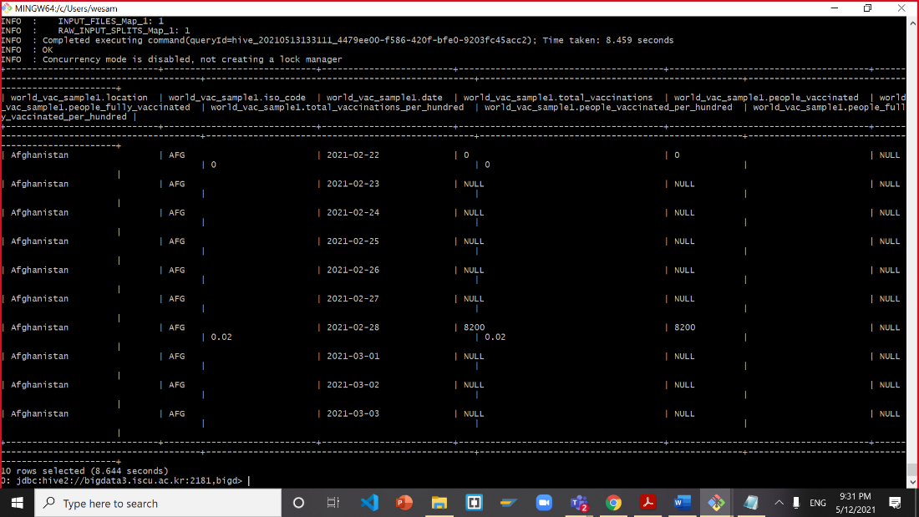

**Join the tables of covid19_case_sample1 & world_vac_sample1 to make vac_case:**

drop table if exists vac_case;

CREATE TABLE IF NOT EXISTS vac_case

AS SELECT

c.location,

c.`date`,

c.total_cases,

c.new_cases,

c.total_deaths,

c.new_deaths,

c.total_cases_per_million,

c.new_cases_per_million,

c.total_deaths_per_million,

c.new_deaths_per_million,

c.population,

v.people_fully_vaccinated_per_hundred

from covid19_case_sample1 as c

left outer JOIN world_vac_sample1 as v

WHERE c.location = v.location

AND c.`date` = v.`date`;

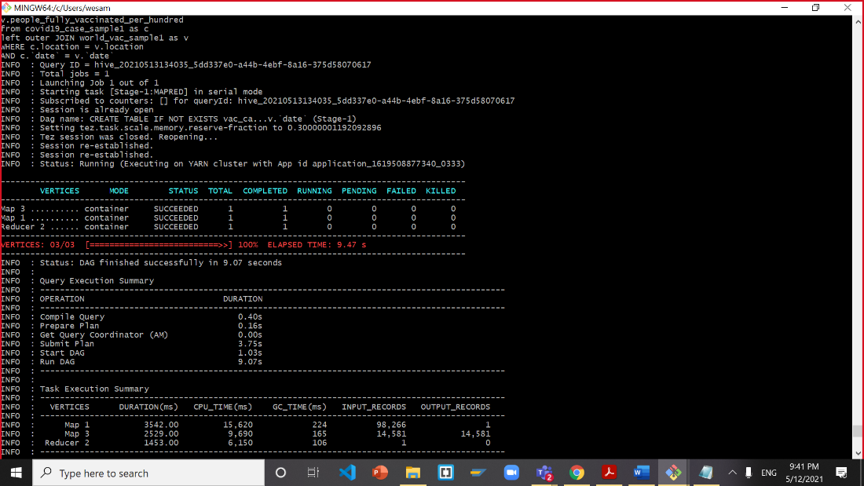

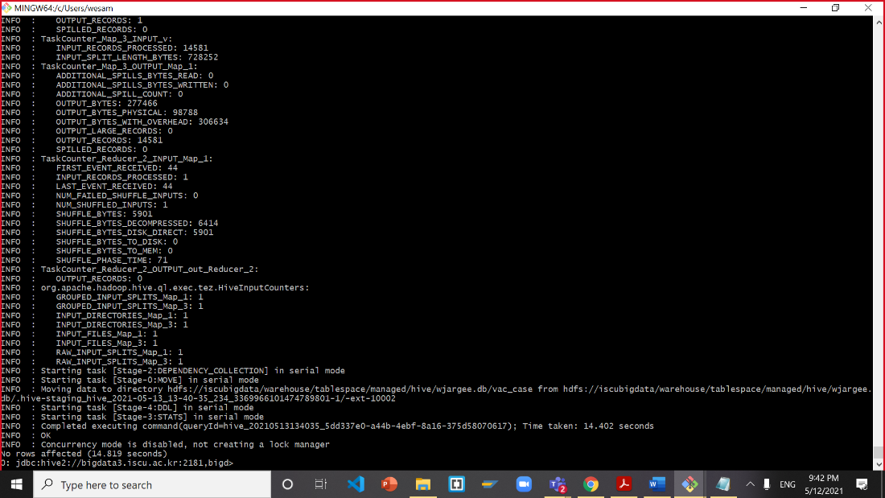

**Test the** vac_case **table**

SELECT * from vac_case where location = 'United States';

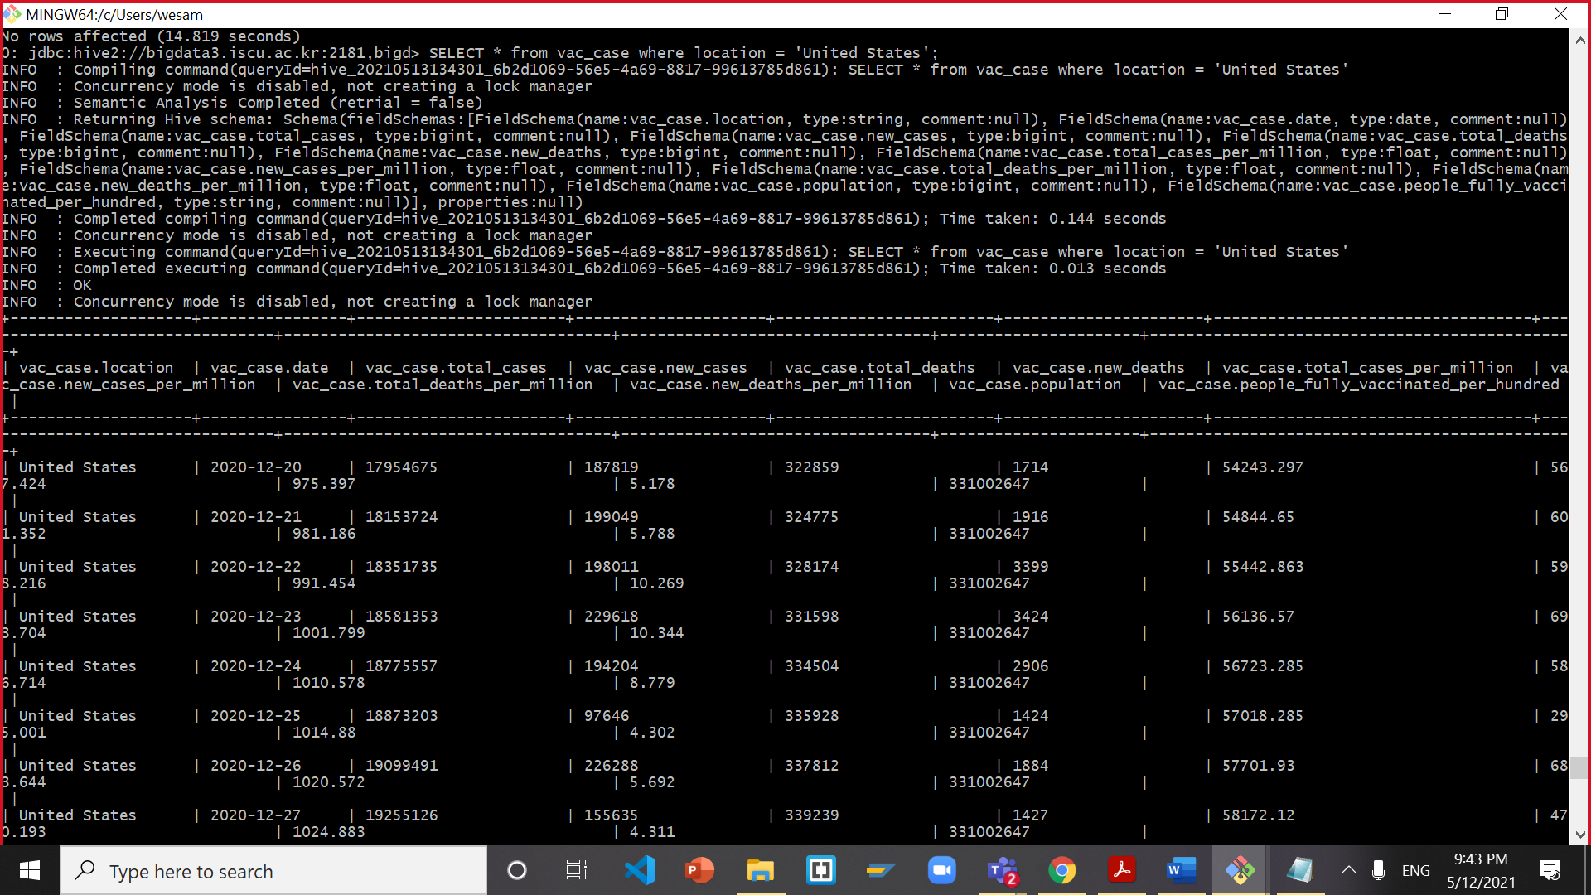

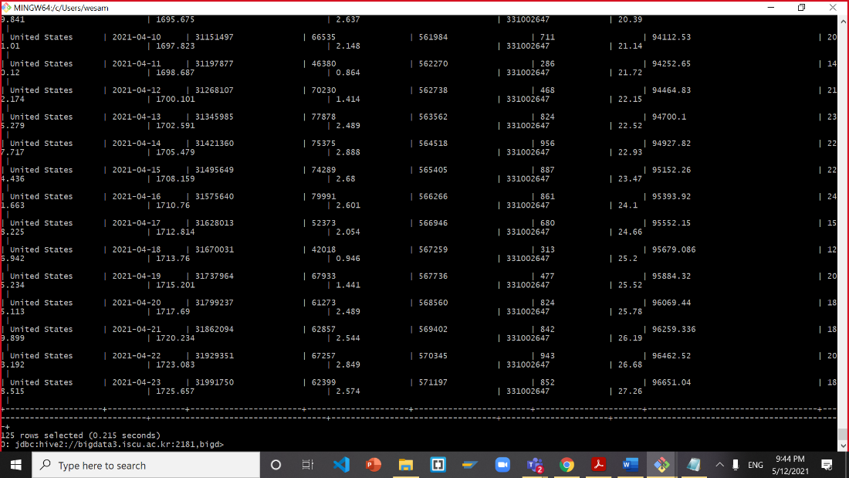

select * from vac_case order by location,`date` limit 10;

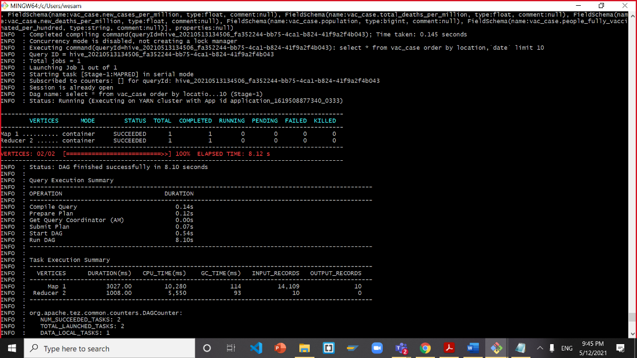

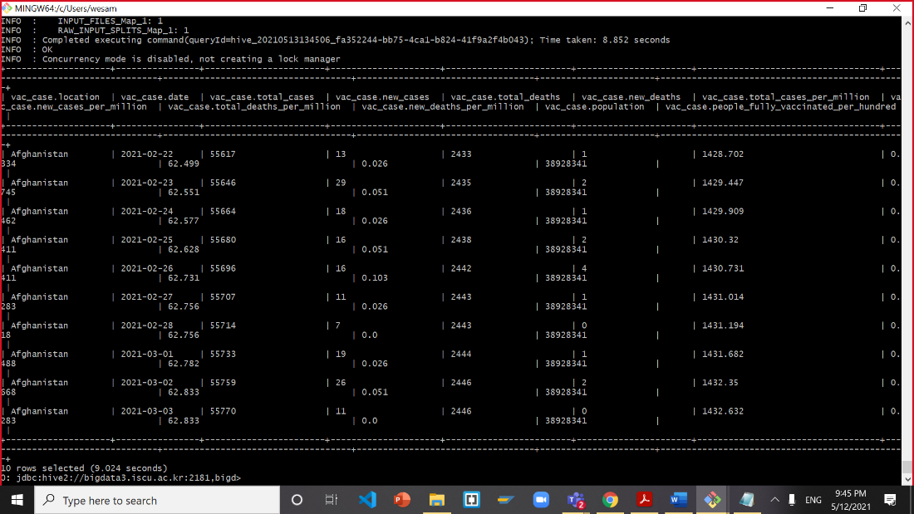

**Now, you need to make the table for tweetid_sentiments where it only contains USA data**

drop table if exists tweetid_sentiments;

CREATE EXTERNAL TABLE IF NOT EXISTS tweetid_sentiments(

tweet_ID STRING,

user_ID STRING,

t1 STRING,

t2 STRING,

t3 STRING,

t4 STRING,

t5 STRING,

t6 STRING,

t7 STRING,

t8 STRING,

t9 STRING,

t10 STRING,

valence_intensity FLOAT,

anger_intensity FLOAT,

fear_intensity FLOAT,

sadness_intensity FLOAT,

joy_intensity FLOAT,

sentiment_category STRING,

emotion_category STRING,

keyword_used STRING,

country_region STRING,

date_stamp STRING)

ROW FORMAT DELIMITED FIELDS TERMINATED BY ','

STORED AS TEXTFILE

LOCATION '/user/jlicea7/group_work/tweetid_sentiments'

TBLPROPERTIES ('skip.header.line.count'='1');

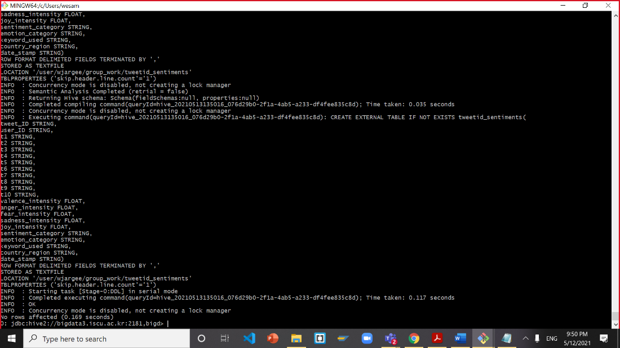

**Test tweetid_sentiments table**

SELECT * from tweetid_sentiments limit 3;

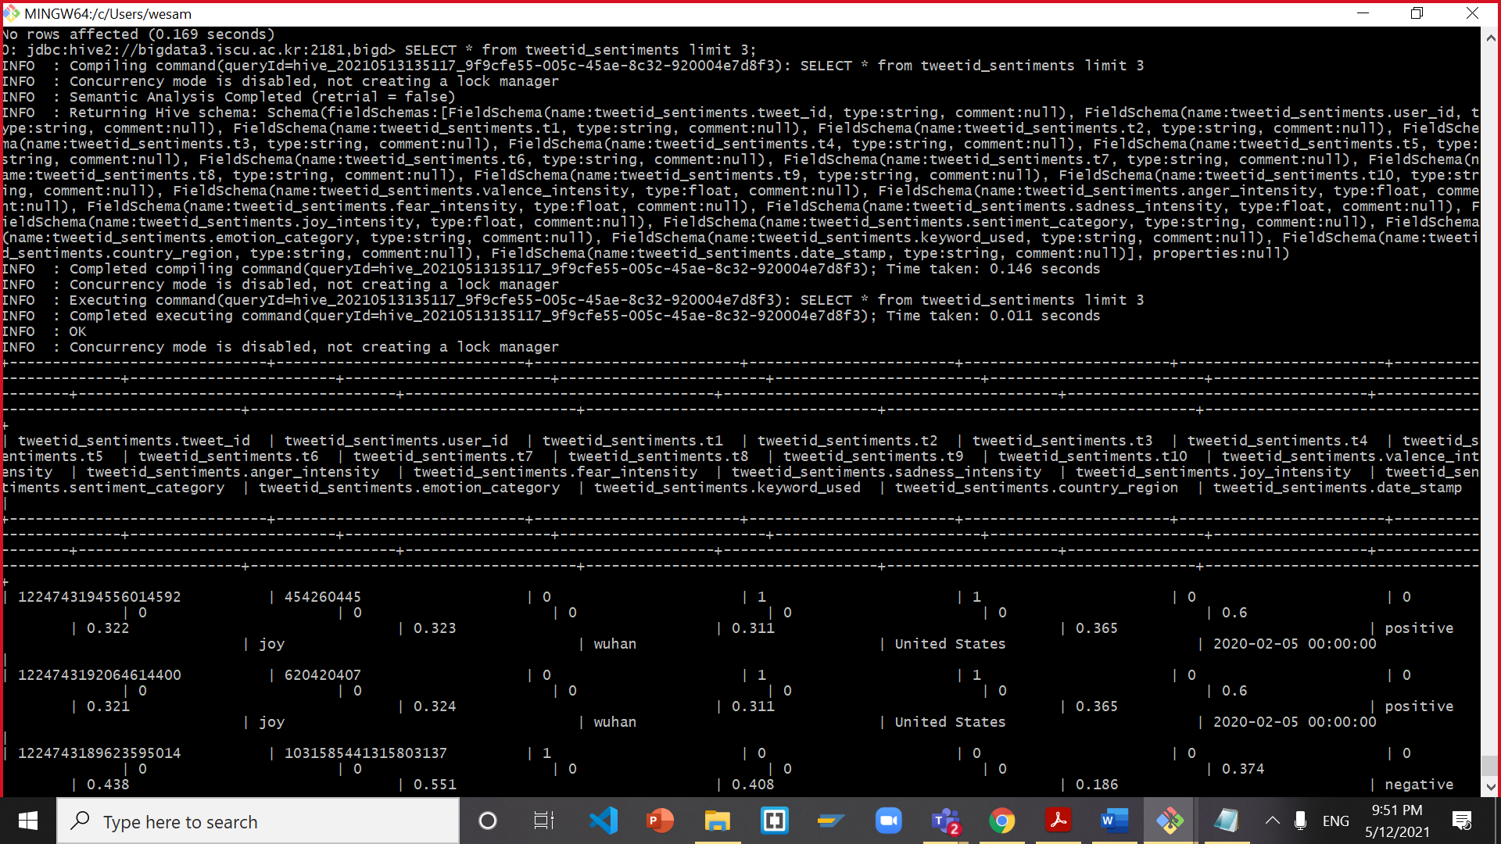

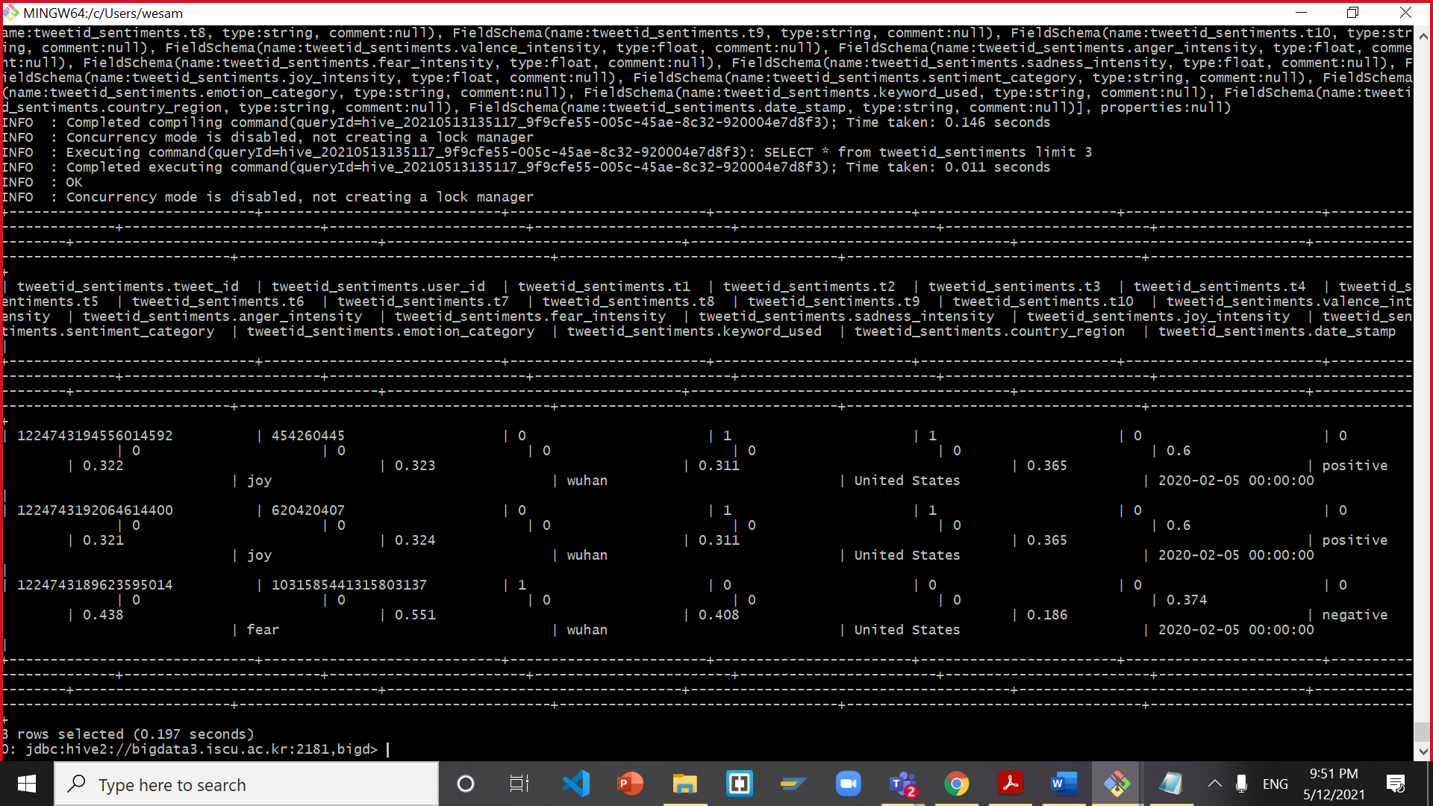

**Now, you need to make the table for tweet_sample to reduce the amount of data shown and speed up the process:**

drop table if exists tweet_sample;

CREATE TABLE IF NOT EXISTS tweet_sample

AS SELECT

country_region,

date_stamp,

sentiment_category,

count(sentiment_category) as cnt

from tweetid_sentiments

group by country_region,

date_stamp,

sentiment_category

limit 5;

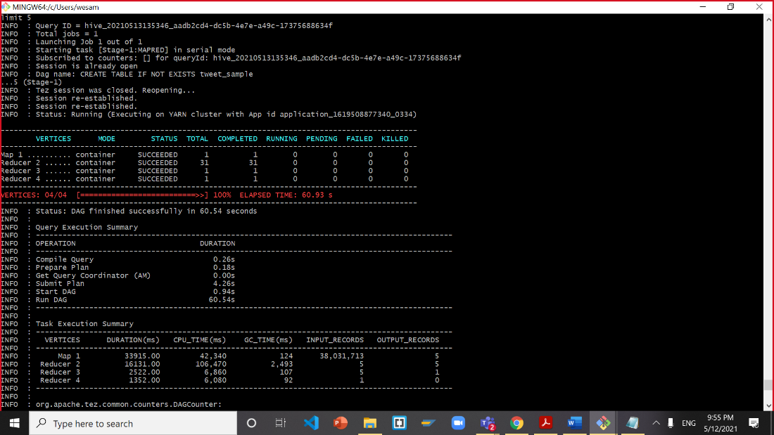

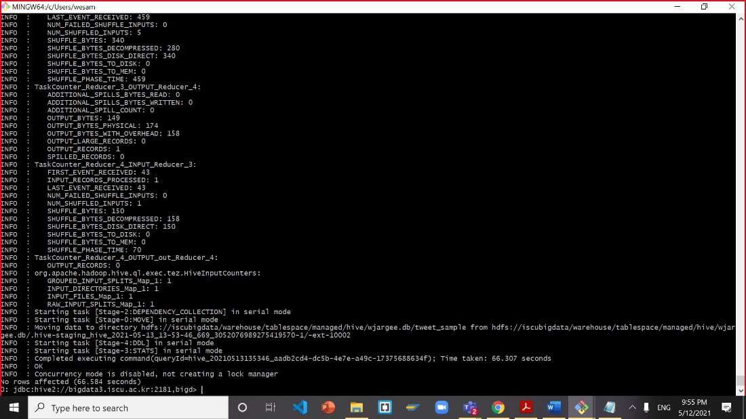

**Test tweet_sample**

SELECT * FROM tweet_sample;

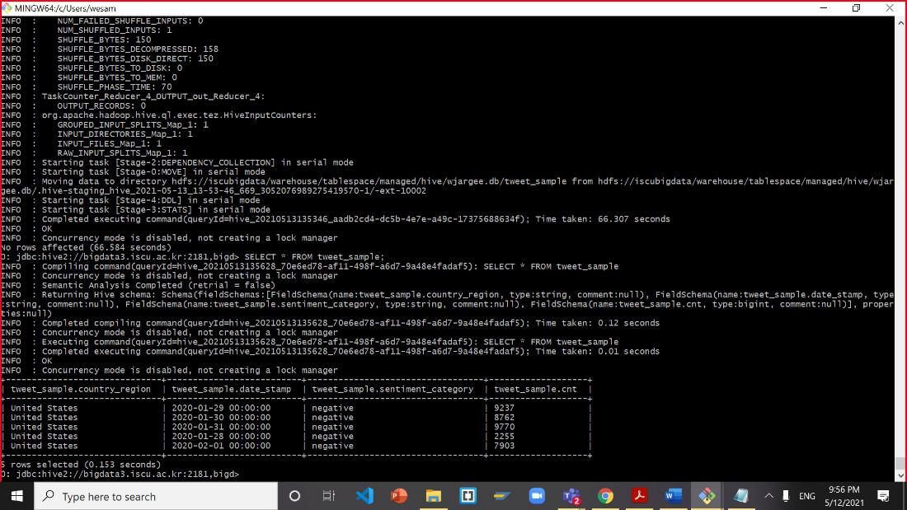

**Now, you need to make the table for tweets_cnt**

drop table if exists tweets_cnt;

CREATE TABLE if not exists tweets_cnt

AS SELECT

country_region,

date_stamp,

sentiment_category,

count(sentiment_category) as cnt

from tweetid_sentiments

group by country_region, date_stamp, sentiment_category

order by date_stamp ASC;

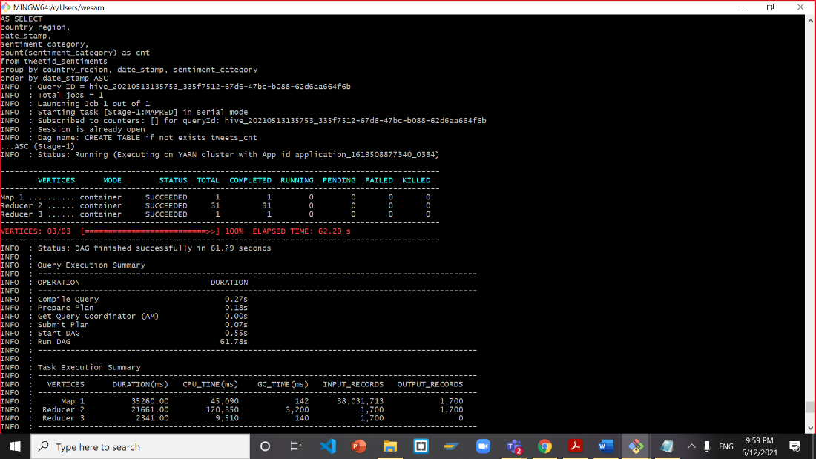

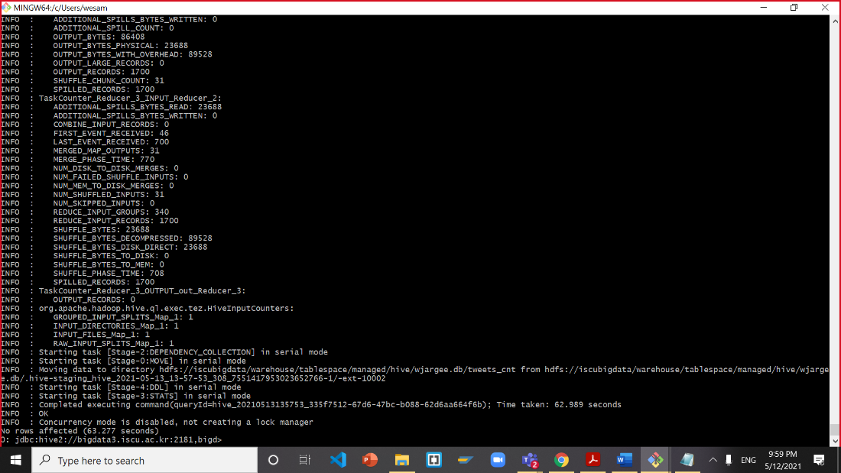

**Test tweets_cnt**

SELECT * from tweets_cnt order by date_stamp, sentiment_category limit 10;

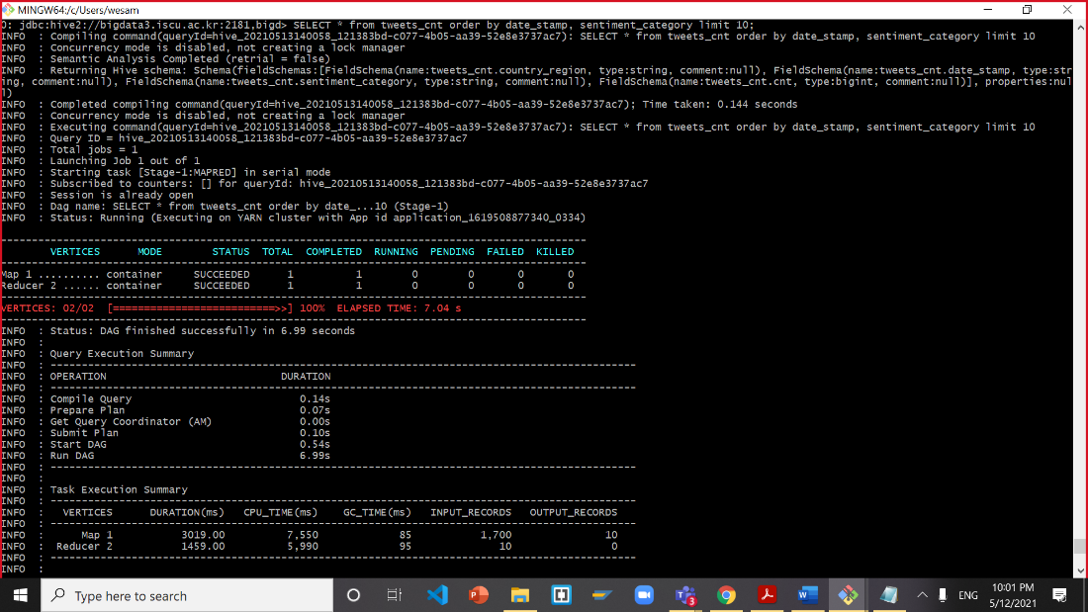

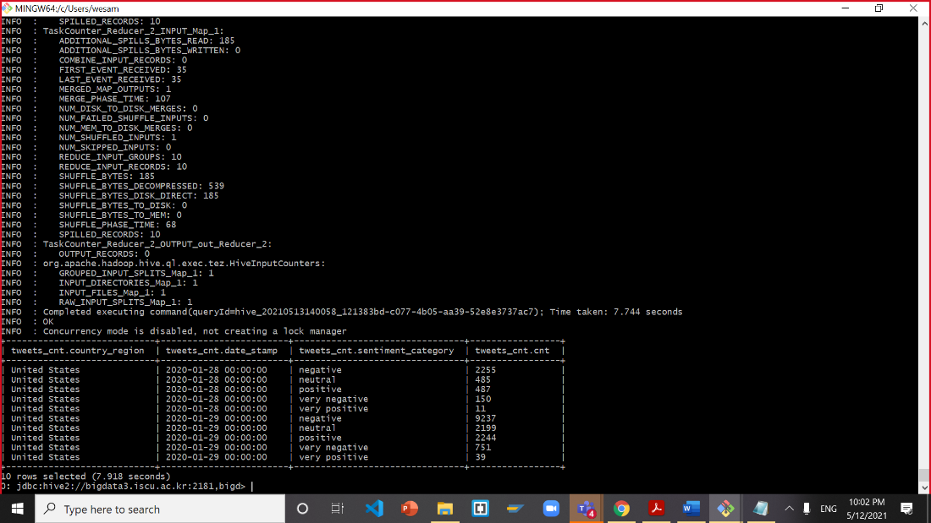

# **STEP 5: Download the files to your computer:**

**Download a file from Covid19_case_sample1 table to HDFS**

INSERT OVERWRITE DIRECTORY '/user/jlicea7/group_work/Covid19_case/'

ROW FORMAT DELIMITED FIELDS TERMINATED BY ','

SELECT * FROM Covid19_case_sample1

order by location, `date`;

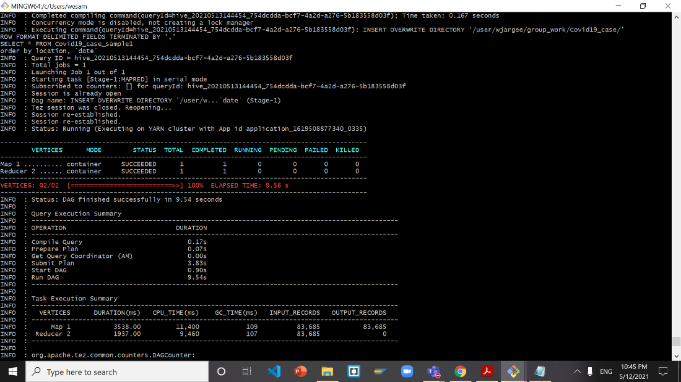

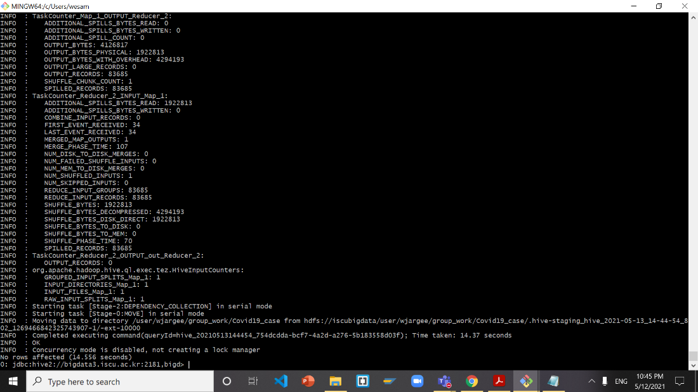

**Return to bash**

hdfs dfs -ls group_work/Covid19_case/

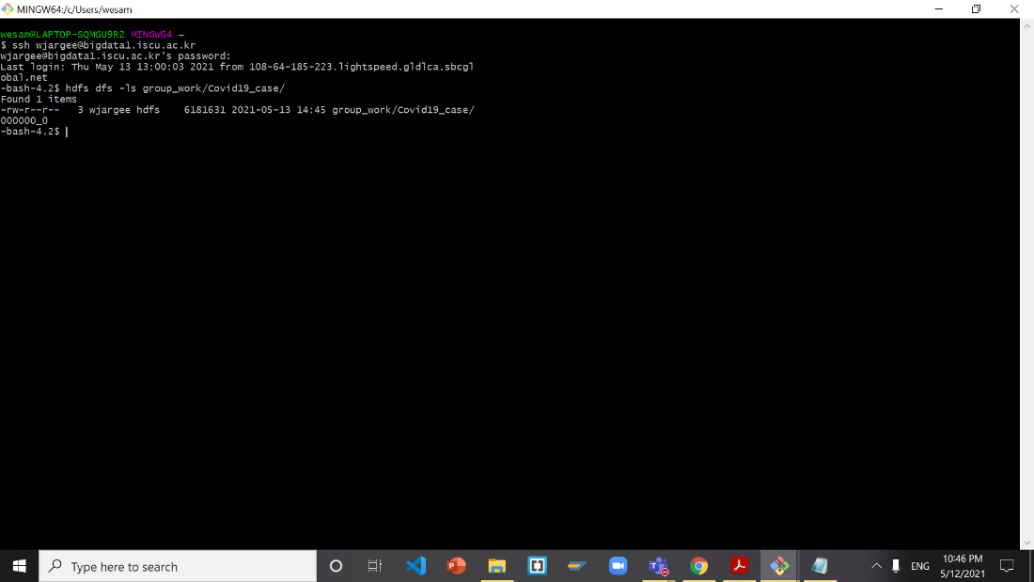

hdfs dfs -get group_work/Covid19_case/000000_0 Covid19_case_sample1.csv

ls

cat Covid19_case_sample1.csv | tail -n 2

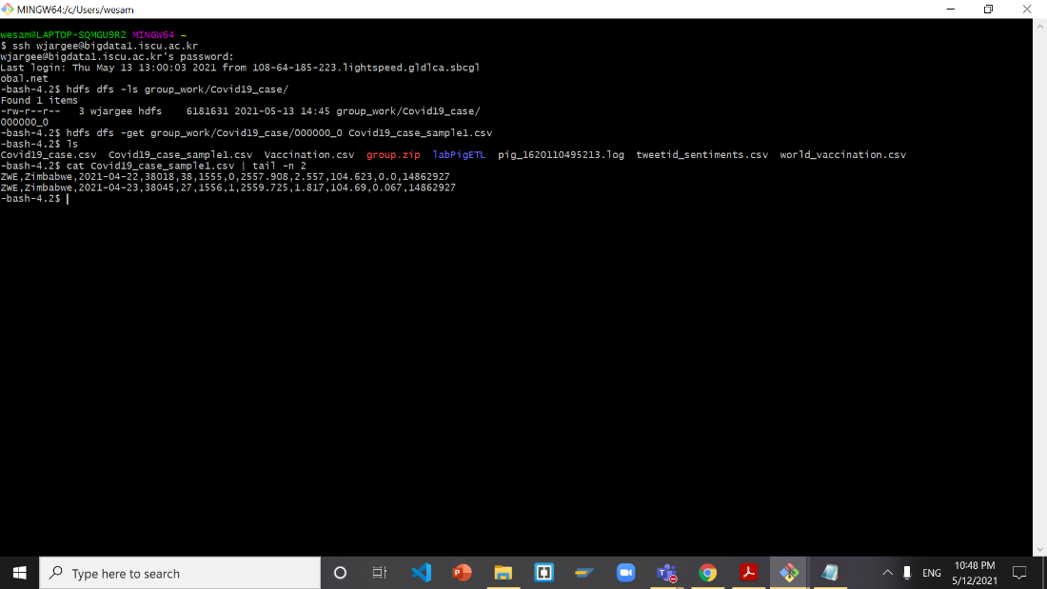

**Open new terminal then download file to local computer**

scp jlicea7@bigdata1.iscu.ac.kr:/home/jlicea7/Covid19_case_sample1.csv .

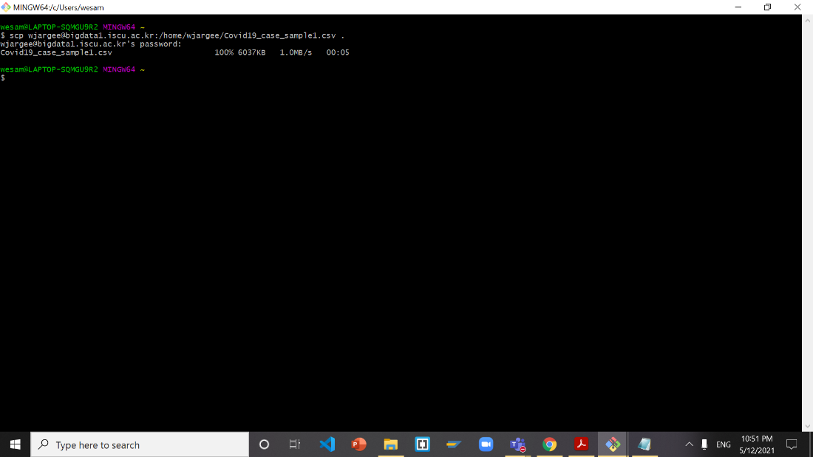

**Go back to Bash and delete 000000_0 and Covid19_case_sample1.csv to avoid corrupt file**

hdfs dfs -rm -R group_work/Covid19_case/000000_0

rm Covid19_case_sample1.csv

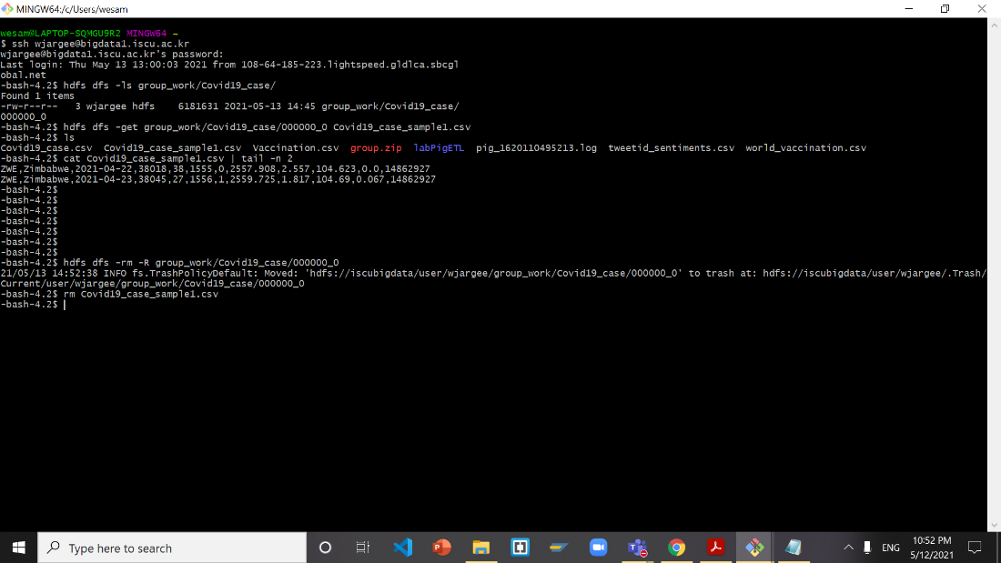

**Go back to hive to download file tweets_cnt to HDFS**

INSERT OVERWRITE DIRECTORY '/user/jlicea7/group_work/tweetid_sentiments/'

ROW FORMAT DELIMITED FIELDS TERMINATED BY ','

SELECT * FROM tweets_cnt

order by date_stamp, sentiment_category;

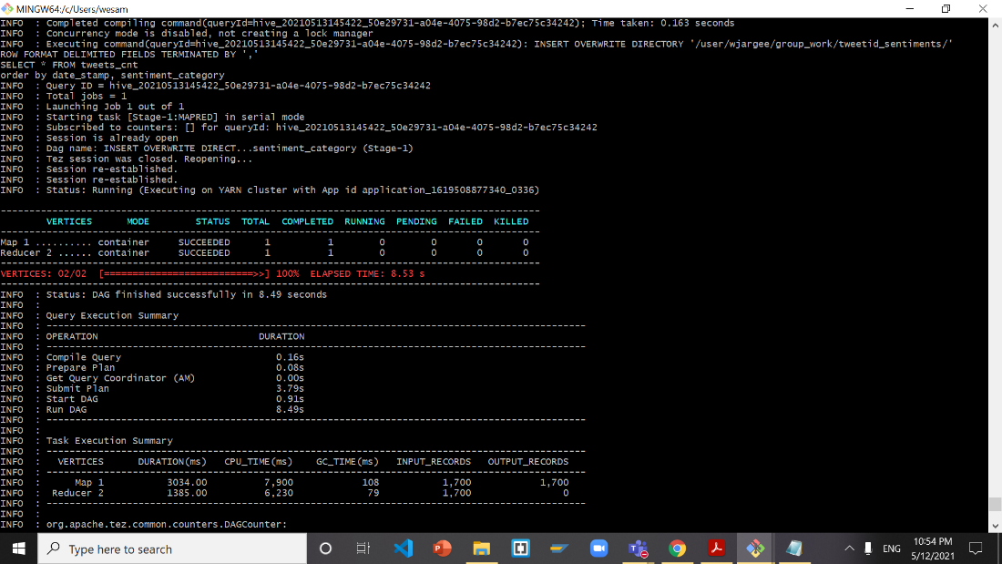

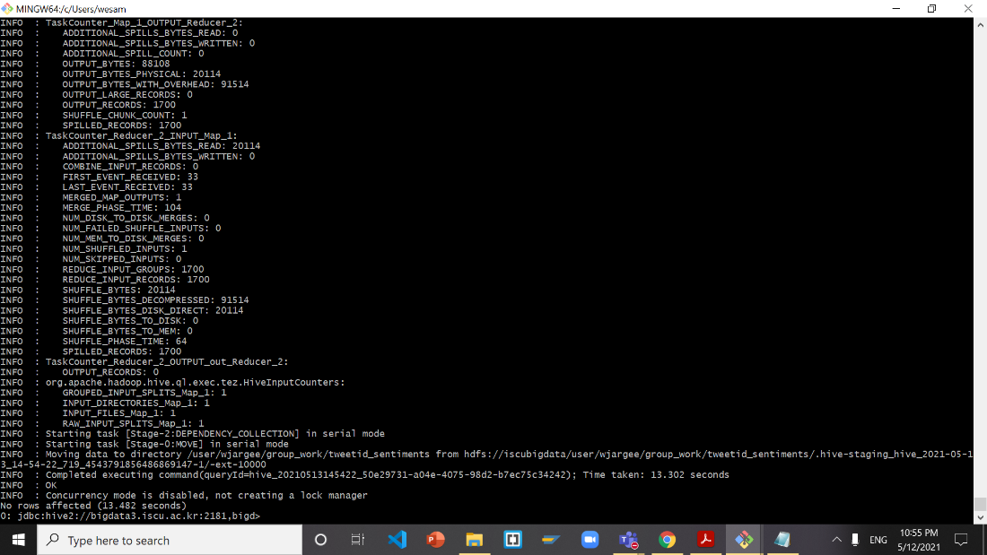

**Return to Bash**

hdfs dfs -ls group_work/tweetid_sentiments/

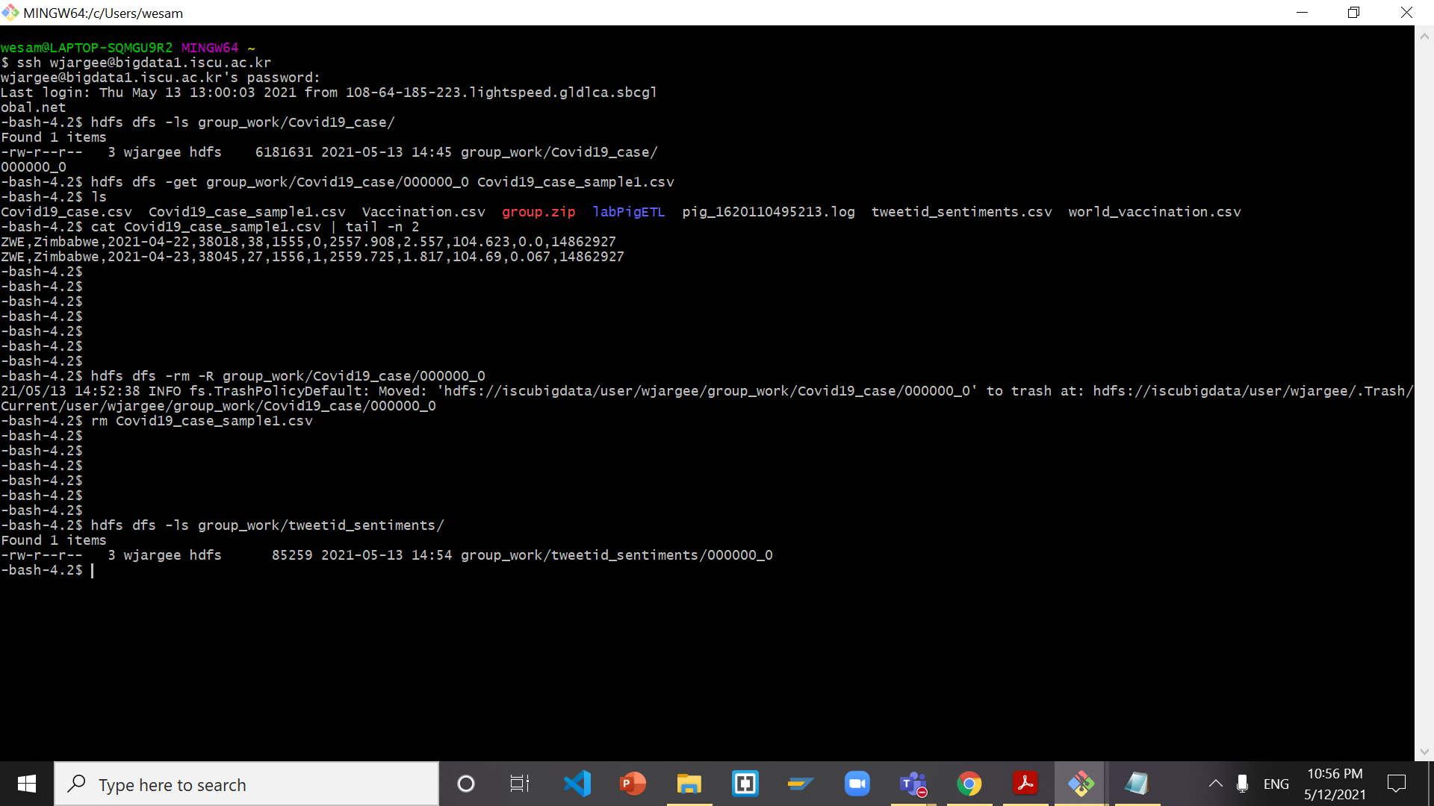

hdfs dfs -get group_work/tweetid_sentiments/000000_0 tweets_cnt.csv

ls

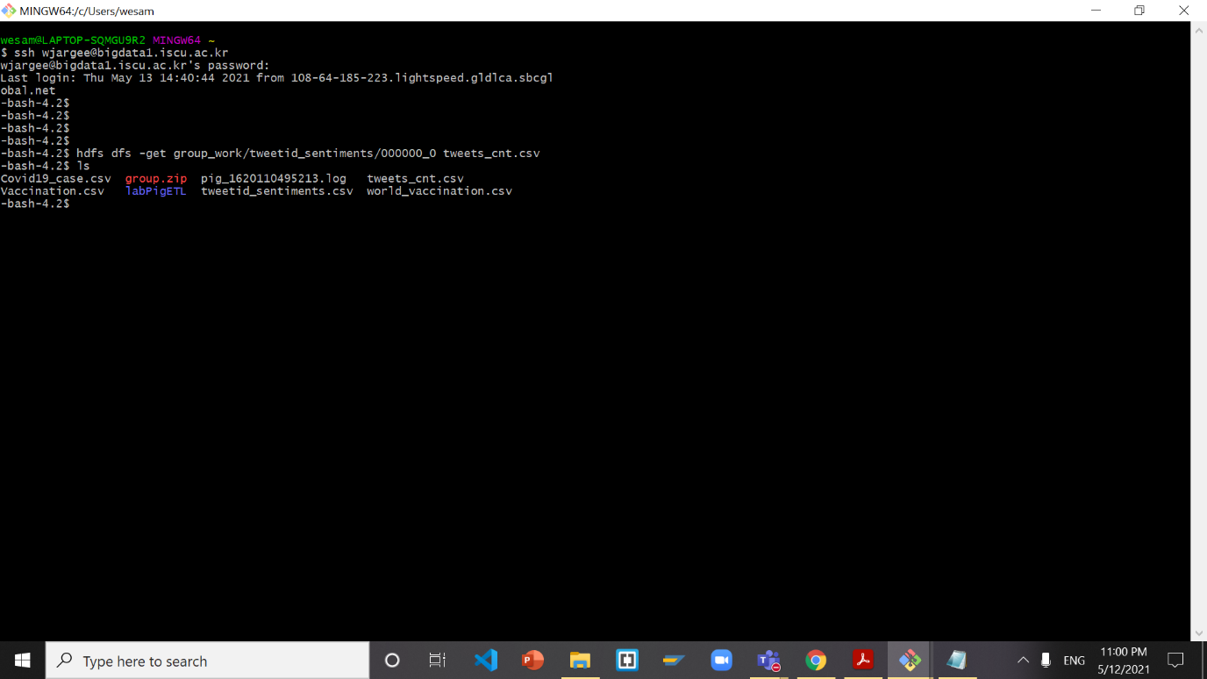

cat tweets_cnt.csv | tail -n 2

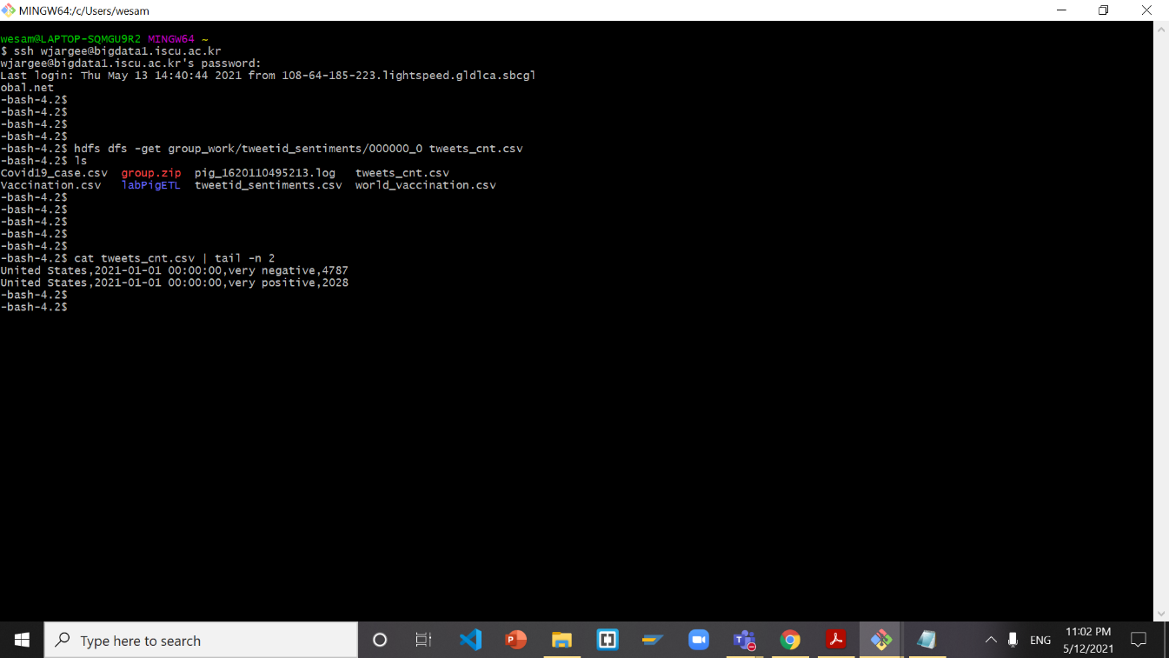

**Open new terminal then download file to local computer**

scp jlicea7@bigdata1.iscu.ac.kr:/home/jlicea7/tweets_cnt.csv .

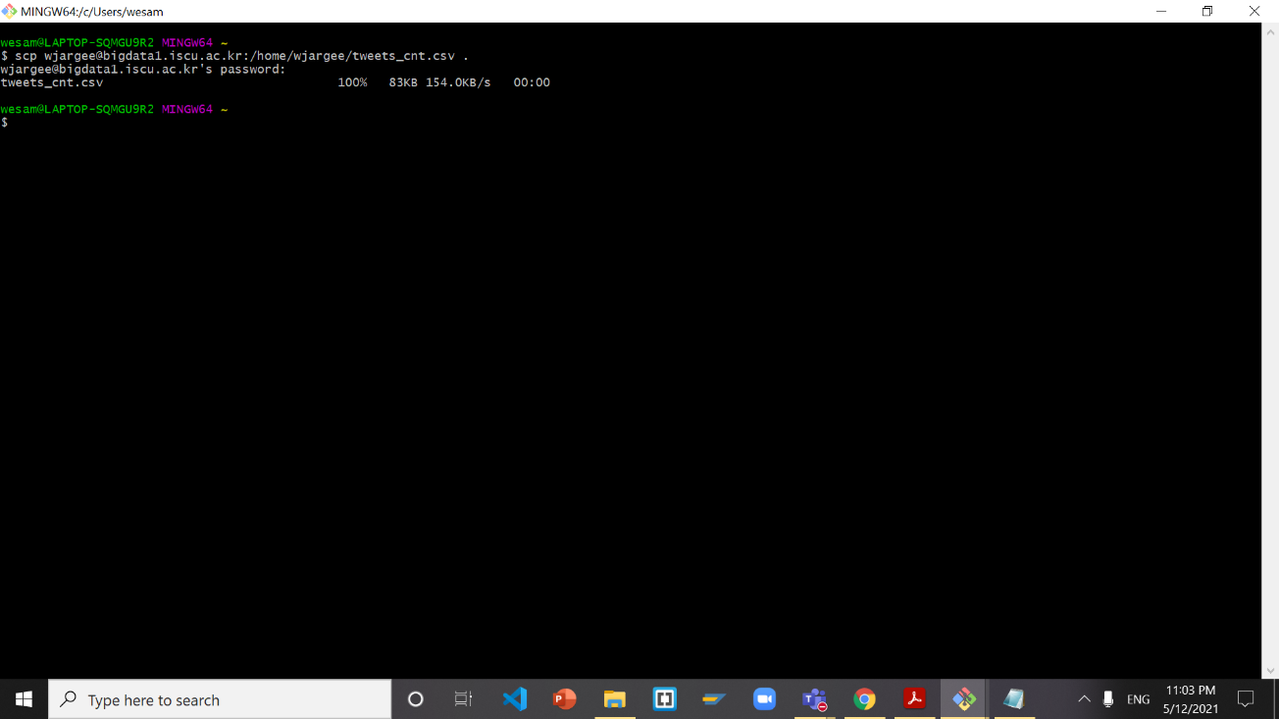

**Return to Bash to delete 000000_0 and tweets_cnt.csv to avoid corrupt file**

hdfs dfs -rm -R group_work/tweetid_sentiments/000000_0

rm tweets_cnt.csv

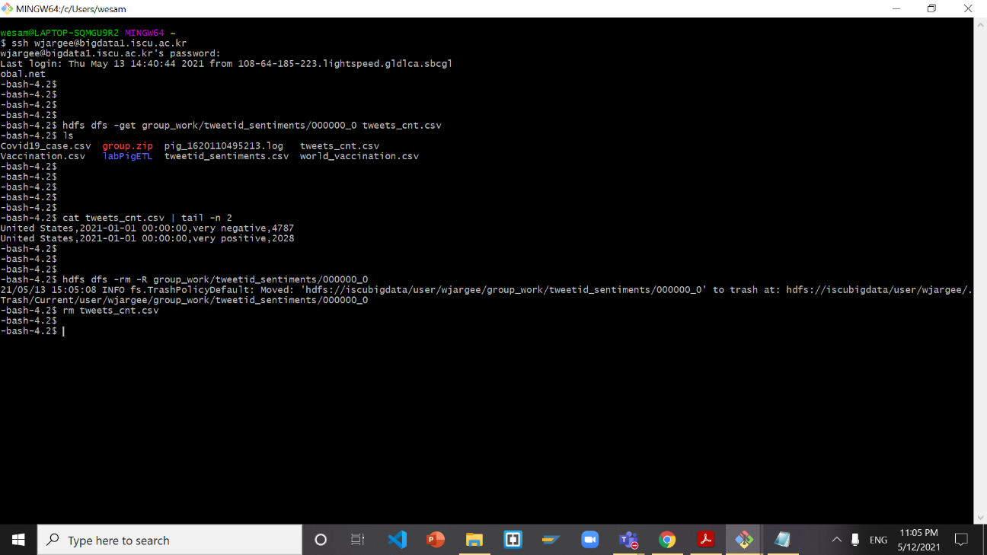

**Download a file form vac_case table from Hive to HDFS**

INSERT OVERWRITE DIRECTORY '/user/jlicea7/group_work/'

ROW FORMAT DELIMITED FIELDS TERMINATED BY ','

SELECT * FROM vac_case

order by location;

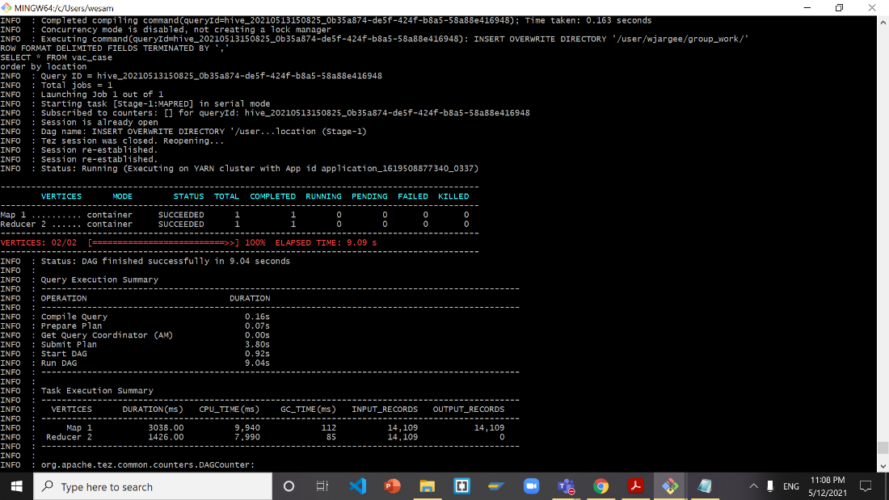

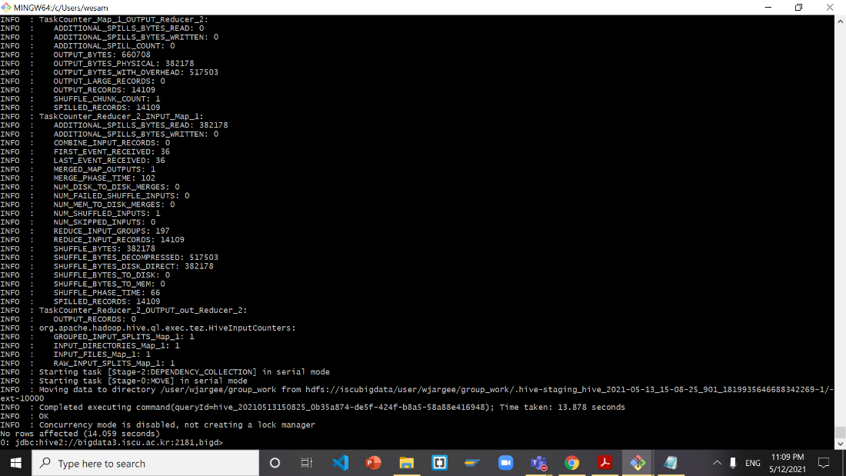

**Return to bash**

hdfs dfs -ls group_work/

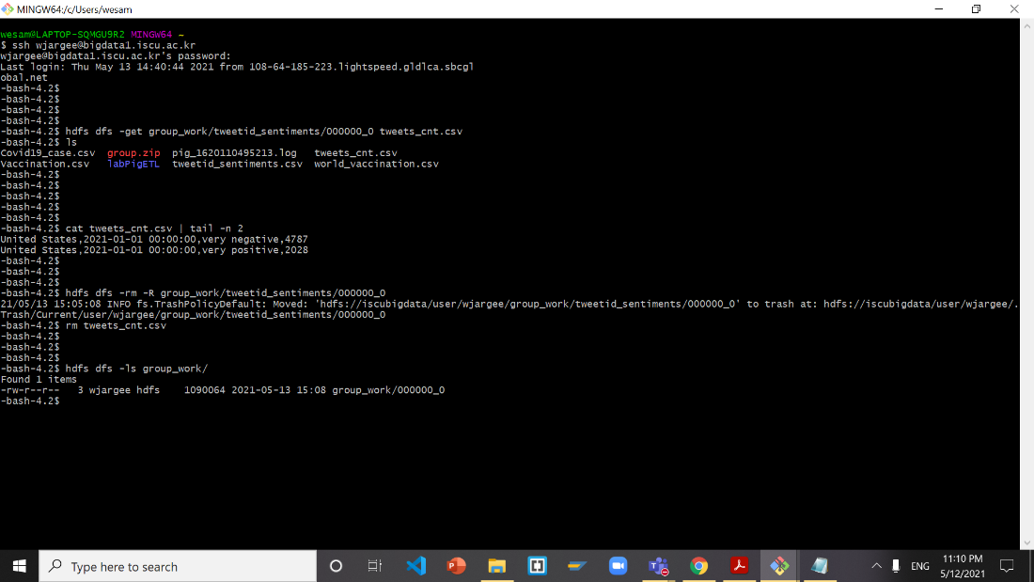

hdfs dfs -get group_work/000000_0 vac_case.csv

ls

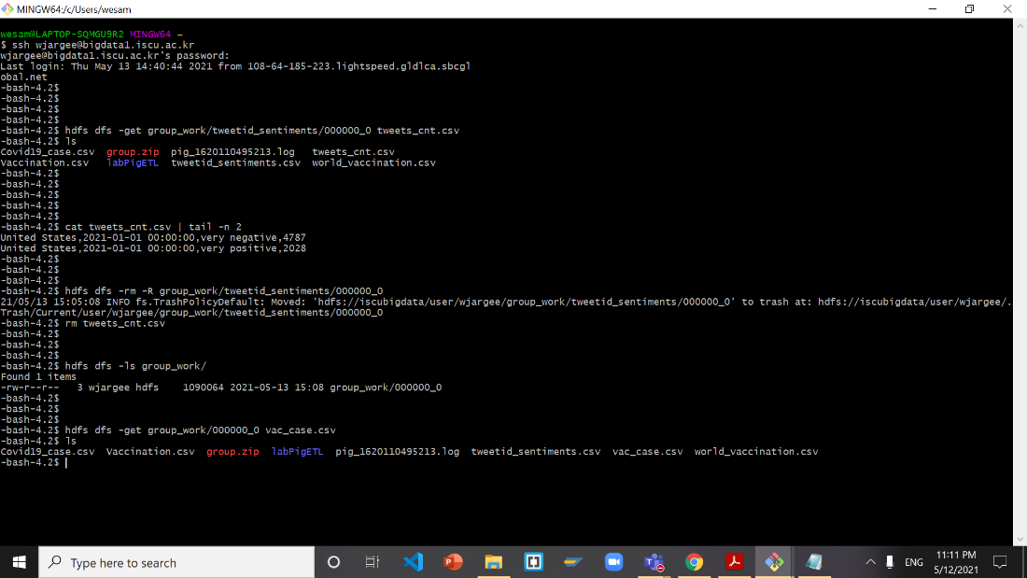

cat vac_case.csv | tail -n 2

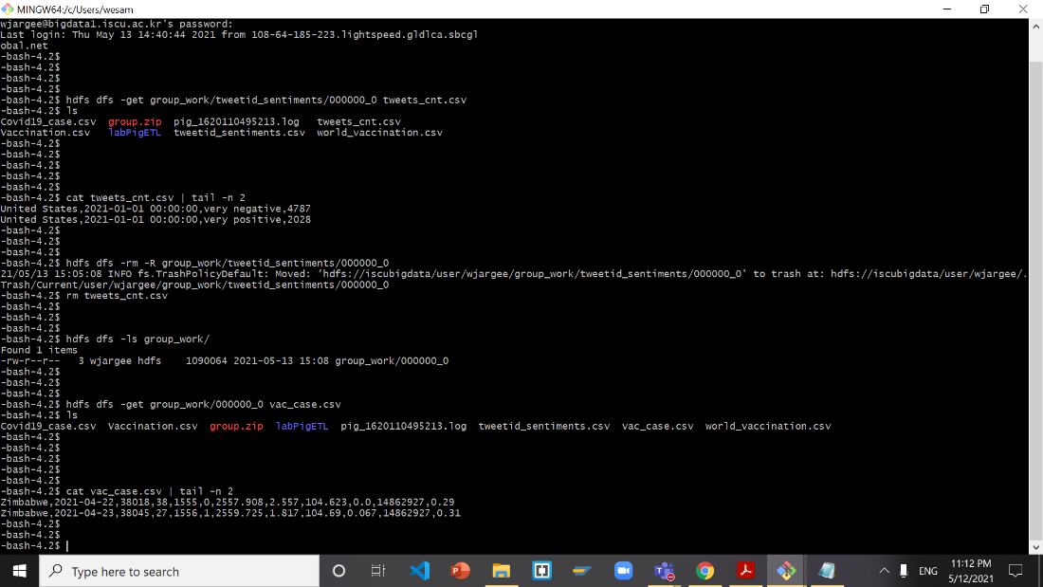

**Open new terminal then download file to local computer**

scp jlicea7@bigdata1.iscu.ac.kr:/home/jlicea7/vac_case.csv .

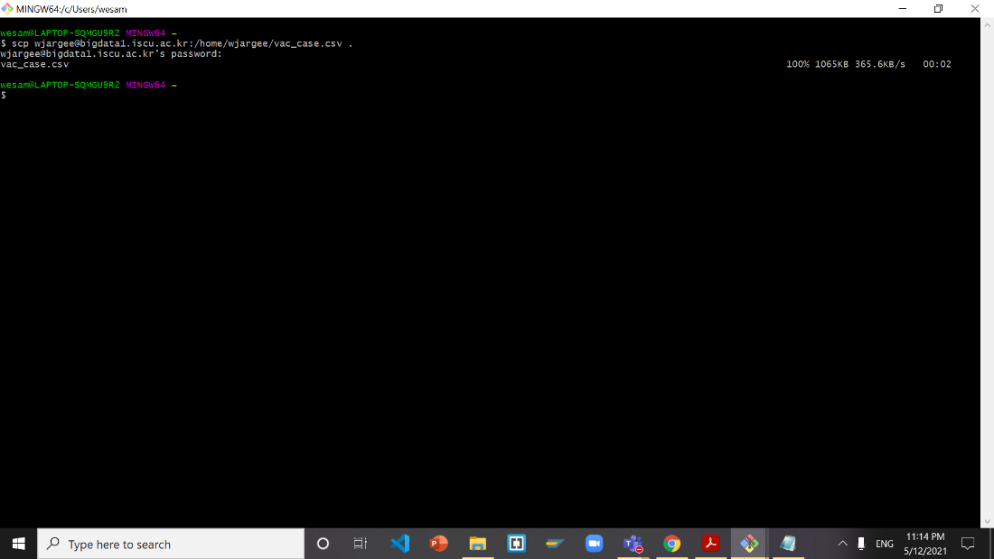

**Return to bash to delete 000000_0 and vac_case.csv to avoid corrupt file**

hdfs dfs -rm -R group_work/000000_0

rm vac_case.csv

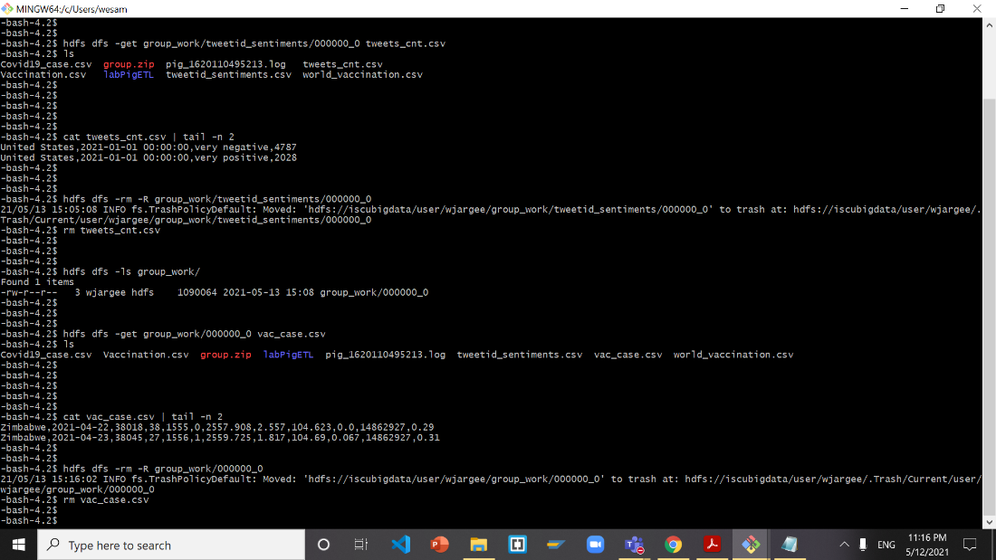

**Add column names thru Notepad for Covid19_case_sample1.csv**

iso_code,location,date,total_cases,new_cases,total_deaths,new_deaths,total_cases_per_million,new_cases_per_million,total_deaths_per_million,new_deaths_per_million,Population

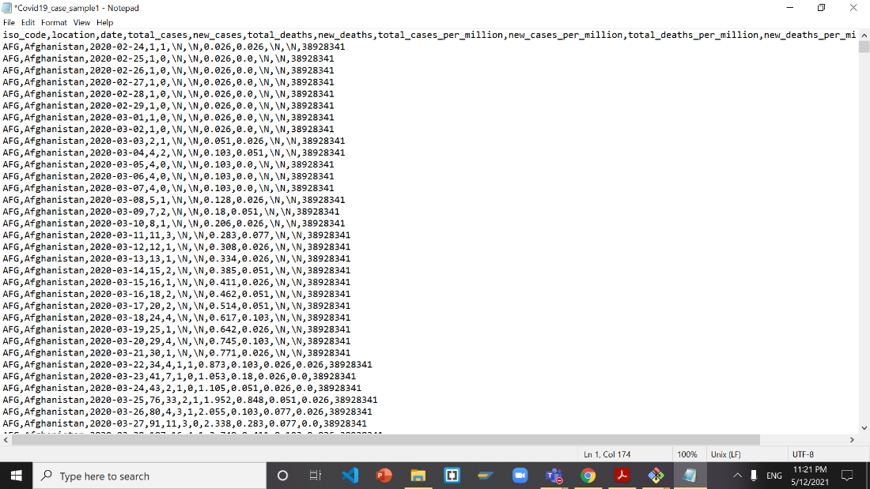

**Add column names thru notepad for tweets_cnt.csv**

country,date_stamp,sentiment_category,cnt

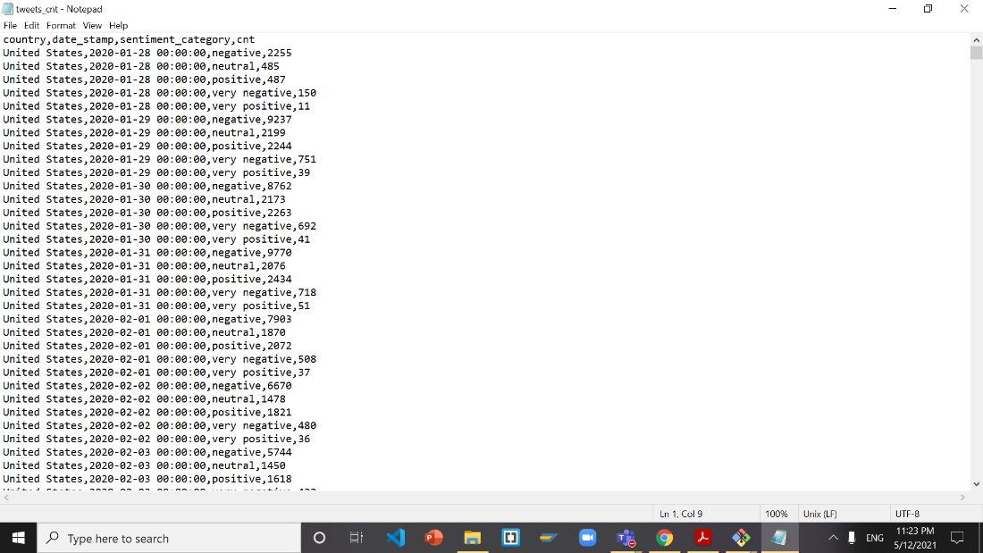

**Add column names thru notepad for vac_case.csv**

location,`date`,total_cases, new_cases,total_deaths,new_deaths,total_cases_per_million, new_cases_per_million,total_deaths_per_million,new_deaths_per_million,population,people_fully_vaccinated_per_hundred

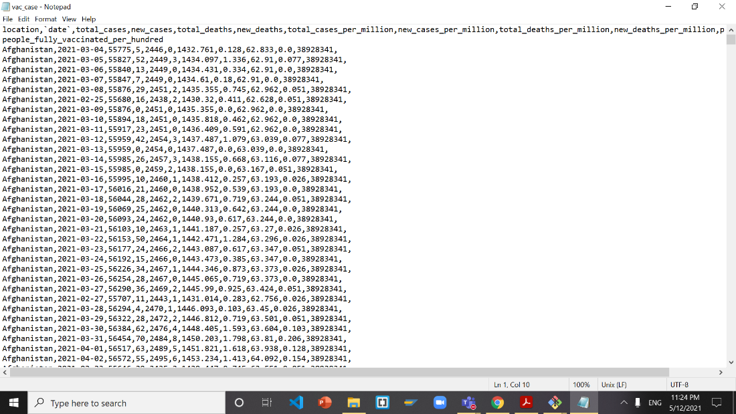

**Step 6: Data Visualization on Excel**

**Open tweets_cnt.csv with Excel**

Save it as Excel Workbook (.xlsx) format:

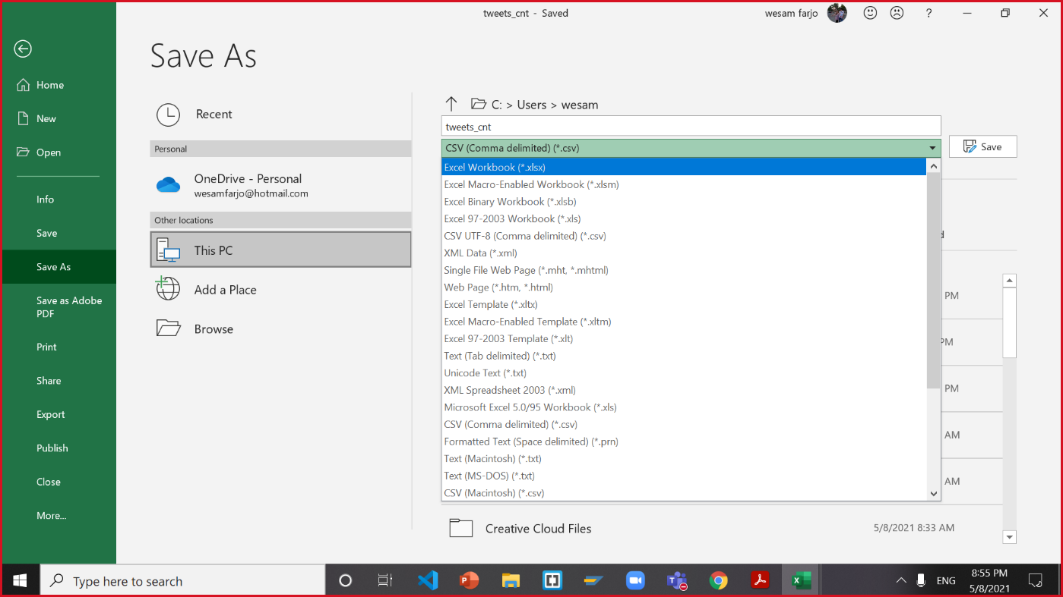

Go to insert tab, then select 3D map:

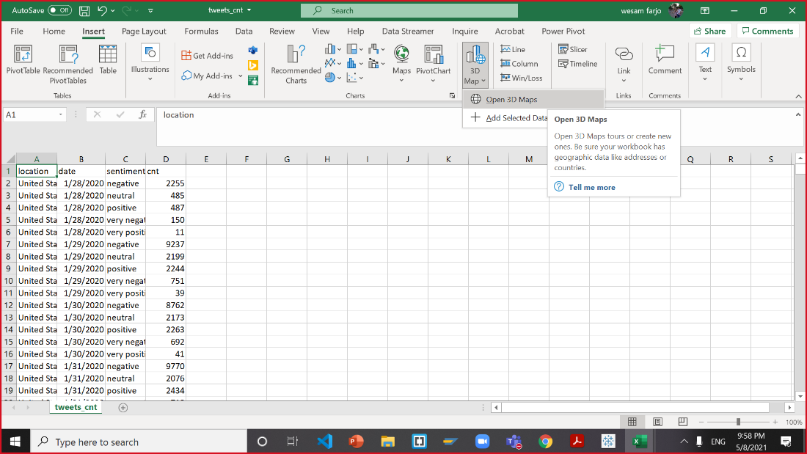

Follow the picture to fill out the fields for the 3D Map:

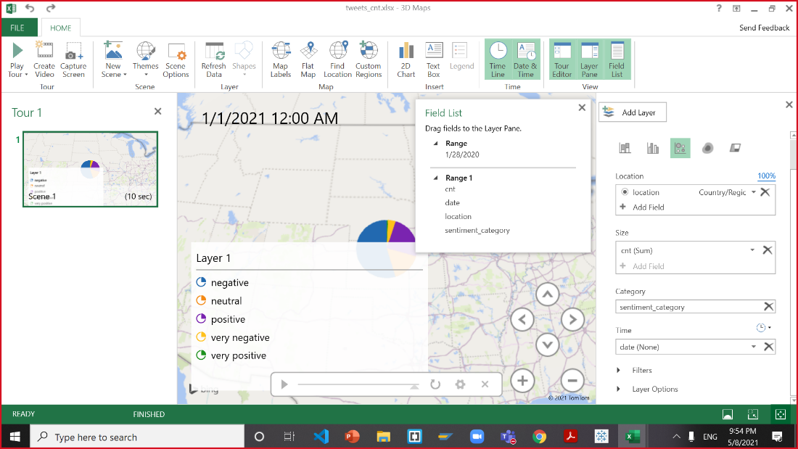

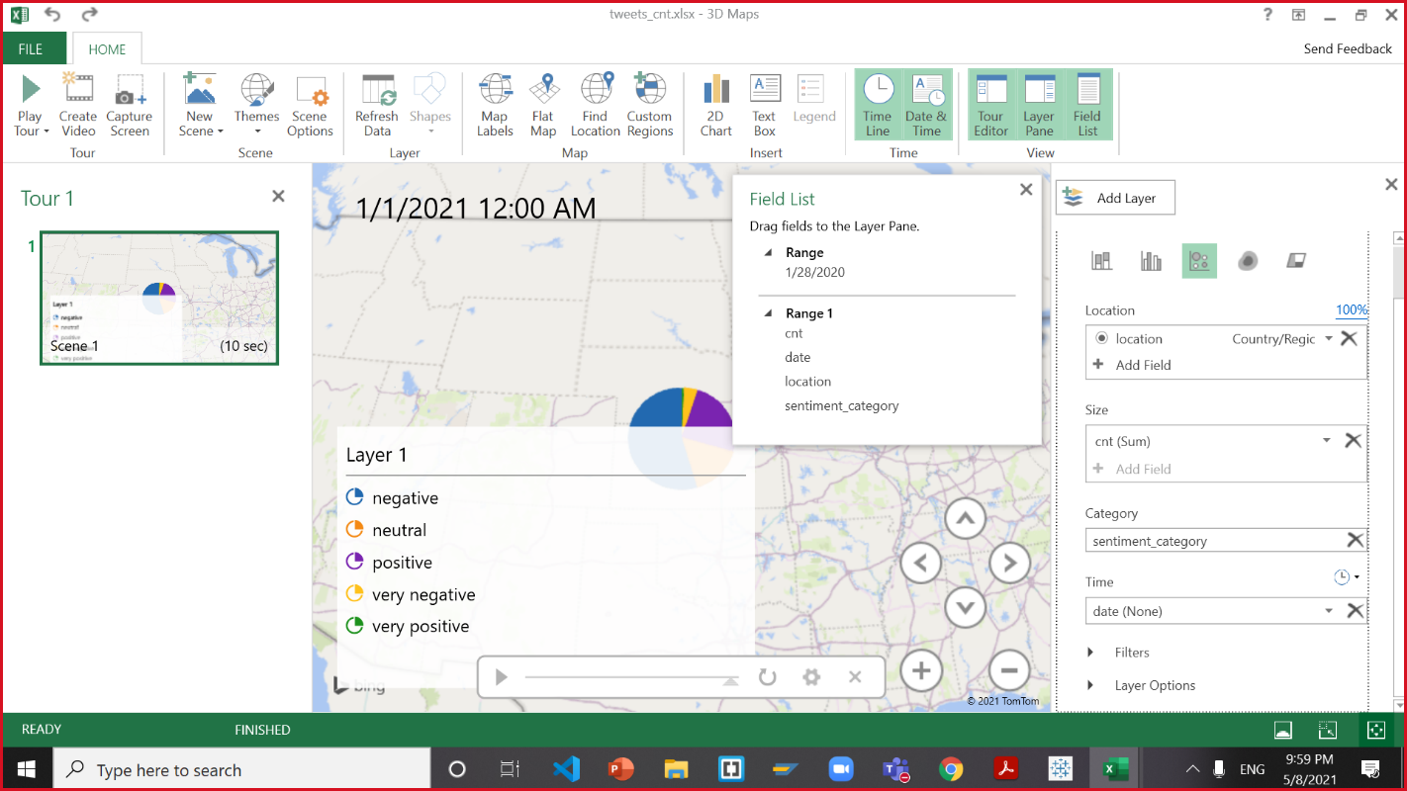

**End Result:**

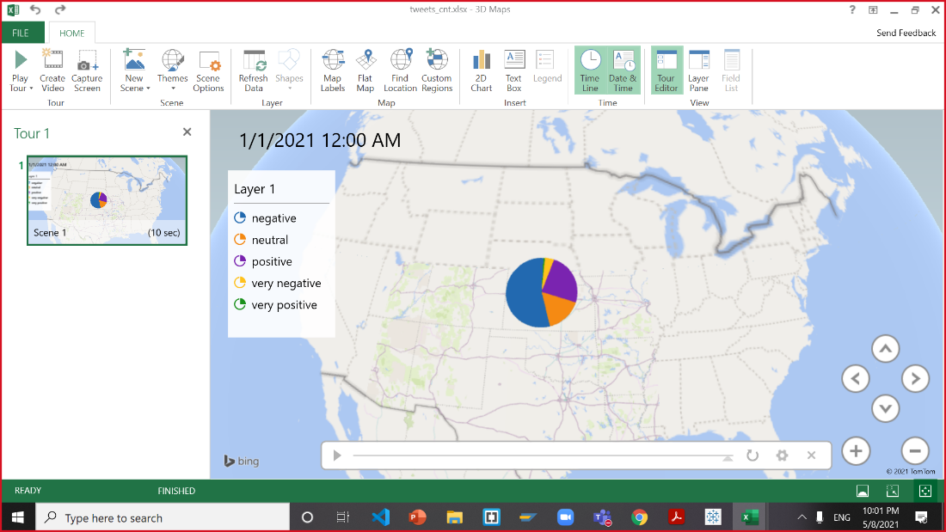

Continue using tweets_cnt

Go to insert

Create a PivotTable

*Make sure to put the new report on a new worksheet*

See Example below

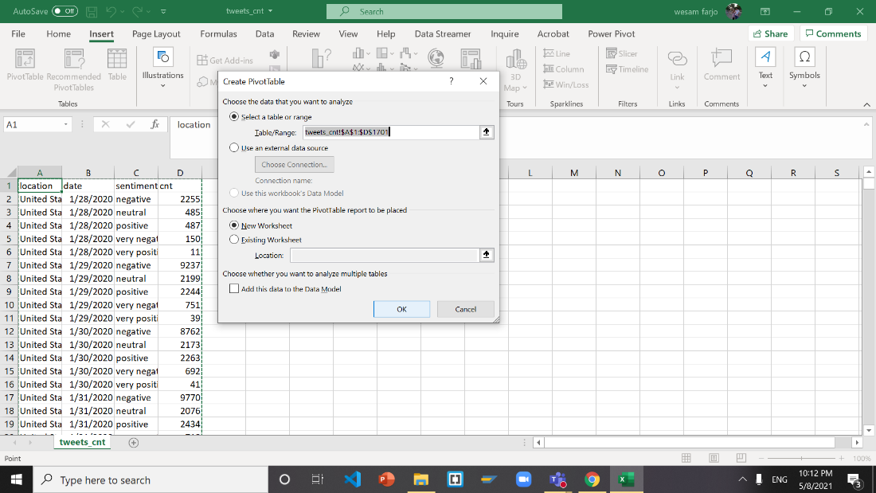

Change the Fields for the PivotTable

Select date, sentiment_category, cnt

Use date for Filters, use sentiment_category for Rows, and Sum of cnt for Values

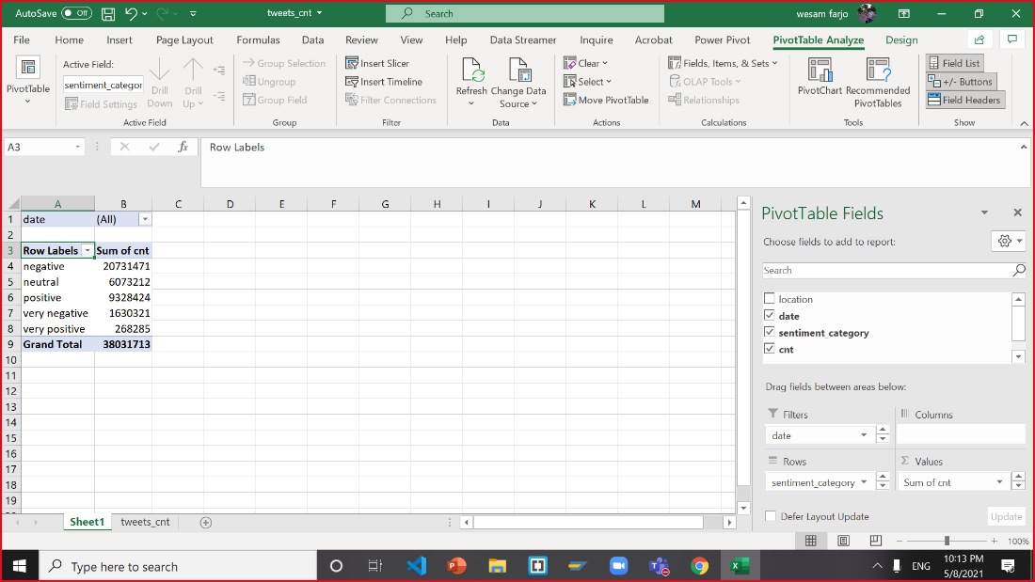

Now Highlight the PivotTable

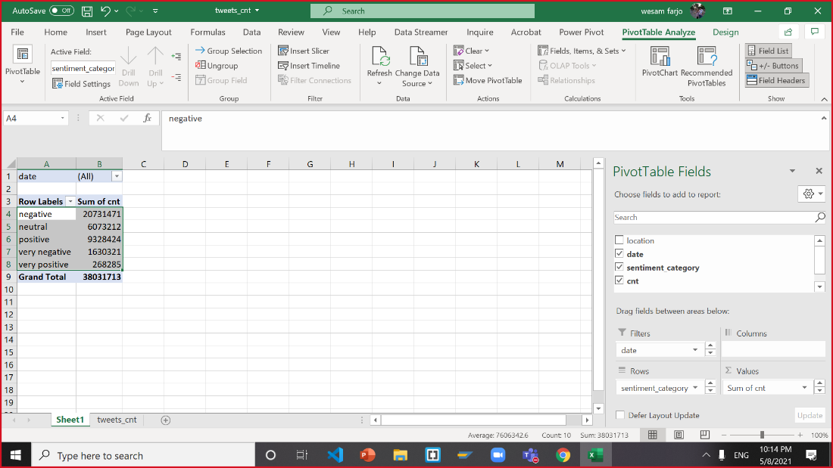

Create a 2-D Pie Chart from the highlighted PivotTable

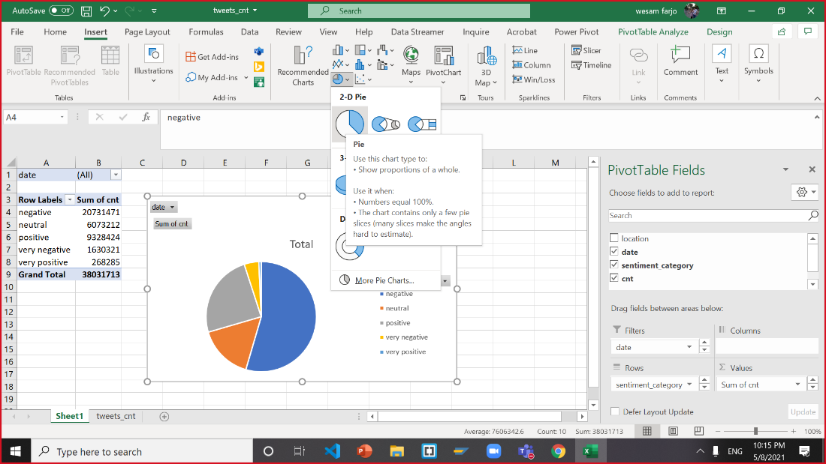

Change the Labels for the 2-D Pie Chart

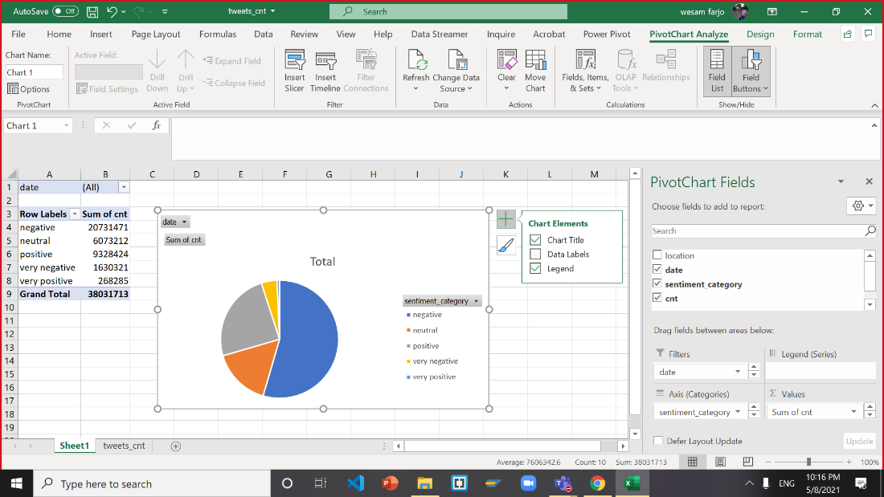

Select Category Name, Percentage, Show Leader Lines

Results should be as below

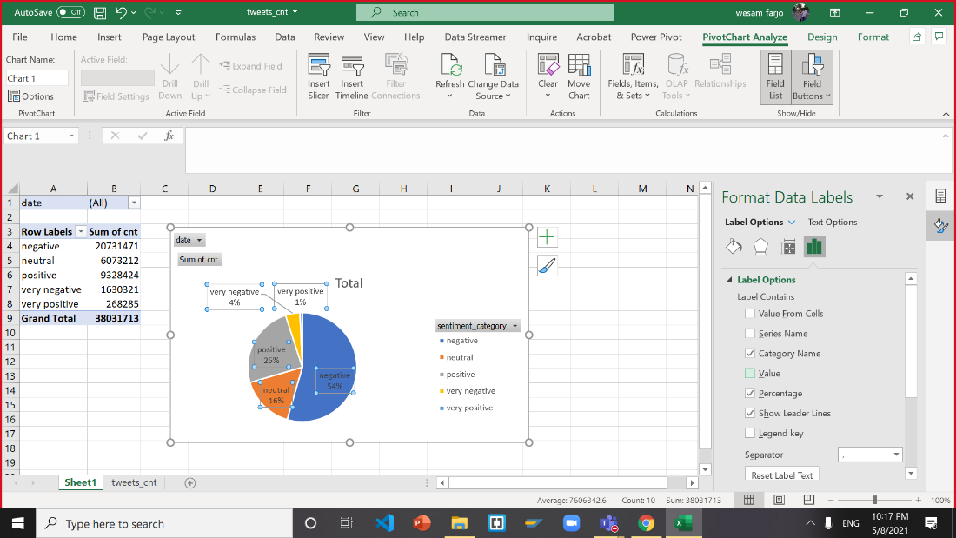

Select the (All) in column b1 and change the date to 1/28/2020

*Doing this allows the user to change the data shown in the chart to whatever date the user chooses*

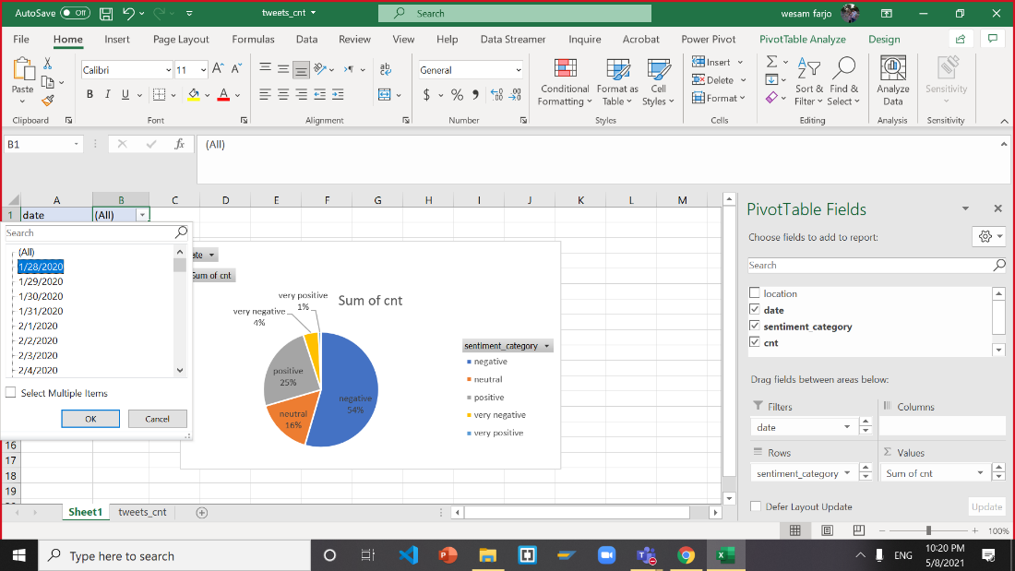

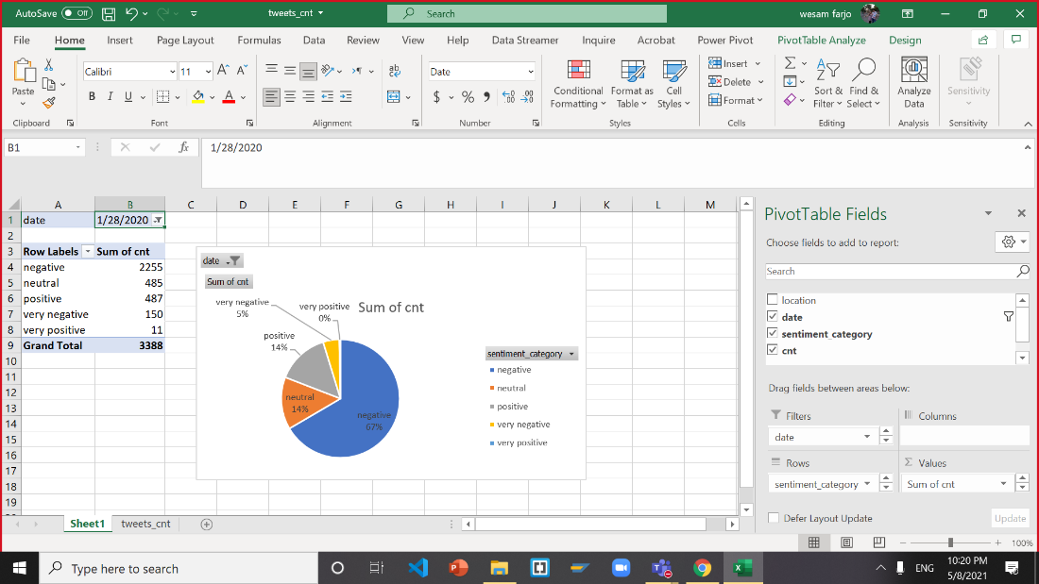

Now select column b1 and change the date to 1/1/2021

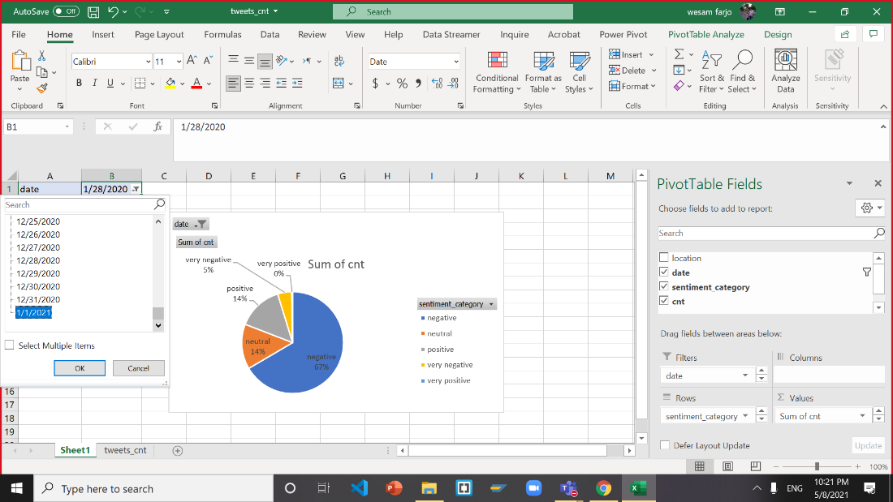

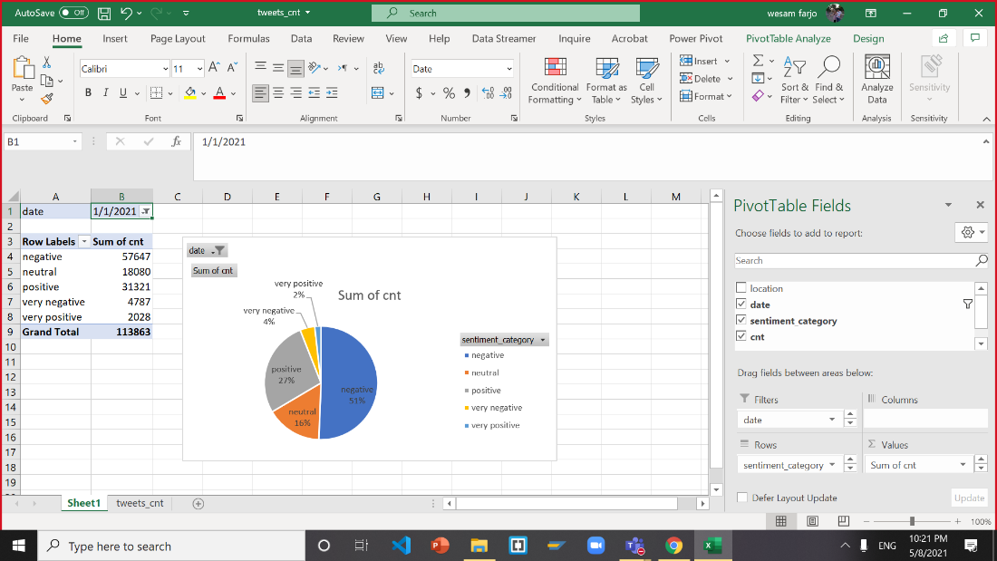

**Step 7: Data Visualization on Tableau**

**Load data source (vac_case.csv)**

Change data type location as country/region:

Then total cases, new cases, total deaths, new deaths as number (whole):

Then total cases per million, new cases per million, total deaths per million, new deaths per million as number (decimal):

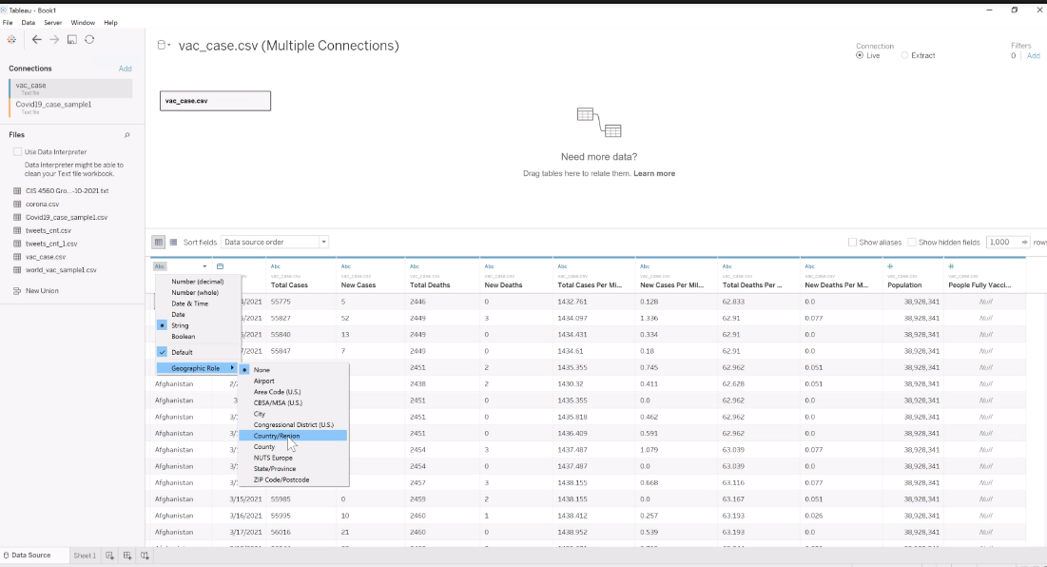

**Open new sheet:**

Drag date to column and then click arrow button, select day, as months day, year:

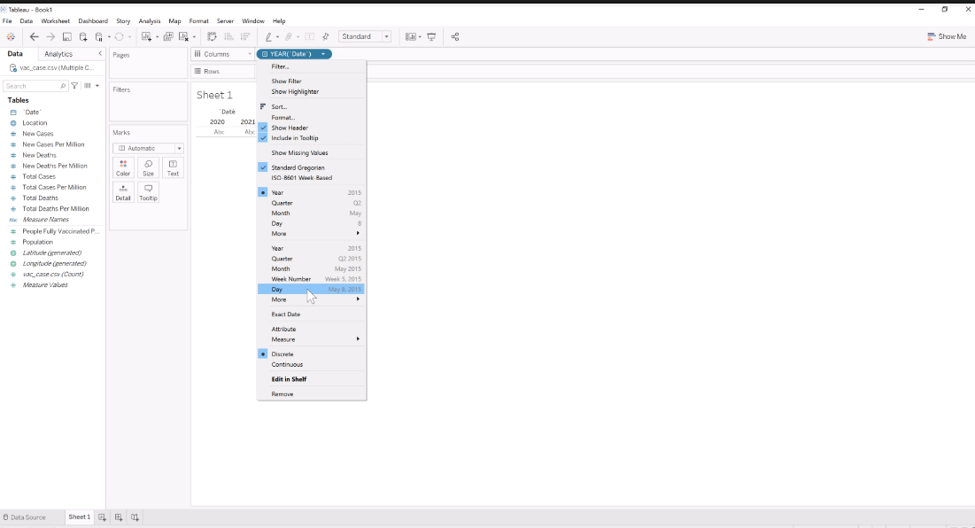

Drag new case per million to row bring the people fully vaccinated per hundred to row. Then drag location to color:

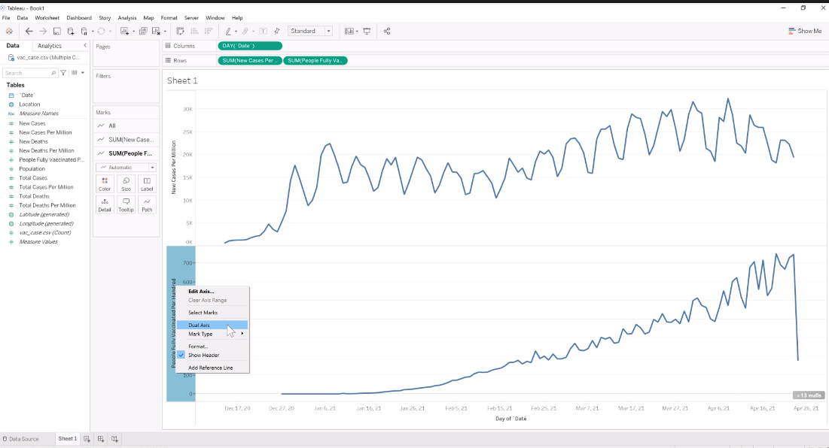

Filter location as Israel, United States, and United Kingdom:

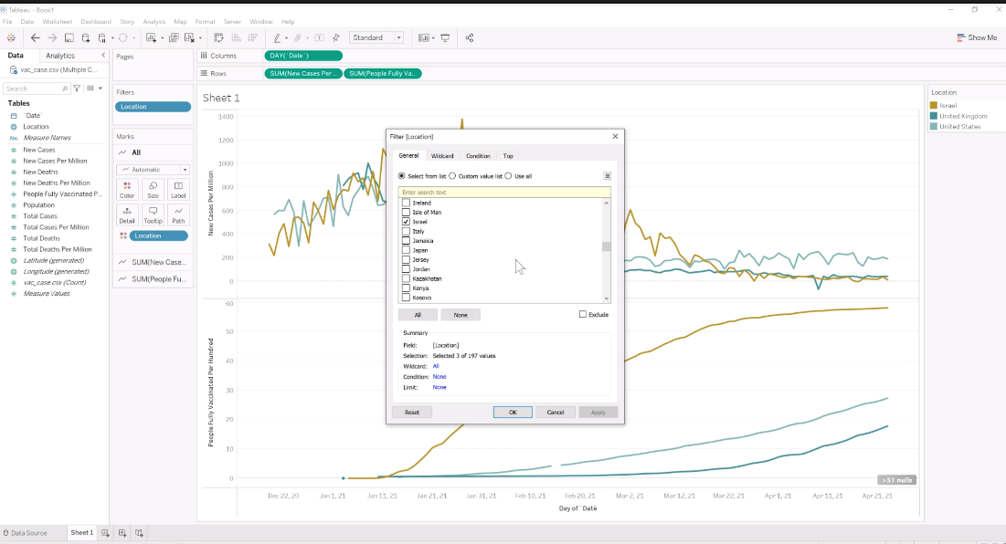

Right click y-axis of people fully vaccinated per hundred. Then select dual axis:

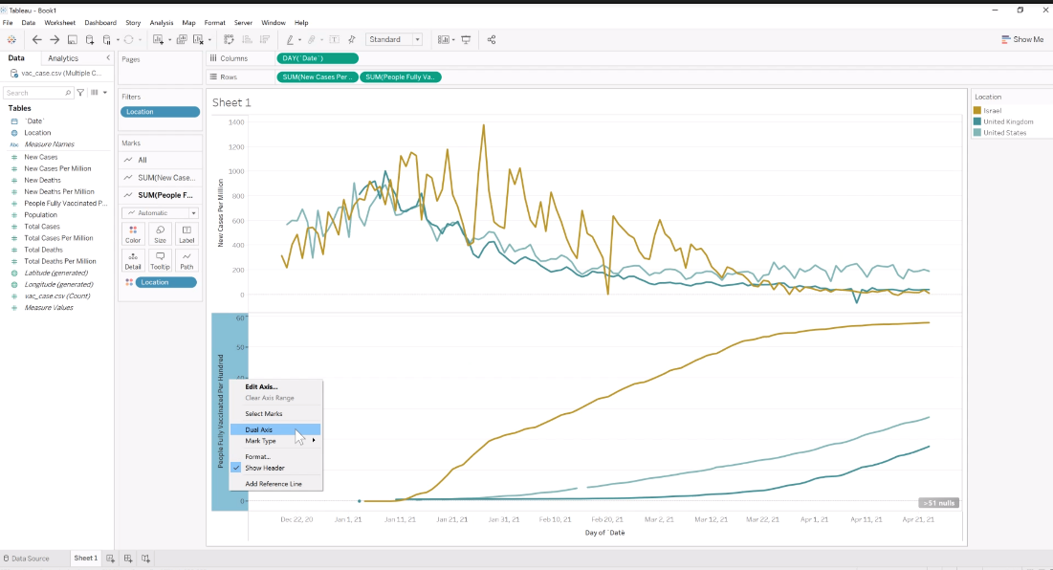

Edit People fully vaccinated per hundred y-axis:

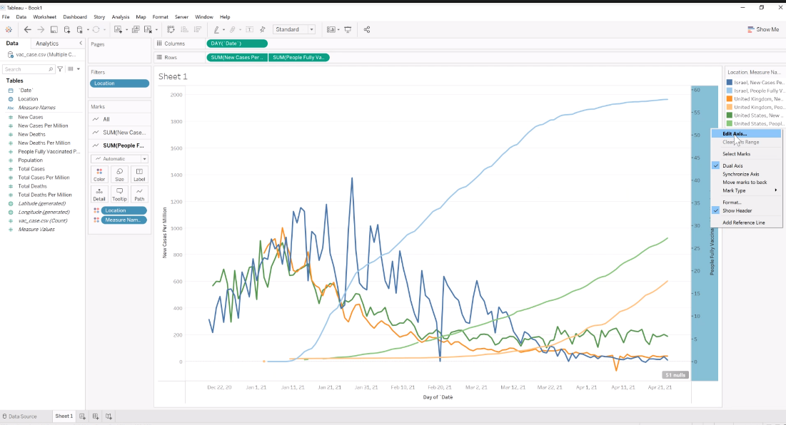

Change range from fixed start to 0 and fixed end to 100:

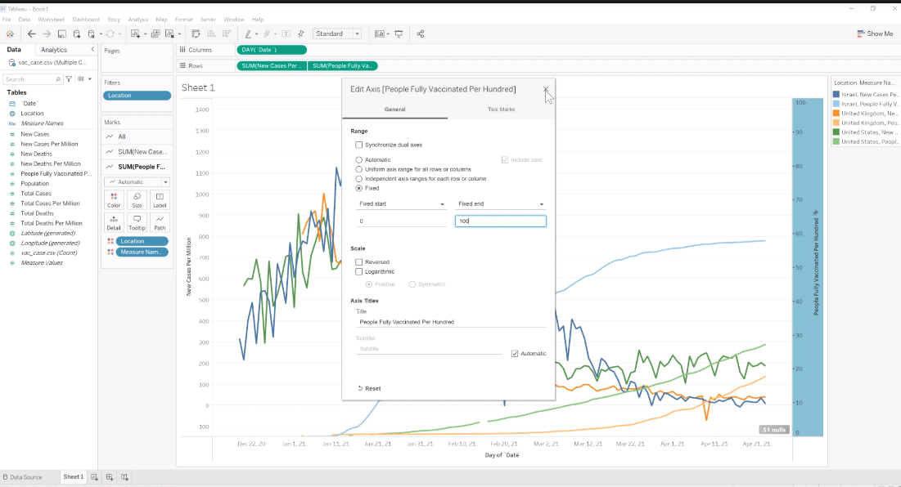

Drag location to Label, then drag new case per million to Label, then drag people fully vaccinated per hundred to Label:

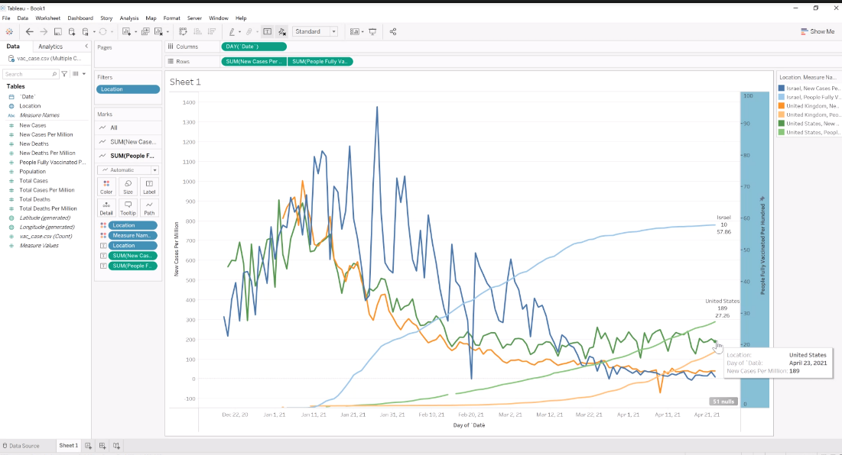

Right Click on the line which does not show description, select mark label to always show:

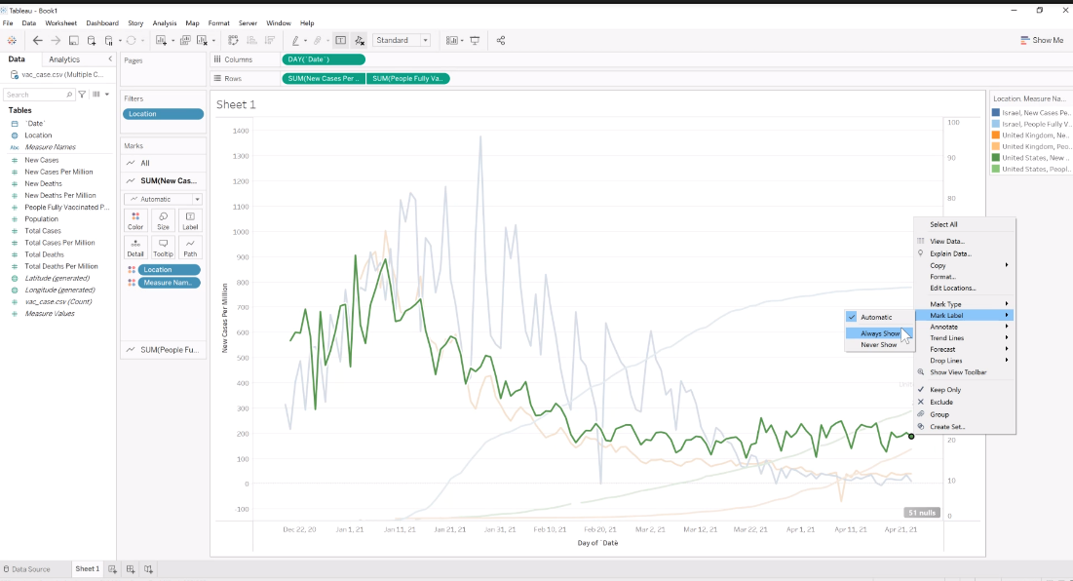

Result should be as below.

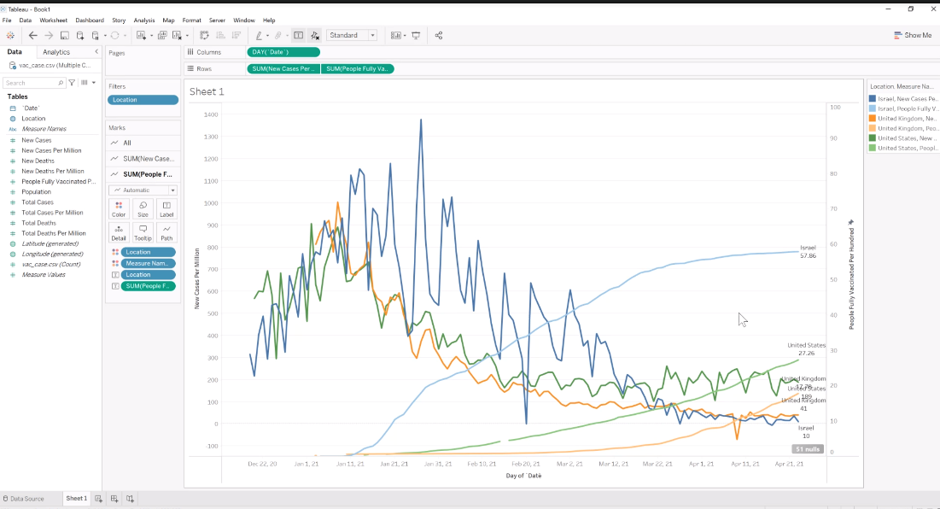

Click Analytics tab on Left panel, then drag Trend Line, then put it on Liner Sum(New case per million).

Duplicate sheet, then change location to purpose(which country you would like to see) :

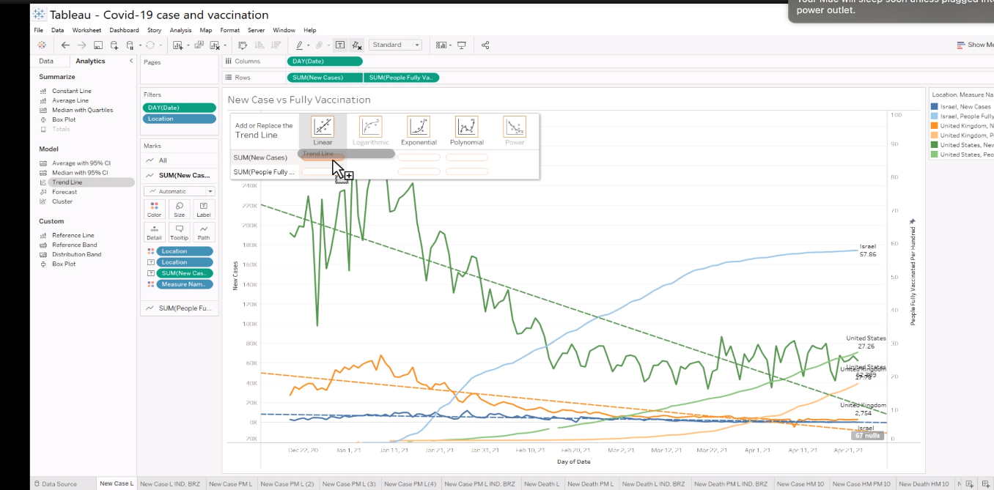

Go back to data source, click data, then click new data source:

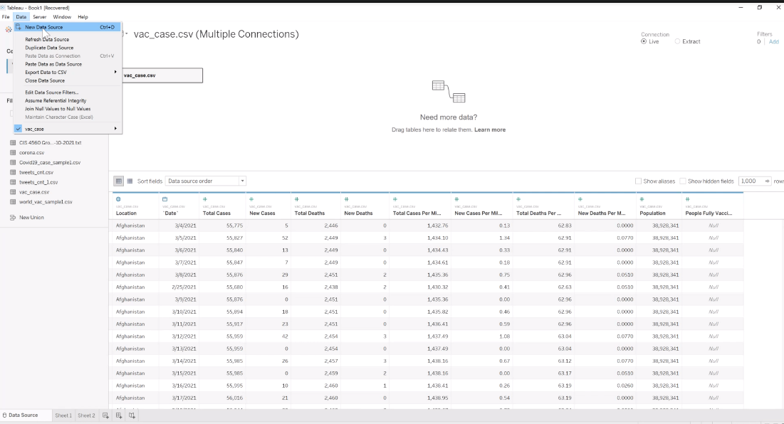

Select text file:

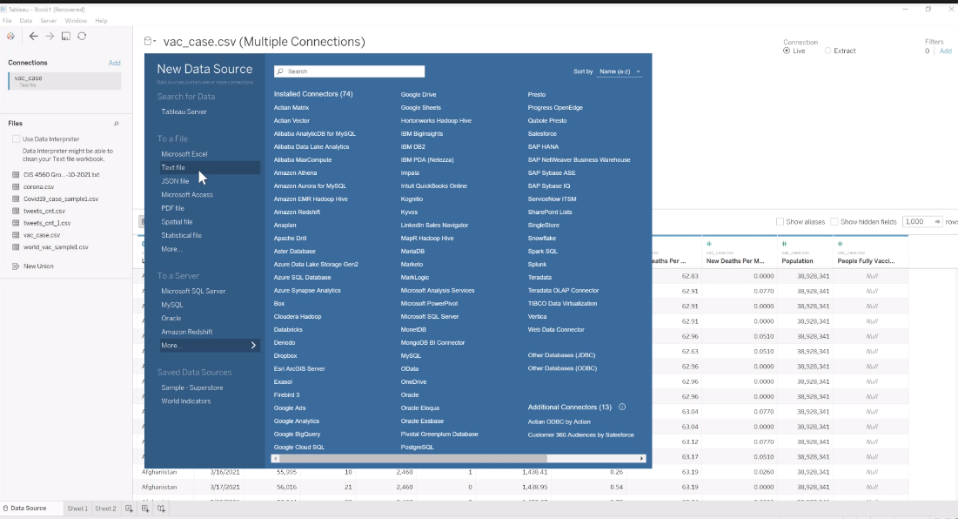

Select Covid19_case_sample1:

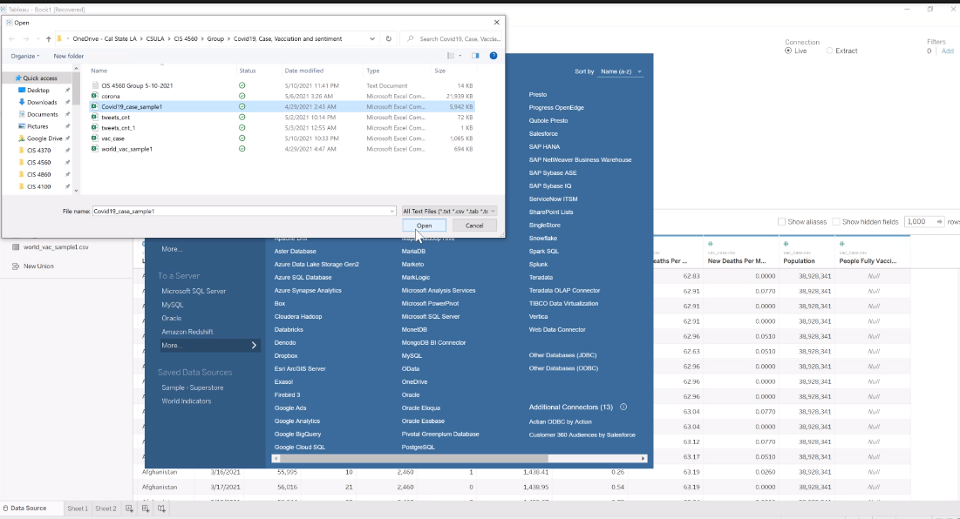

Open new sheet then click, then select covid19_case_sample1 data source:

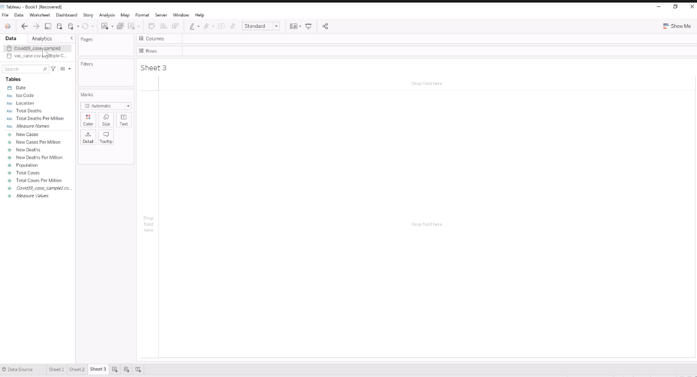

Go back to the data source, then change data type as previous step:

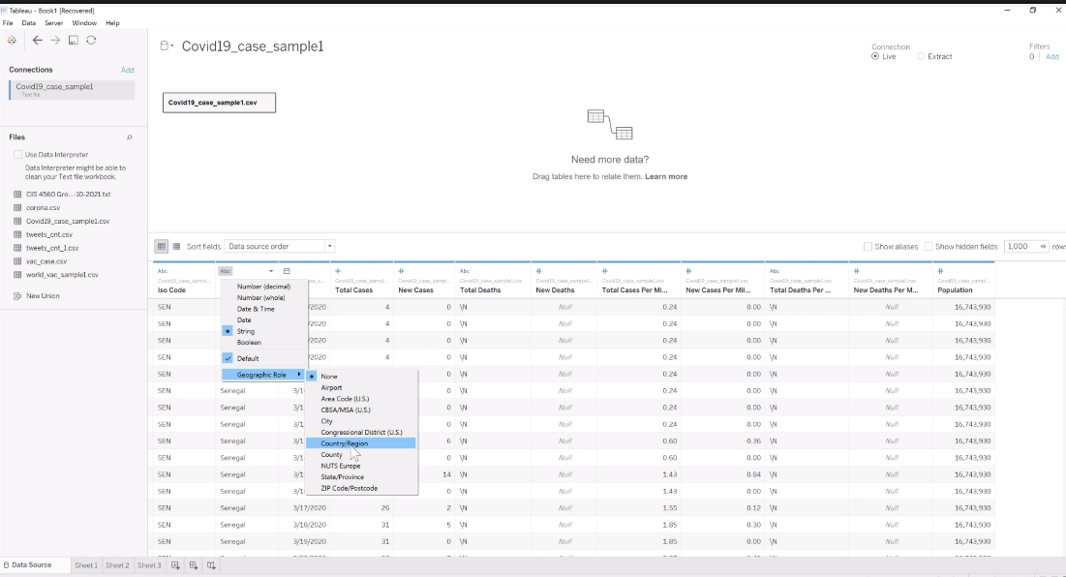

Drag location to Columns, then drag new case per million to Rows:

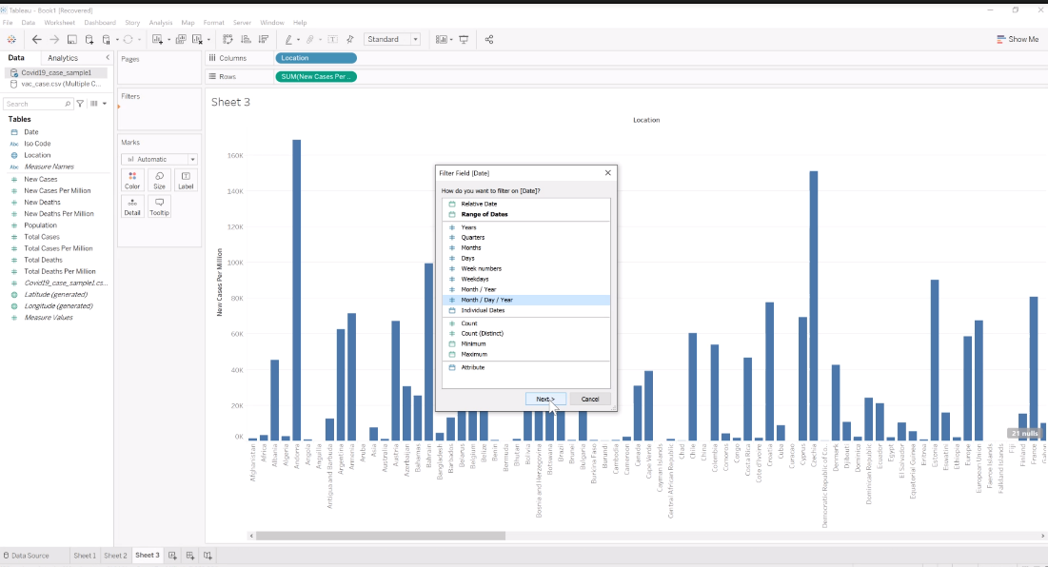

Drag data Filters, then Select day as month_day,year, then Select specific date:

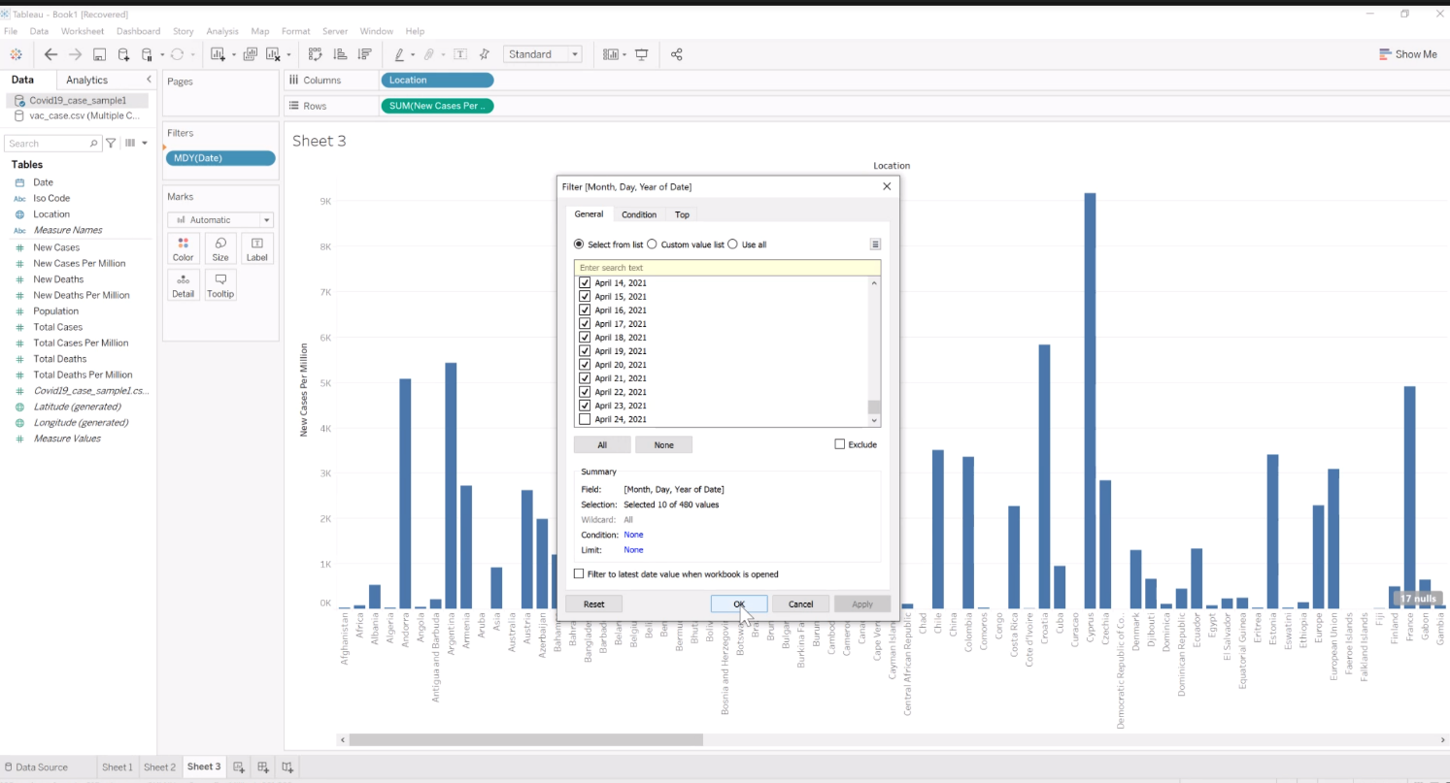

On top right corner click Show Me, select For maps try:

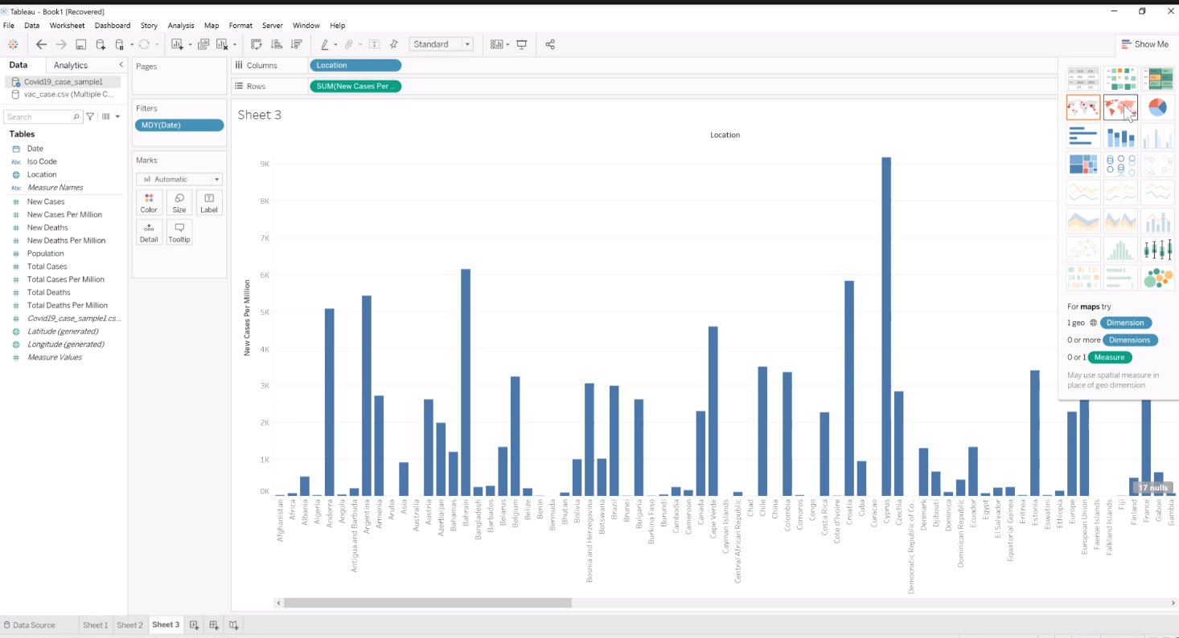

Click down arrow from legend, then select Edit Colors, then drag location to Label, then drag new case per million to Label:

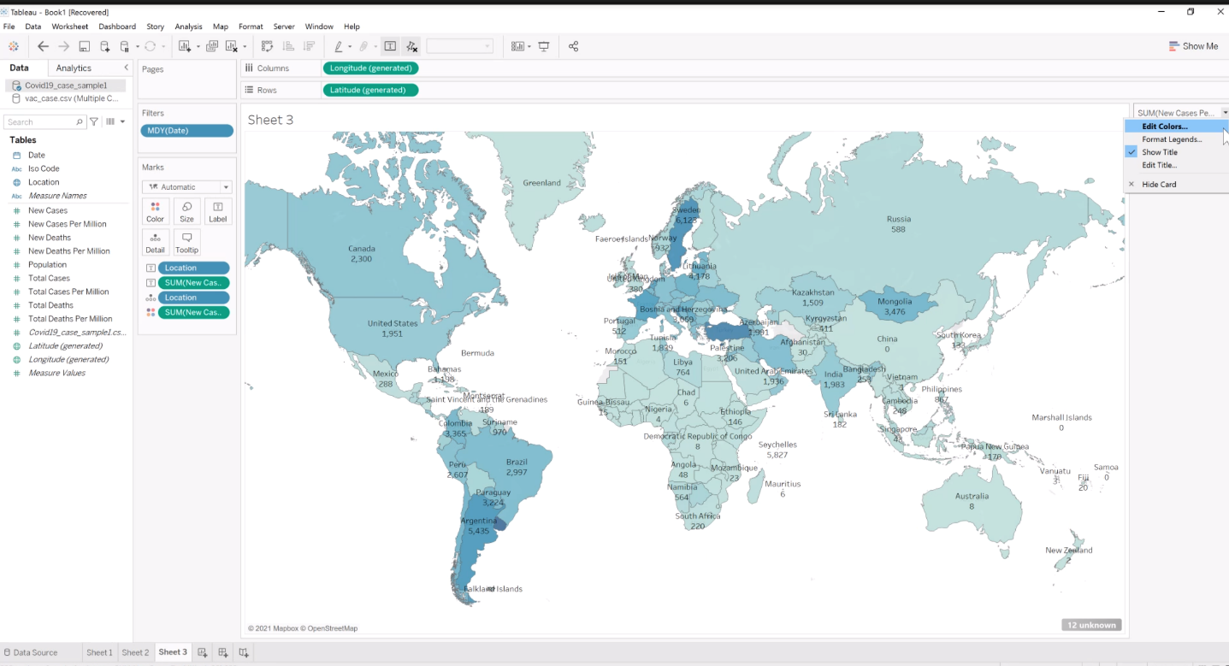

Select Red:

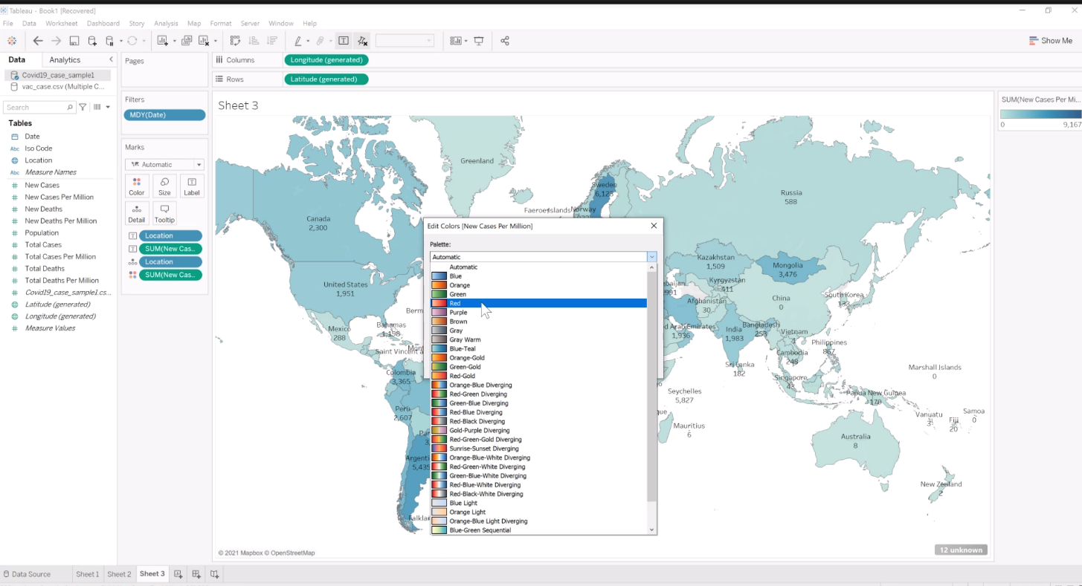

Result should be as below, you can duplicate sheet and change the measure to what you want to see:

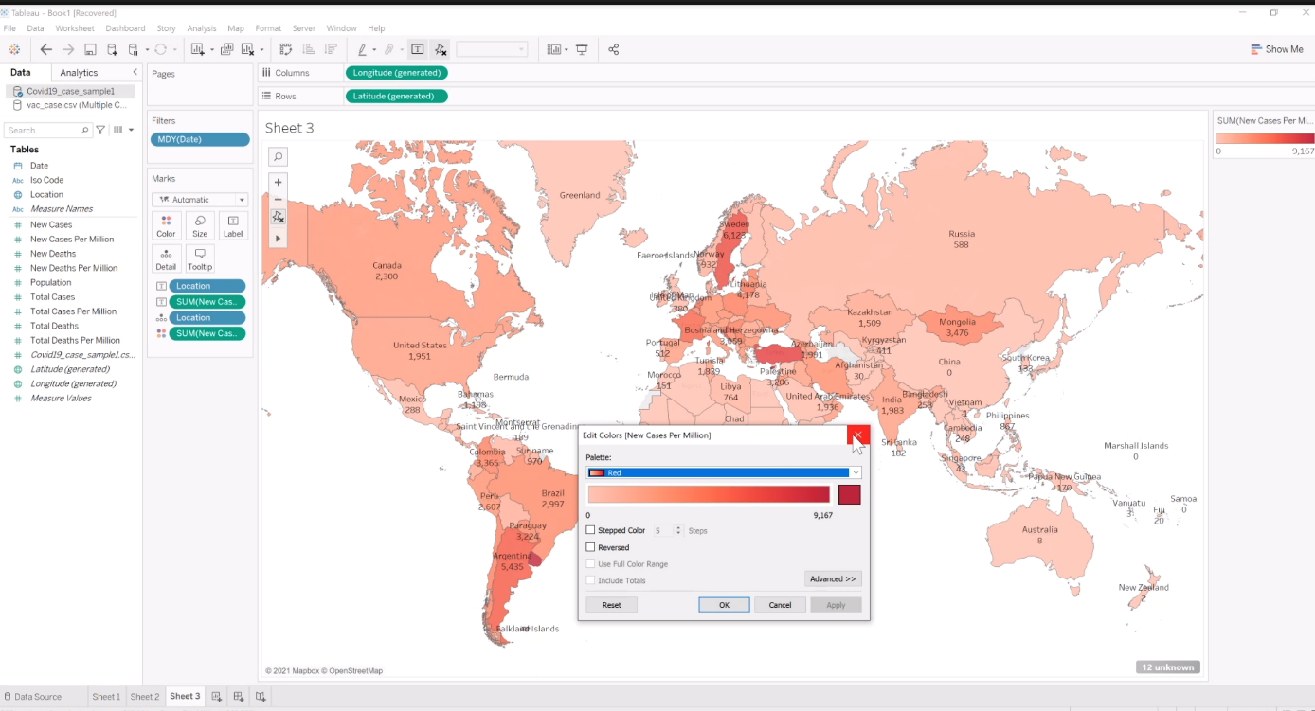

**This is the end of the lab.**